***INTERNET OF THINGS***

Unit I -IoT definition, Characteristics, IoT conceptual and architectural framework, Physical and logical design of IoT, IoT enablers, Modern day IoT applications, M2M communications, IoT vs M2M, IoT vs WoT, IoT reference architecture, IoT Network configurations, IoT LAN, IoT WAN, IoT Node, IoT Gateway, IoT Proxy, IPv4 vs IPV6 Unit II - Sensor, Basic components and challenges of a sensor node, Sensor features, Sensor resolution; Sensor classes: Analog, Digital, Scalar, Vector Sensors; Sensor Types, bias, drift, Hysteresis error, quantization error; Actuator; Actuator types: Hydraulic, Pneumatic, electrical, thermal/magnetic, mechanical actuators, soft actuators Unit III - Basics of IoT Networking, IoT Components, Functional components of IoT, IoT service oriented architecture, IoT challenges, 6LowPAN, IEEE 802.15.4, ZigBee and its types, RFID Features, RFID working principle and applications, NFC (Near Field communication), Bluetooth, Wireless Sensor Networks and its Applications Unit IV -MQTT, MQTT methods and components, MQTT communication, topics and applications, SMQTT, CoAP, CoAP message types, CoAP Request-Response model, XMPP, AMQP features and components, AMQP frame types Unit V -IoT Platforms, Arduino, Raspberry Pi Board, Other IoT Platforms; Data Analytics for IoT, Cloud for IoT, Cloud storage models & communication APIs, IoT case studies

UNIT-1

IOT DEFINITION

* IoT comprises things that have unique identities and are connected to internet. By 2020 there will be a total of 50 billion devices /things connected to internet. IoT is not limited to just connecting things to the internet but also allow things to communicate and exchange data.

Note: *The term "Internet of Things" (IoT) was chosen for a few key reasons:*

* ***It accurately reflects the core concept:*** *The term clearly conveys the idea of everyday objects (things) being connected to the internet, forming a network of interconnected devices.*
* ***It leverages the popularity of the internet:*** *In 1999, when the term was coined, the internet was rapidly growing in popularity and public awareness. Using "internet" in the name helped gain attention and make the concept easier to understand.*
* ***It is catchy and memorable:*** *The term "Internet of Things" is concise, easy to pronounce, and memorable. This has helped it become widely adopted and recognized around the world.*

*It's important to note that while the term "internet" is used, not all connected devices need to be directly connected to the public internet. They can be connected to other local networks or communicate through various protocols. However, the core idea of interconnectedness and data exchange remains the same.*

*Here's a bit more about the origin of the term:*

* ***Coined in 1999:*** *The term "Internet of Things" was first coined by Kevin Ashton, a computer scientist working at Procter & Gamble at the time.*
* ***Originally used for supply chain management:*** *Ashton initially proposed using the term to promote the use of Radio-Frequency Identification (RFID) technology for tracking products in supply chains. He strategically used the then-popular term "internet" to grab the attention of management.*

*Over time, the term evolved beyond its initial use case and became the widely accepted term for the broader phenomenon of interconnected devices.*

* The internet of things, or IoT, is a network of interrelated devices that connect and exchange data with other IoT devices and the cloud. [IoT devices](https://www.techtarget.com/iotagenda/definition/IoT-device) are typically embedded with technology such as sensors and software and can include mechanical and digital machines and consumer objects. Increasingly, organizations in a variety of industries are using IoT to operate more efficiently, deliver enhanced customer service, improve decision-making and increase the value of the business. With IoT, data is transferable over a network without requiring human-to-human or human-to-computer interactions.
* A *thing* in the internet of things can be a person with a heart monitor implant, a farm animal with a biochip transponder, an automobile that has built-in sensors to alert the driver when tire pressure is low, or any other natural or man-made object that can be assigned an [Internet Protocol](https://www.techtarget.com/searchunifiedcommunications/definition/Internet-Protocol) address and is able to transfer data over a network.
* The Internet of Things (IoT) refers to a network of physical devices, embedded with sensors, software, and other technologies, that are able to connect and exchange data with other devices and systems over the internet. These devices can range from simple everyday objects, like thermostats and refrigerators, to complex industrial tools and machinery.
* A **dynamic** global n/w infrastructure with **self- configuring** capabilities based on standard and **interoperable communication protocols** where physical and virtual things have **identities,** physical attributes and virtual personalities and use intelligent interfaces, and are seamlessly integrated into information n/w, often communicate data associated with users and their environments.
* These devices, also known as **smart objects**

Here are some key points about IoT:

* **Connectivity:** IoT devices are able to connect and communicate with each other and with other systems over the internet.
* **Data exchange:** These devices collect and share data, allowing them to automate tasks, improve efficiency, and provide valuable insights.
* **Applications:** IoT has a wide range of applications across various industries, including manufacturing, healthcare, transportation, and agriculture.
* **Impact:** IoT is transforming the way we live, work, and interact with the world around us.

CHARACTERISTICS

* DYNAMIC & SELF ADAPTING- IOT Devices and systems may have the capability to dynamically adapt with the changing contexts and take actions based on their operating conditions ,user’s context or sensed environment. For e.g. , consider a surveillance system comprising of a number of surveillance cameras. The surveillance cameras can adapt their modes based on whether it is night or day .Camera could switch from lower resolution to higher resolution modes when any motion is detected and alert nearby cameras to do the same .In this example the surveillance system is adapting itself based on the context and changing (dynamic) conditions.
* SELF -CONFIFURATION- IOT devices may have self-configuring capabilities , allowing a large number of devices to work together to provide certain functionality(such as weather monitoring).These devices have the ability to configure themselves(in association with monitoring),setup the networking , and fetch latest software upgrades with minimal manual or user intervention.
* INTEROPERABLE COMMUNICATION PROTOCOLS-IOT devices may support a number of interoperable communication protocols and can communicate with other devices and also with the infrastructure.
* UNIQUE IDENTITY- Each IOT devices has a unique identity and a unique identifier(such as address or a URI). IOT systems may have intelligent interfaces which adapt based on the context , allow communicating with users and the environment contexts. IOT device interface allow users and the environment contexts. IOT device interface allow users to query the devices, monitor their status and control them remotely , in association with the context , configuration and management infrastructure.
* INTEGRATED INTO INFORMATION NETWORK- IOT devices are usually integrated into the information network that allows them to communicate and exchange data with other devices and systems. IOT devices can be dynamically discovered in the network , by other devices and(or devices) to other devices or user applications. For e.g. a weather monitoring node can describe its monitoring capabilities to another connected node so that they can communicate and exchange data. Integration into the information network helps in making IOT systems “smarter” due to the collective intelligence of the individual devices in collaboration with the infrastructure. Thus the data from a large number of connected weather monitoring IOT nodes can be aggregated and analysed to predict the weather.

The goal of IOT is to extent internet connectivity from standard devices such as computer , mobile phone and electronic devices.

IOT connects object and make them talk to each other and share information among themselves and use that information for actions.

IOT make entire world deeply and widely connected.

IOT make every object – addressable, accessible, actionable

Connect everyday objects to internet including various industrial devices

*Here are some of the key characteristics of IoT devices:*

***Connectivity:*** *This is the backbone of IoT, as devices need to connect and exchange data with other devices and systems. This can be achieved through various wireless technologies like Wi-Fi, Bluetooth, cellular networks, or even specialized protocols.*

***Intelligence and Identity:*** *Many IoT devices are equipped with embedded processors and software that allow them to collect data from sensors, process it to some extent, and make basic decisions. Additionally, each device needs a unique identifier to be recognized and addressed within the network.*

***Scalability:*** *IoT systems are designed to be scalable, meaning they can easily accommodate a growing number of devices being added to the network. This is crucial as the number of connected devices is expected to continue to increase significantly.*

***Dynamic and Self-Adapting:*** *Due to the ever-changing nature of the environment and user needs, some IoT devices have the capability to adapt and adjust their behavior accordingly. This can involve learning from past data, updating their software, or even reconfiguring themselves based on real-time situations.*

***Data-driven:*** *As they collect vast amounts of data from sensors and other sources, IoT devices are essentially data-driven systems. This data is used for various purposes, including improving device performance, gaining insights into the surrounding environment, and making informed decisions.*

***Security:*** *With increasing concerns about privacy and security, securing IoT devices is paramount. This involves implementing robust security measures to protect the devices themselves, the data they collect, and the networks they connect to.*

***Other characteristics:*** *Depending on the specific device and application, other characteristics may include:*

* ***Low power consumption:****Many IoT devices are battery-powered or operate in resource-constrained environments, making low power consumption essential.*
* ***Long range:****For certain applications, especially in industrial settings or remote locations, the ability to communicate over long distances is crucial.*
* ***Reliability:****As many IoT devices are deployed in critical applications, they need to be reliable and function consistently with minimal downtime.*

IOT CONCEPTUAL AND ARCHITECTURAL FRAME WORK

-  The main tasks of this framework are to analyze and determine the smart activities of these intelligent devices through maintaining a dynamic interconnection among those devices. The proposed framework will help to standardize IoT infrastructure so that it can receive e-services based on context information leaving the current infrastructure unchanged. The active collaboration of these heterogeneous devices and protocols can lead to future ambient computing where the maximum utilization of cloud computing will be ensured.

- Physical Object + Controller, Sensor and Actuators + Internet = Internet of Things(simple)

- Gather + Enrich + Stream + Manage + Acquire + organize and Analyse = Internet of Things Enterprise (oracle)

-Gather + Consolidate + Connect + Collect + Assemble + Manage and Analyse = Internet of Things connected to Cloud Services

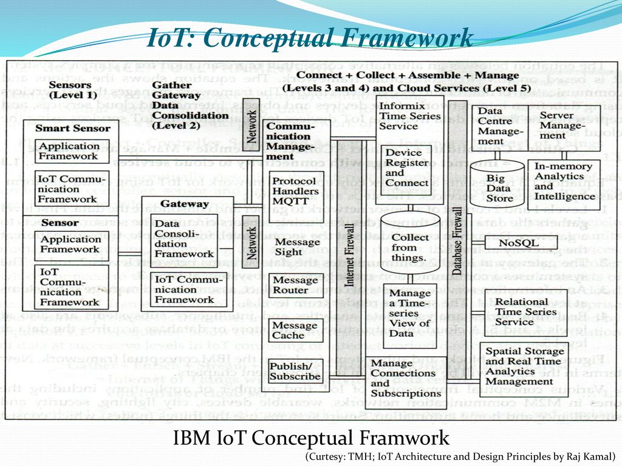

* a conceptual framework for IoT provides a **high-level, abstract view** of the different components and their interactions within an IoT system.
* **Gather**:
  + In the gather phase, IoT devices equipped with sensors and actuators collect data from the physical environment. These devices can range from simple sensors measuring temperature or humidity to complex systems monitoring industrial machinery or urban infrastructure.
* **Consolidate**:
  + Once data is gathered from various IoT devices, it needs to be consolidated into a unified format for further processing. This involves standardizing data formats, protocols, and interfaces to ensure interoperability and compatibility across different devices and systems.
* **Connect**:
  + The connect phase involves establishing communication links between IoT devices, edge devices, gateways, and cloud platforms. This may include wired or wireless connections such as Wi-Fi, Bluetooth, Zigbee, cellular networks, or Ethernet, depending on the specific application requirements and environmental constraints.
* **Collect**:
  + In the collect phase, the consolidated data is transmitted from IoT devices to centralized data storage repositories, such as cloud servers or edge computing platforms. This may involve batch processing or real-time streaming of data, depending on the application's latency and throughput requirements.
* **Assemble**:
  + Once the data is collected, it needs to be assembled into meaningful datasets or data streams for analysis. This involves organizing, structuring, and preprocessing the raw data to remove noise, handle missing values, and extract relevant features for further analysis.
* **Manage**:
  + The manage phase involves overseeing the entire IoT ecosystem, including device management, security, privacy, and scalability. This may include tasks such as device provisioning, configuration, monitoring, firmware updates, access control, and compliance with regulatory standards.
* **Analyze**:
  + In the analyze phase, advanced analytics techniques are applied to the assembled data to extract insights, detect patterns, and make predictions. This may involve descriptive analytics to summarize historical data, diagnostic analytics to identify root causes of problems, predictive analytics to forecast future trends, or prescriptive analytics to recommend optimal courses of action
* An **IoT architectural framework** delves deeper than a conceptual framework by providing a **detailed blueprint** for designing and implementing an IoT system. It outlines the specific **components, technologies, protocols, and standards** used in the system, defining its **concrete structure and functionalities**.
* **LEVEL -1 GATHER ( Object Integrated with sensors)**
  + **SENSOR-**A sensor is a device that measures physical input from its environment and convert it into data that can be interpreted by a computer.
  + **SMART SENSOR-** It have the ability to compute and communicate.
    - The sensors have the capacity to take measurement such as temperature , air quality ,speed, humidity, pressure , flow, movement , electricity etc
    - Smart sensor collect the data and then transmit it to level-2 through transcode( which does coding and decoding).
  + **APPLICATION FRAMEWORK –** These are libraries with the help of these sensor will connect with gateway and other devices.
  + **IOT COMMUNICATION FRAMEWORK-**This is medium/protocol with the help of which devices are connected with each other .It may be WIFI , internet, IP ,Bluetooth , etc.
* LEVEL-2 ENRICH
  + GATEWAY – It is the hardware which behave like a gate between the two devices , it may be router, server
    - To transport massive volume of data produced by sensors , a robust and high performance wired or wireless network infrastructure is required.
    - Data from sensors come to gateway after the encoding and when data go to the next level from gateway decoding is done.
* 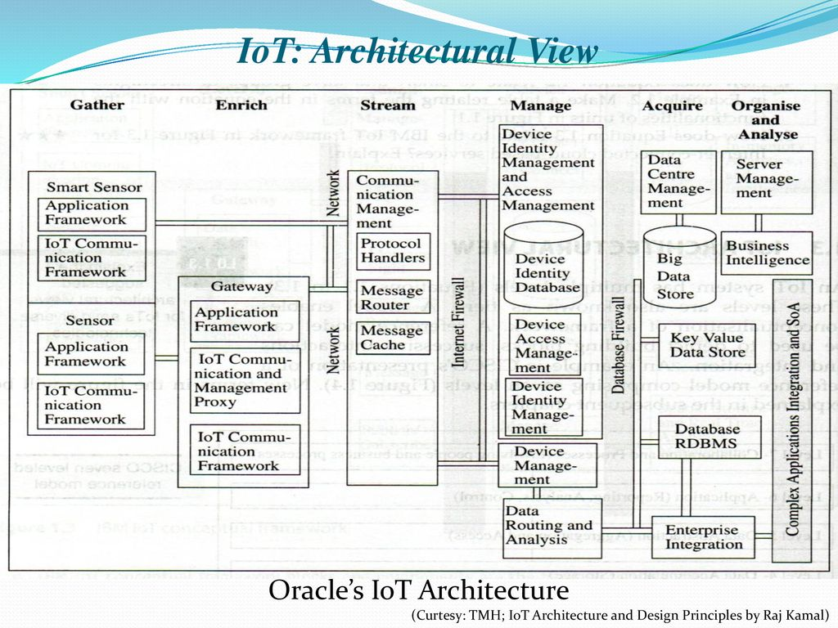
* LEVEL -3 STREAM – communication management is done here to send and receive the data stream
  + Protocol handlers -These are used to check whether the device connected in IOT has ability to access the Internet or not.
  + Message Router- If any device send the message then the router will decide to whom it will go.
  + Message cache -It stores the recently came data
* LEVEL -4 MANAGE – Level 4 receive the device data. Here device management , device identity management and access management receives devices data. The device / hardware which we are using should be registerd .The registered device can only access the data.
  + For e.g . The two mobile phones are connected to each other and if first mobile phone wants to communicate with second mobile phone , the first mobile phone need to be registered and data of this mobile is on level 4 like data of device register ,device identity etc.
* LEVEL-5 ACQUIRE – A data store or database acquires data at level 5.
* LEVEL 6 ORGANIZE AND analyse – Data routed from previous levels are organized and analysed at level-6 . Data routed from previous levels are organized and analyzed at level 6. Data is analyzed for collecting business intelligence. Data is analyzed and to check whether the data is authenticated sensitive or non sensitive.

IOT ARCHITECTURAL LAYER/ ARCHITECTURAL VIEW

* 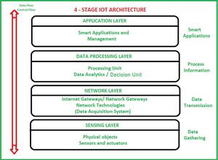
* Sensing Layer – The sensing layer is the first layer of the IoT architecture and is responsible for collecting data from different sources. This layer includes sensors and actuators that are placed in the environment to gather information about temperature, humidity, light, sound, and other physical parameters. These devices are connected to the network layer through wired or wireless communication protocols.
* Network Layer – The network layer of an IoT architecture is responsible for providing communication and connectivity between devices in the IoT system. It includes protocols and technologies that enable devices to connect and communicate with each other and with the wider internet. Examples of network technologies that are commonly used in IoT include WiFi, Bluetooth, Zigbee, and cellular networks such as 4G and 5G. Additionally, the network layer may include gateways and routers that act as intermediaries between devices and the wider internet, and may also include security features such as encryption and authentication to protect against unauthorized access.
* Data processing Layer – The data processing layer of IoT architecture refers to the software and hardware components that are responsible for collecting, analyzing, and interpreting data from IoT devices. This layer is responsible for receiving raw data from the devices, processing it, and making it available for further analysis or action.The data processing layer includes a variety of technologies and tools, such as data management systems, analytics platforms, and machine learning algorithms. These tools are used to extract meaningful insights from the data and make decisions based on that data.Example of a technology used in the data processing layer is a data lake, which is a centralized repository for storing raw data from IoT devices.
* Application Layer – The application layer of IoT architecture is the topmost layer that interacts directly with the end-user. It is responsible for providing user-friendly interfaces and functionalities that enable users to access and control IoT devices.This layer includes various software and applications such as mobile apps, web portals, and other user interfaces that are designed to interact with the underlying IoT infrastructure. It also includes middleware services that allow different IoT devices and systems to communicate and share data seamlessly.The application layer also includes analytics and processing capabilities that allow data to be analyzed and transformed into meaningful insights. This can include machine learning algorithms, data visualization tools, and other advanced analytics capabilities.

PHYSICAL AND LOGICAL DESIGN OF IOT

PHYSICAL SEDIGN OF IOT -The physical design of IoT (internet of things) includes things and different protocols.

* THINGS IN IOT: The things in IoT refers to IoT devices which have unique identities and perform remote sensing, actuating and monitoring capabilities. IoT devices can exchange data with other connected devices and applications. It collects data from other devices and process data either locally or remotely
* 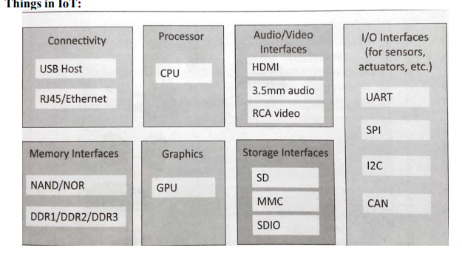
* An IoT device may consist of several interfaces for communication to other devices both wired and wireless. These includes (i) I/O interfaces for sensors, (ii) Interfaces for internet connectivity (iii) memory and storage interfaces and (iv) audio/video interfaces.
* ***Note – collect data from sensors, actuators help in interaction between iot and non-iot devices, communicate and analyze information for further processing***
* ***Types of iot devices-home appliances, smartphones and computers, wearable electronics, automobiles, energy system, retail payment systems, printers, industrial machine, healthcare monitoring ,surveillance cameras***

***IT PROTOCOLS***

* **LINK LAYER-** The link layer protocol determines how the data is physically sent over the network ‘s physical layer or medium (copper wire, coaxial cable, radio wave).The scope of the link layer is the local network connection to which host is attached. Hosts on the same link exchange data packets over the link layer using link layer protocols. Link layer determines how the packet are coded and signaled by the hardware device over the medium to which the host is attached(such as coaxial cable).Link Layer Protocol are:
  + **802.3-Ethernet**: IEEE802.3 is collection of wired Ethernet standards for the link layer. Eg: 802.3 uses co-axial cable; 802.3i uses copper twisted pair connection; 802.3j uses fiber optic connection; 802.3ae uses Ethernet over fiber.
  + **802.11-WiFi**: IEEE802.11 is a collection of wireless LAN(WLAN) communication standards including extensive description of link layer. Eg: 802.11a operates in 5GHz band, 802.11b and 802.11g operates in 2.4GHz band, 802.11n operates in 2.4/5GHz band, 802.11ac operates in 5GHz band, 802.11ad operates in 60Ghzband.
  + **802.16 - WiMax**: IEEE802.16 is a collection of wireless broadband standards including exclusive description of link layer. WiMax provide data rates from 1.5 Mb/s to 1Gb/s.
  + **802.15.4-LR-WPAN**: IEEE802.15.4 is a collection of standards for low rate wireless personal area network(LR-WPAN). Basis for high level communication protocols such as ZigBee. Provides data rate from 40kb/s to250kb/s.
  + **2G/3G/4G**-Mobile Communication: Data rates from 9.6kb/s(2G) to up to100Mb/s(4G).
* NETWORK LAYER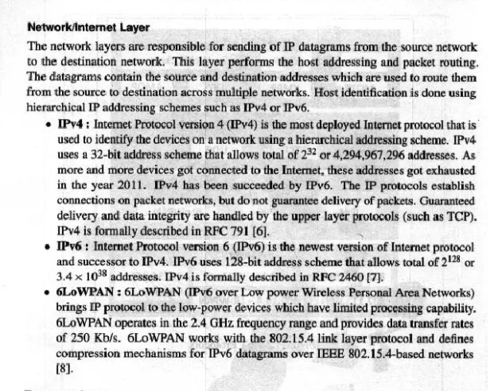
* TRANSPORT LAYER
* 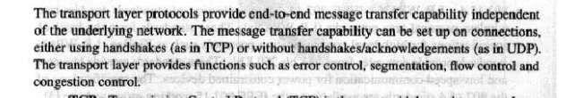
* 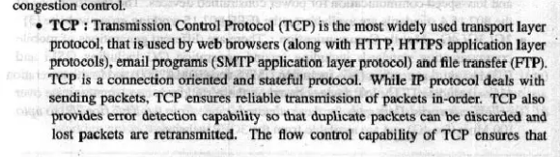
* 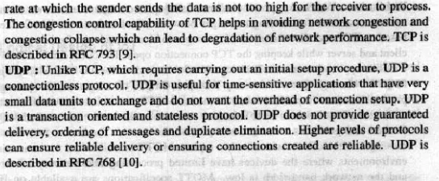
* APPLICATION LAYER
* 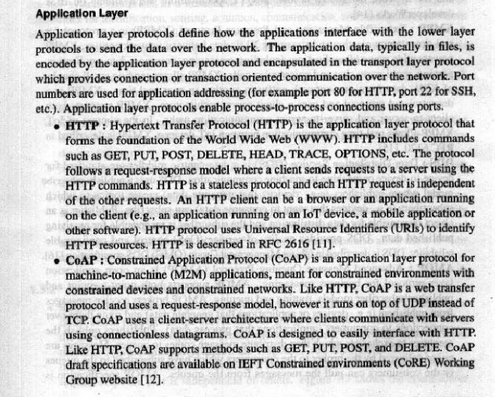
* **HTTP (Hypertext Transfer Protocol):** The foundation of the web, HTTP is a versatile protocol used for transferring data between devices. While not ideal for resource-constrained devices due to its overhead, it can be used in some IoT applications requiring web-based data access, like controlling smart home devices or fetching sensor data from buildings.
* **CoAP (Constrained Application Protocol):** Designed for constrained networks and devices, CoAP is a lightweight alternative to HTTP. It utilizes a similar request-response structure but with a simpler design for efficient data exchange. CoAP is often used in conjunction with UDP for low latency and power consumption, making it suitable for smart homes and industrial automation.
* **WebSocket:** This protocol enables full-duplex communication between devices, allowing real-time data exchange over a single TCP connection. WebSockets are commonly used in applications requiring bi-directional communication, such as smart wearables transmitting health data or real-time chat applications.
* **MQTT (Message Queuing Telemetry Transport):** Designed for resource-constrained devices, MQTT is a lightweight publish-subscribe messaging protocol. Devices publish data to specific topics, and interested subscribers receive relevant data. MQTT is popular for remote monitoring and sensor data collection due to its efficiency and scalability.
* **XMPP (Extensible Messaging and Presence Protocol):** Primarily used for real-time messaging and presence information exchange, XMPP is an open-source protocol enabling communication between various entities, including devices, applications, and users. While not as widely used in pure IoT scenarios, XMPP can be found in applications like instant messaging and social networking services.
* **DDS (Data Distribution Service):** Designed for high-performance and reliable data exchange, DDS is a publish-subscribe messaging protocol commonly used in industrial automation and other mission-critical applications. It offers features like data filtering, quality of service control, and discovery services, making it suitable for complex data distribution scenarios.
* **AMQP (Advanced Message Queuing Protocol):** AMQP is a versatile messaging protocol known for its reliability, security, and flexibility. It's often used in enterprise applications requiring guaranteed message delivery and message routing across various platforms. While not as lightweight as MQTT or CoAP, AMQP can be an option for robust messaging needs in enterprise IoT deployments.
* 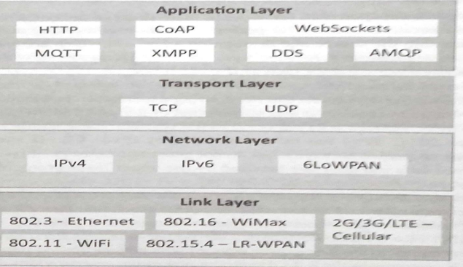
* 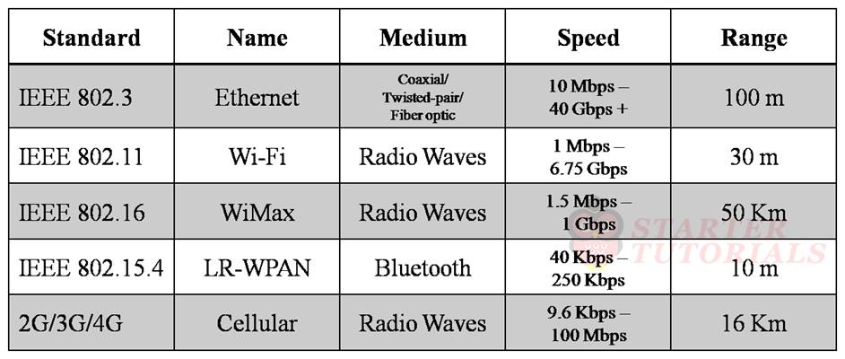

LOGICAL DESIGN OF IOT Refers to an abstract represent of entities and processes without going into the low level specifies of implementation. INCLUDES 1) IoT Functional Blocks 2) IoT Communication Models 3) IoT Comm. APIs.

**IOT FUNCTIONAL BLOCKS** Different functional blocks in an IoT system or application are device, communication, services, application, management, and security.

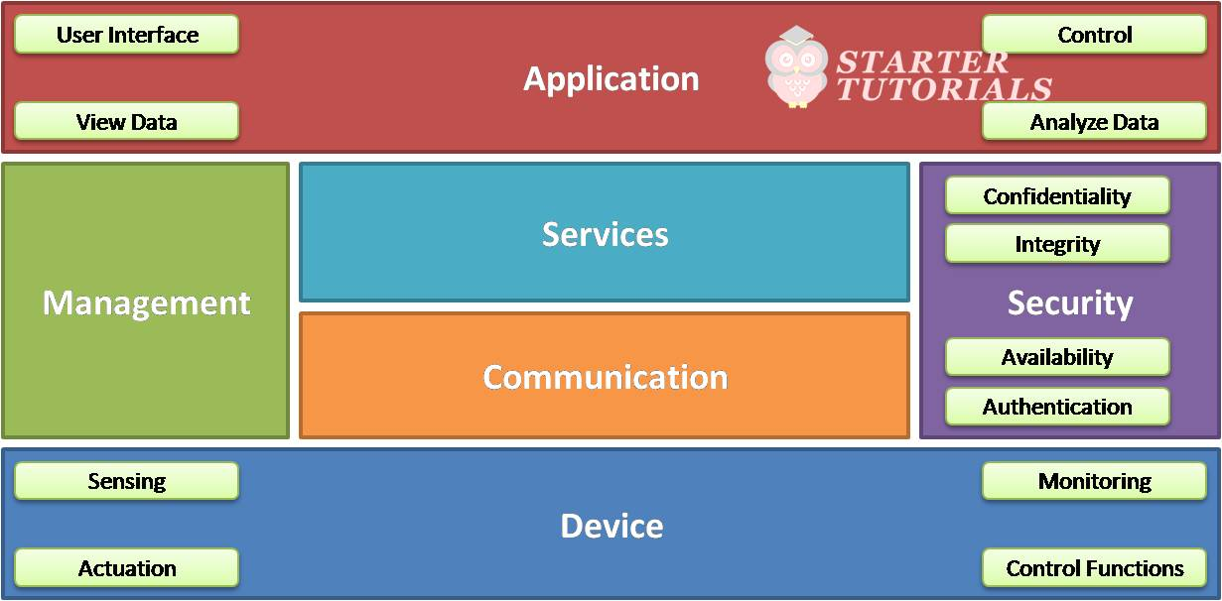

* **DEVICES :The device block** contains sensing, actuation, monitoring and control functions for controlling the devices. The device block interacts with the communication block.
* **COMMUNICATION** The communication block contains different protocols (wired or wireless) through which the data moves from devices to Internet and from Internet to devices.
* **SERVICES-**The services block acts as a middleware which can provide services like device identification, device discovery, or data processing and analysis.
* **APPLICATION-** The users of an IoT application interacts with the application block. It provides user interface with which the user can access the data sent by the sensors, perform operations on that like aggregation, simplification, etc. and visualize that data.The application interface can also provide control functions for controlling the sensors, actuators or functionality of the application.
* **MANAGEMENT**  The management block allows us to manage the other blocks like device, services, communication, application, and security.
* **SECURITY-**The security block provides different security services like confidentiality, integrity, availability, and authentication.

**IOT COMMUNICATION MODELS**

Internet of things supports different communication models between the entities in an IoT system. These communication models are:

* Request-Response Model
* Publish-Subscribe Model
* Push-Pull Model
* Exclusive Pair Model
* **Request-Response Model**

[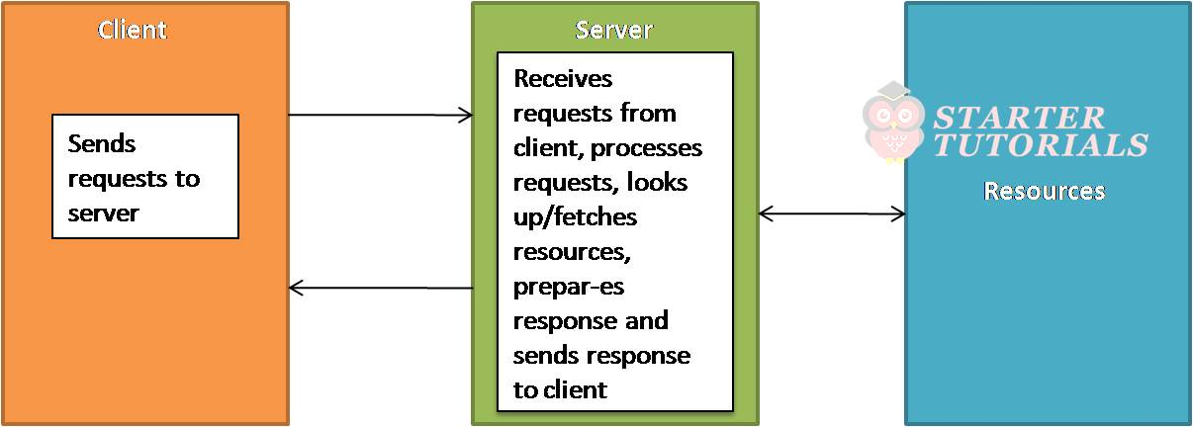](https://www.startertutorials.com/blog/wp-content/uploads/2022/08/Request_Response_Model_IoT.jpg)

The two main entities in request-response model are client and server. The client can be a web application, mobile application, etc. The client may be a browser requesting web pages or accessing an email. Each access of a resource will be treated as request.

The server accepts the requests from the clients, processes them and sends back responses to the clients. While processing the requests, the server might access additional resources like file, databases, etc. The request-response model is stateless, i.e., the requests in a session are not related to each other with respect to a server. Each request is treated as a new one and is completely unrelated to the previous requests.

Publish-Subscribe Model

[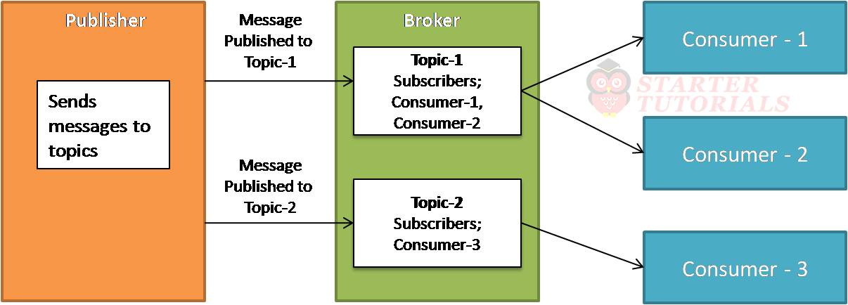](https://www.startertutorials.com/blog/wp-content/uploads/2022/08/Publish_Subscribe_Model_IoT.jpg)

The three main entities in publish-subscribe model are publisher, consumer, and broker. The publisher always publishes messages at a pre-defined interval. The sensors in IoT can be thought of as publishers. The publishers publish data as topics. The broker is an entity that maintains different topics to which consumers subscribe. The broker is generally a server.

The published messages of publishers are maintained by the broker. The consumers consume the data published by the publishers. A consumer is generally the IoT application through which the users interact. A consumer can subscribe to one or more topics maintained by a broker.

Push-Pull Model

[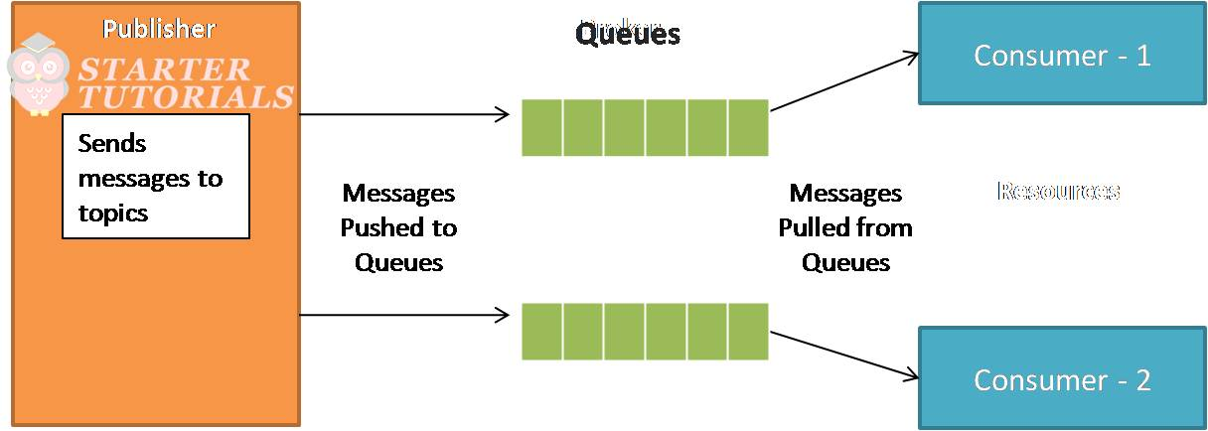](https://www.startertutorials.com/blog/wp-content/uploads/2022/08/Push_Pull_Model_IoT.jpg)

The main entities in a push-pull model are publisher, consumer, and queues. The publisher pushes messages to the queues. The sensors in IoT can be thought of as publishers of data. One or more queues store that data pushed by the publishers.

Unlike the publish-subscribe model, there is ordering of messages in push-pull model. The consumers pull the messages from the queues and consume the messages. A consumer is generally the IoT application through which the users interact.

 Exclusive Pair Model

[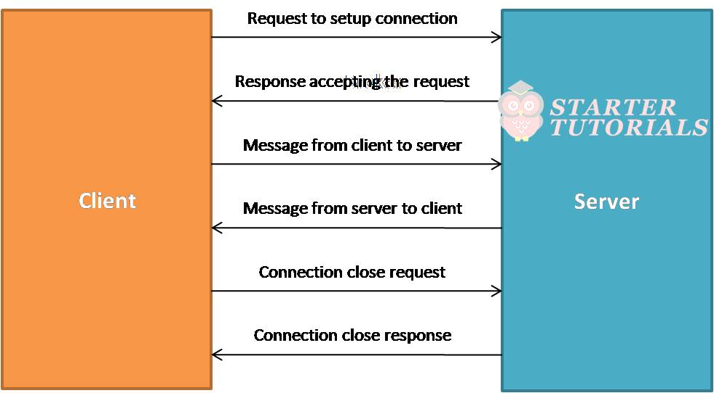](https://www.startertutorials.com/blog/wp-content/uploads/2022/08/Exclusive_Pair_Model_IoT.jpg)

The main entities in an exclusive pair model are client and server. The client and server establish a full duplex connection for sending and receiving data. Before sending a request, the client establishes a connection with the server and then sends the request.

The data requests can be one or more. The server receives these requests through the same connection and sends back responses. After the data transfer is complete, the connection between the client and server is terminated. Unlike publish-subscribe model, exclusive pair model is stateful. So, the server can automatically identify that the request is coming from a previous client or not.

**IOT COMMUNICATION APIS**

An Application Programming Interface (API) provides an unified interface to access the server resources. An API is the one which connects the things together in the Internet of Things. APIs act as a point of interaction between the IoT devices and the Internet and/or other elements within the network. In IoT there two types of communication APIs. They are:

* REST-based communication APIs
* WebSocket-based communication APIs

### REST-based Communication APIs

REpresentational State Transfer (REST) is a set of architectural principles by which we can design web services and web APIs that focus on a system’s resources and how resource states are addressed and transferred. REST APIs follow request-response model. REST architectural constraints apply to components, connectors, and data elements within a system

In a REST-based communication, the client sends HTTP or HTTPS requests like GET, POST, PUT, DELETE, etc., to the server where the REST-based API will accept these requests, process them and send back responses. The responses sent back to the clients will be in Extensible Markup Language (XML) or JavaScript Object Notation (JSON) format as shown below.

A RESTful web service is a web API implemented using HyperText Transfer Protocol (HTTP) and REST principles. RESTful web service is a collection of resources which are represented by URIs. Clients send requests to these URIs using HTTP or HTTPS methods like GET, POST, PUT, DELETE. REST architectural constraints are:

* **Client-Server:** As REST is based on request-response model, the communication involves two entities namely, client and server. A client sends requests and the server process the requests and sends back responses.
* **Stateless:** As REST follows request-response model, it is stateless. The server will not be able to associate a set of requests to a client. It will treat each request as a new request.
* **Cacheable:** The response sent by the server might be cached at the client side. This will allow the client to load the response faster next time when it is needed.
* **Layered System:** The REST architecture is layered where there is a clear separation in the functionality carried by different entities.
* **Uniform Interface:** REST provides an uniform interface for all kinds of applications and devices.
* **Code on Demand:** REST enables to access the code based on a specific request. Based on the request, the code that is going to be executed might be changed.
* 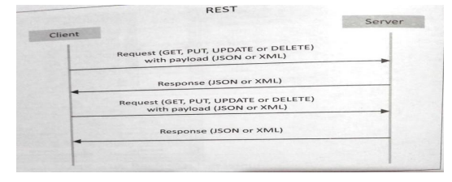

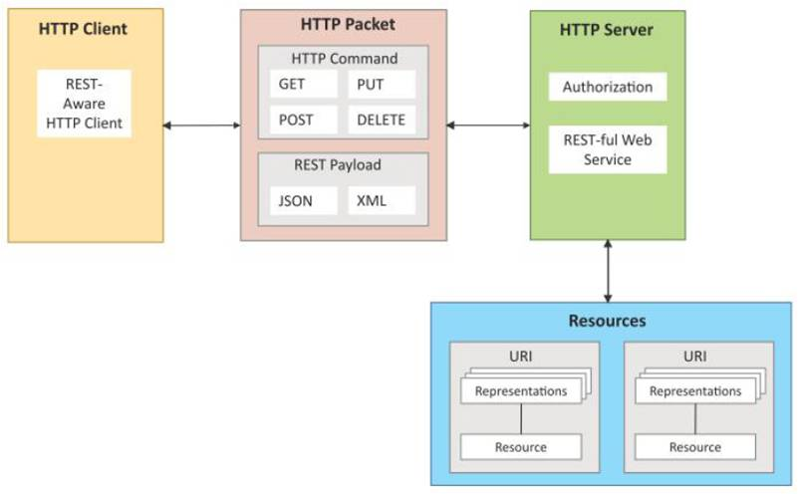

### WebSocket-based Communication APIs

WebSocket-based API creates full-duplex communication between clients and servers. It follows exclusive Web pair communication model. WebSocket-based communication is stateful.

 No need to establish connection for each request. It is suitable for IoT applications that need low latency. WebSocket-based communication process can be illustrated as shown below.

[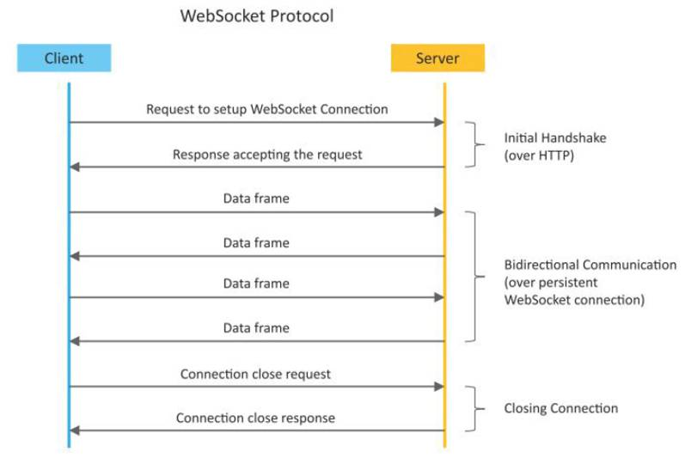](https://www.startertutorials.com/blog/wp-content/uploads/2022/08/Websocket_based_Communication_API.jpg)

IOT ENABLERS

In the realm of the Internet of Things (IoT), **enablers** refer to the various technologies, tools, and resources that facilitate the development, deployment, and operation of IoT systems. These enablers play a crucial role in bridging the gap between the physical world and the digital world, allowing connected devices to collect, share, and analyze data. Here are some key categories of IoT enablers:

**IoT(internet of things) enabling technologies are**

1. Wireless Sensor Network
2. Cloud Computing
3. Big Data Analytics
4. Communications Protocols
5. Embedded System

**1. Wireless Sensor Network(WSN) :**  
A **WSN** comprises distributed devices with sensors which are used to monitor the environmental and physical conditions. A **wireless sensor network** consists of end nodes, routers and coordinators. End nodes have several sensors attached to them where the data is passed to a coordinator with the help of routers. The coordinator also acts as the gateway that connects WSN to the internet. Zig Bee is one of the most popular wireless technologies used by WSNs WSN are low cost and low power as they deploy sensing nodes for continuous monitoring of environmental and physical conditions. WSN’s are also self organizing networks. Since WSN have large number of nodes , manual configuration of each node is not possible .the self organizing capability of WSN makes the network robust .In the event of failure of some nodes or addition of new nodes to the network , the network can reconfigure itself.  
Example –

* Weather monitoring system
* Indoor air quality monitoring system
* Soil moisture monitoring system
* Surveillance system
* Health monitoring system

**2. Cloud Computing :**  
It provides us the means by which we can access applications as utilities over the internet. Cloud means something which is present in remote locations.  
With Cloud computing, users can access any resources from anywhere like databases, webservers, storage, any device, and any software over the internet.  
**Characteristics –**

1. Broad network access
2. On demand self-services
3. Rapid scalability
4. Measured service
5. Pay-per-use

Provides different services, such as –

* **IaaS (**Infrastructure as a service**)**  
  Infrastructure as a service provides online services such as physical machines, virtual machines, servers, networking, storage and data center space on a pay per use basis. Major IaaS providers are Google Compute Engine, Amazon Web Services and Microsoft Azure etc.   
  Ex : Web Hosting, Virtual Machine etc.
* **PaaS (**Platform as a service**)**  
  Provides a cloud-based environment with a very thing required to support the complete life cycle of building and delivering West web based (cloud) applications – without the cost and complexity of buying and managing underlying hardware, software provisioning and hosting. Computing platforms such as hardware, operating systems and libraries etc. Basically, it provides a platform to develop applications.  
  Ex : App Cloud, Google app engine
* **SaaS** **(**Software as a service**)**  
  It is a way of delivering applications over the internet as a service. Instead of installing and maintaining software, you simply access it via the internet, freeing yourself from complex software and hardware management.  
  SaaS Applications are sometimes called web-based software on demand software or hosted  software.  
  SaaS applications run on a SaaS provider’s service and they manage security availability and performance.  
  Ex : Google Docs, Gmail, office etc.

**3. Big Data Analytics :**  
It refers to the method of studying massive volumes of data or big data. Collection of data whose volume, velocity or variety is simply too massive and tough to store, control, process and examine the data using traditional databases.  
Big data is gathered from a variety of sources including social network videos, digital images, sensors and sales transaction records.  
Several steps involved in analyzing big data –

1. Data cleaning
2. Munging
3. Processing
4. Visualization

Examples –

* Bank transactions
* Data generated by IoT systems for location and tracking of vehicles
* E-commerce and in Big-Basket
* Health and fitness data generated by IoT system such as a fitness bands

**4. Communications Protocols :**  
They are the backbone of IoT systems and enable network connectivity and linking to applications. Communication protocols allow devices to exchange data over the network. Multiple protocols often describe different aspects of a single communication. A group of protocols designed to work together is known as a protocol suite; when implemented in software they are a protocol stack.  
They are used in

1. Data encoding
2. Addressing schemes

**5. Embedded Systems :**  
It is a combination of hardware and software used to perform special tasks.  
It includes microcontroller and microprocessor memory, networking units (Ethernet Wi-Fi adapters), input output units (display keyword etc. ) and storage devices (flash memory).  
It collects the data and sends it to the internet.  
Embedded systems used in  
Examples –

1. Digital camera
2. DVD player, music player
3. Industrial robots
4. Wireless Routers etc.

MODERN DAY IOT APPLICATIONS

1. **Smart Home:**
   * **Home Automation:** IoT devices such as smart thermostats, smart lighting systems, and smart locks enable homeowners to remotely control and automate various aspects of their homes, enhancing convenience and energy efficiency.
   * **Security and Surveillance:** IoT-enabled security cameras, doorbell cameras, and smart locks provide homeowners with real-time monitoring and alerts, enhancing home security and deterring potential intruders**.**
   * **Energy Management**: Smart energy meters and appliances monitor energy consumption patterns and adjust settings for optimal energy usage, resulting in reduced energy bills and environmental impact**.**
2. **Healthcare:**
   * **Remote Patient Monitoring:** IoT devices such as wearable health trackers and medical sensors enable healthcare providers to remotely monitor patients' vital signs, medication adherence, and overall health status, facilitating proactive intervention and personalized care**.**
   * **Telemedicine:** IoT platforms connect patients with healthcare professionals via video conferencing and remote consultations, improving access to healthcare services, especially in rural or underserved areas**.**
   * **Smart Medical Devices:** IoT-enabled medical devices such as insulin pumps, pacemakers, and continuous glucose monitors collect and transmit patient data in real-time, enabling timely adjustments to treatment plans and improving patient outcomes.
3. **Industrial Internet (IIoT):**
   * **Predictive Maintenance:** IoT sensors installed on industrial equipment monitor machine performance and detect anomalies or signs of potential failure, enabling predictive maintenance strategies to minimize downtime and optimize asset utilization.
   * **Supply Chain Optimization:** IoT-enabled tracking systems provide real-time visibility into the movement and location of goods throughout the supply chain, enabling efficient inventory management, demand forecasting, and logistics optimization.
   * **Remote Monitoring and Control**: IIoT solutions allow remote monitoring and control of industrial processes, equipment, and facilities, enabling operators to optimize operations, improve safety, and reduce operational costs**.**
4. **Smart Cities:**
   * **Traffic Management**: IoT sensors embedded in roads, traffic lights, and vehicles collect real-time traffic data, enabling dynamic traffic management systems to optimize traffic flow, reduce congestion, and improve road safety**.**
   * **Environmental Monitoring:** IoT sensors monitor air quality, water quality, noise levels, and other environmental parameters, providing valuable data for environmental management and pollution control initiatives**.**
   * **Public Safety and Emergency Management:** IoT-enabled surveillance cameras, emergency response systems, and smart infrastructure enhance public safety and enable timely responses to emergencies and natural disasters.
5. **Agriculture:**
   * **Precision Agriculture:** IoT sensors installed in fields collect data on soil moisture, temperature, nutrient levels, and crop health, enabling farmers to make data-driven decisions regarding irrigation, fertilization, and pest control, thereby optimizing crop yields and resource usage.
   * **Livestock Monitoring:** IoT-enabled wearable devices and tracking systems monitor the health, behavior, and location of livestock, enabling early detection of health issues, efficient management of grazing patterns, and improved animal welfare.
6. **Retail:**

* **Customer Analytics:** IoT sensors, RFID tags, and beacons track customer movements and behavior within retail stores, providing valuable insights into shopping patterns, product preferences, and dwell times. Retailers can use this data to optimize store layouts, product placements, and marketing strategies to enhance the customer experience and increase sales.
* **Inventory Management:** IoT-enabled inventory management systems automatically track and manage stock levels in real-time, minimizing stockouts, reducing overstocking, and improving inventory accuracy. RFID tags, barcode scanners, and smart shelves enable efficient inventory tracking from the warehouse to the point of sale, streamlining supply chain operations and reducing costs.
* **Personalized Shopping Experiences**: IoT-powered digital signage, mobile apps, and interactive displays deliver personalized product recommendations, promotions, and offers based on customer preferences, purchase history, and demographic information. By tailoring the shopping experience to individual customers, retailers can drive engagement, loyalty, and sales conversion rates**.**

1. **Transportation and Logistics:**

* **Fleet Management**: IoT devices installed in vehicles, such as GPS trackers, onboard sensors, and telematics systems, enable fleet managers to monitor vehicle location, performance, and fuel efficiency in real-time. Fleet optimization algorithms analyze this data to optimize route planning, minimize fuel consumption, and improve driver safety and compliance**.**
* **Cargo Tracking and Monitoring:** IoT-enabled cargo tracking devices and sensors monitor the condition, location, and security of shipments throughout the supply chain. Real-time visibility into cargo status helps logistics companies ensure timely delivery, prevent theft or damage, and comply with regulatory requirements.
* **Smart Transportation Systems:** IoT sensors and communication networks enable smart transportation systems to collect and analyze traffic data, optimize traffic signal timing, and dynamically adjust routes and modes of transportation based on real-time conditions. Intelligent transportationmanagement solutions improve traffic flow, reduce congestion, and enhance overall urban mobility**.**

1. **Energy Management:**

* **Smart Grids:** IoT sensors, smart meters, and advanced analytics enable utilities to monitor and manage energy distribution more efficiently, balance supply and demand in real-time, and integrate renewable energy sources into the grid. Smart grid technologies improve grid reliability, resilience, and energy efficiency while enabling consumers to participate in demand response programs and optimize energy usage.
* **Home Energy Management:** IoT-enabled smart home energy management systems monitor energy consumption patterns, preferences, and tariffs, allowing homeowners to optimize energy usage, reduce peak demand, and lower electricity bills. Smart appliances, thermostats, and energy storage systems can automatically adjust settings based on user preferences, occupancy schedules, and real-time energy prices.

**Advantages of IoT:**

* Increased Efficiency and Automation: IoT devices can automate tasks, collect data, and optimize processes, leading to increased efficiency and productivity in various sectors like manufacturing, agriculture, and logistics.
* Improved Decision-Making: By collecting and analyzing data from sensors and devices, IoT can provide valuable insights that can help businesses and individuals make better informed decisions.
* Enhanced Convenience and Comfort: Smart homes and connected appliances can improve comfort and convenience by allowing for remote control and automation of various functions.
* Resource Optimization: IoT systems can optimize resource utilization, such as energy and water, by monitoring and adjusting usage based on real-time data.
* Improved Safety and Security: IoT-enabled security systems and wearables can enhance personal and property safety by providing real-time monitoring and alerts.
* New Business Opportunities: The vast amount of data generated by IoT devices creates new opportunities for businesses to develop innovative products and services**.**

**Disadvantages of IoT:**

* Security and Privacy Concerns: Connecting devices to the internet raises concerns about data security and privacy, as vulnerabilities in these devices can be exploited by attackers.
* Complexity and Interoperability: Integrating and managing diverse IoT devices from different vendors can be complex due to the lack of standardized protocols and interoperability issues.
* Cost and Scalability: Implementing and maintaining large-scale IoT deployments can be expensive, and ensuring scalability to accommodate growth can be challenging.
* Ethical Considerations: The widespread use of IoT raises ethical concerns about data ownership, surveillance, and potential biases in AI algorithms used in these systems.
* Environmental Impact: Manufacturing, deploying, and powering the vast number of IoT devices can contribute to the environmental impact through resource consumption and electronic waste generation.
* Job displacement: Automation enabled by IoT may lead to job displacement in certain sectors, requiring workforce training and adaptation to new skill sets.

M2M COMMUNICATION

Machine-to-Machine (M2M) refers to networking of machines(or devices) for the purpose of remote monitoring and control and data exchange.

• Term which is often synonymous with IoT is Machine-to-Machine (M2M). • IoT and M2M are often used interchangeably

M2M, which stands for **machine-to-machine communication**, refers to the technology that allows devices to communicate with each other directly, without human intervention. This communication can take place over various channels, including wired and wireless networks.

Here are some key points about M2M communication:

* **Direct communication:** Devices exchange data directly with each other, without needing a human to initiate or control the interaction.
* **Applications:** M2M is used in various sectors, including manufacturing, healthcare, logistics, and smart cities. Some common applications include:
  + **Industrial automation:** Sensors in factories can monitor equipment health and send data to control systems for preventive maintenance.
  + **Smart meters:** Utility companies can use M2M to collect real-time energy consumption data from meters.
  + **Connected vehicles:** Cars can communicate with each other and infrastructure to improve traffic flow and safety.
* **Relationship to IoT:** M2M is considered a subset of the **Internet of Things (IoT)**. While M2M typically involves direct communication between two devices, IoT can involve a broader network of interconnected devices that collect and share data through various platforms and service

M2M (Machine-to-Machine) communication refers to the direct exchange of information between devices without human intervention. This technology allows devices to sense, gather data, and communicate with each other, enabling various applications in different industries.

**Here's how M2M communication works:**

1. **Data Collection:** M2M devices, such as sensors or meters, collect data from their surroundings, like temperature, pressure, or location.
2. **Data Transmission:** The collected data is then transmitted to another device or a central server using various communication protocols like cellular networks, Wi-Fi, Bluetooth, or satellite connections.
3. **Data Processing:** The received data is processed, analyzed, and used to perform specific actions or generate insights. This could involve triggering automated responses, sending alerts, or storing data for further analysis.

**Benefits of M2M Communication:**

* **Increased Efficiency:** Automates tasks and processes, reducing human intervention and improving efficiency.
* **Improved Decision Making:** Real-time data collection provides valuable insights for better decision making.
* **Cost Reduction:** Automates tasks, reduces manpower needs, and optimizes resource utilization, leading to cost savings.
* **Enhanced Productivity:** Streamlines processes and improves overall productivity.

Machine-to-machine (M2M) communication refers to direct communication between devices or machines without human intervention. In M2M communication, devices are equipped with sensors, actuators, and communication modules that enable them to exchange data and perform actions automatically. This communication can occur over wired or wireless networks, such as the internet, cellular networks, or local area networks (LANs).

M2M communication enables various applications across industries, including:

1. Smart Grids: M2M technology allows utility companies to monitor and control electricity distribution more efficiently by collecting data from smart meters and other devices installed throughout the grid.
2. Industrial Automation: M2M communication facilitates automation and monitoring in factories and industrial environments, optimizing processes, reducing downtime, and improving productivity.
3. Healthcare: In the healthcare sector, M2M communication is used for remote patient monitoring, tracking medical equipment, and managing inventory in hospitals and clinics.
4. Transportation and Logistics: M2M technology is utilized for vehicle tracking, fleet management, and optimizing logistics operations by collecting real-time data on vehicle location, fuel consumption, and route efficiency.
5. Environmental Monitoring: M2M devices can be deployed for monitoring environmental conditions such as air quality, water quality, and weather conditions, allowing for better management of resources and early detection of environmental hazards.

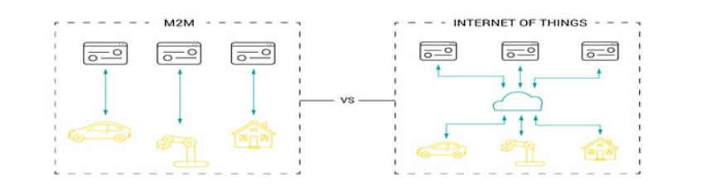IOT vs M2M

**Scope:**

* **IoT:** Broader scope, encompassing a wide range of connected devices, including sensors, wearables, appliances, vehicles, and industrial equipment.
* **M2M:** Focuses solely on direct communication between machines or devices, typically in industrial settings.

**Connectivity:**

* **IoT:** Devices typically connect to the internet using various networks like Wi-Fi, cellular, or satellite. This allows for data exchange and interaction with cloud-based platforms for analysis and control.
* **M2M:** Communication often occurs through dedicated networks like LAN or WAN, or via specialized protocols like Bluetooth or Zigbee. They may not necessarily connect to the broader internet.

**Complexity:**

* **IoT:** Devices can have varying levels of complexity, from simple sensors to devices with built-in processing power and advanced capabilities.
* **M2M:** Devices are generally designed to be simpler and more focused on specific tasks like data exchange or remote control.

**Intelligence:**

* **IoT:** Devices can exhibit varying degrees of intelligence, allowing for data processing, decision-making, and even autonomous actions.
* **M2M:** Limited intelligence observed, primarily focused on data exchange and basic control functions.

**Data Management:**

* **IoT:** Data collected from devices is often sent to the cloud for storage, analysis, and visualization. This allows for insights, automation, and remote control.
* **M2M:** Data exchange may be limited to specific devices within a closed system, with less emphasis on centralized data management and analytics.

**Scalability:**

* **IoT:** Designed for scalability to accommodate a large number of devices and integrate with existing systems.
* **M2M:** Setting up and maintaining M2M networks can be more labor-intensive, requiring new point-to-point connections for each device, making scalability challenging.

**In essence, M2M is a subset of IoT. M2M forms the foundation for device-to-device communication, which is a core element of the broader IoT ecosystem.**

|  |  |  |
| --- | --- | --- |
| Feature | IoT | M2M |
| **Scope** | Connects a wide range of devices (sensors, wearables, appliances, vehicles, industrial equipment) to the internet and each other, creating a vast ecosystem of interconnected devices. | Focuses specifically on direct communication between two or more machines or devices, typically in closed or controlled environments like industrial settings. |
| **Connectivity** | Leverages various internet protocols (IP) and networks like Wi-Fi, cellular, or satellite to connect devices to the internet and to each other. This enables data exchange and interaction with cloud-based platforms for central management and analysis. | Often utilizes dedicated network infrastructures like local area networks (LAN) or wide area networks (WAN). Specialized protocols like Bluetooth, Zigbee, or proprietary protocols could also be used for communication. Connection to the broader internet may not always be necessary. |
| **Complexity** | Devices can have varying levels of complexity, ranging from simple sensors with limited functionality to complex devices with built-in processing power, advanced features, and embedded artificial intelligence (AI) capabilities. | Devices are generally designed to be simpler with limited functionalities. They are often dedicated to performing specific tasks like data collection, monitoring, or remote control. |
| **Intelligence** | Devices can exhibit varying degrees of intelligence, allowing them to collect, process, and analyze data, make decisions based on pre-defined rules or AI algorithms, and even perform autonomous actions. | Limited intelligence observed. Devices primarily focus on data exchange and basic control functions. |
| **Data Management** | Data collected from devices is often sent to the cloud for secure storage, analysis, and visualization. This centralized data management enables valuable insights, automation of tasks, and remote control of devices based on collected data and analytics. | Data exchange may be limited to specific devices within a closed system. Centralized data management and analytics are less emphasized. Data may be stored locally on devices or on specific servers within the closed system. |
| **Security** | Requires robust security measures due to the vast network of connected devices and potential access to sensitive data. Security considerations include device authentication, data encryption, and secure communication protocols. | Security is still crucial, but the closed and controlled nature of M2M systems often makes them less susceptible to large-scale security breaches compared to the broader IoT landscape. |
| **Scalability** | Designed for high scalability to accommodate a large and ever-growing number of devices seamlessly. Standardized protocols and open architectures facilitate integration with existing systems, enabling efficient scaling. | Setting up and maintaining M2M networks can be more labor-intensive and less scalable compared to IoT. Each new device might require a dedicated point-to-point connection, making it challenging to manage large-scale deployments. |
| **Applications** | Wide range of applications across various industries and domains, including smart homes, smart cities, wearables, healthcare, industrial automation, agriculture, transportation, and environmental monitoring. | Primarily used in industrial automation, process control, remote monitoring, asset tracking, supply chain management, and SCADA (Supervisory Control and Data Acquisition) systems. |

**Additional Points:**

* **Standardization:** IoT leverages standardized protocols like TCP/IP and open architectures, enabling easier interoperability between devices and platforms from different vendors. M2M systems might rely on vendor-specific protocols or proprietary solutions, leading to potential compatibility issues.
* **Cost:** Costs can vary depending on the complexity of devices, infrastructure required, and chosen communication protocols. Generally, implementing large-scale IoT solutions can be more expensive compared to M2M setups due to the wider range of considerations involved.
* **Impact:** IoT has a broader societal impact, with the potential to transform various aspects of our lives and industries. M2M's impact is primarily focused on improving efficiency, reliability, and automation within specific applications and contexts.

| **Aspect** | **Machine-to-Machine (M2M)** | **Internet of Things (IoT)** |
| --- | --- | --- |
| Scope and Scale | Point-to-point communication between devices, typically within specific applications or industries. | Connects a vast network of devices and systems to the internet, enabling data exchange on a larger scale across various industries. |
| Data Processing | Data transmission between devices or to a central server, often involving simple data exchange. | Requires sophisticated data processing and analytics techniques to handle vast amounts of data generated by interconnected devices. |
| Interoperability | Relies on proprietary or industry-specific protocols and standards, which may hinder interoperability between different systems. | Emphasizes interoperability and standardization to enable seamless communication and integration between diverse devices and systems. |
| Scalability | Typically designed for specific use cases or applications, with limited scalability beyond the initial deployment. | Highly scalable, capable of supporting a wide range of use cases and accommodating diverse devices and data sources. |
| Flexibility | Tailored to the requirements of specific industries or organizations, with limited flexibility to adapt to changing needs. | Designed to be flexible and adaptable, with the ability to support a variety of applications and accommodate evolving requirements. |

IOT vs WOT—7

**Web of Things (WoT)** refers to a specific set of **standards** developed by the World Wide Web Consortium (W3C) to address the **interoperability** challenges within the broader IoT landscape.

WOT is all about making devices accessible over the web using web protocols like HTTP, websocket, JSON etc agnostic to anything below the application layer , so that any device can be part of univerasal WOT regardless of what protocols it uses to connect to the internet.

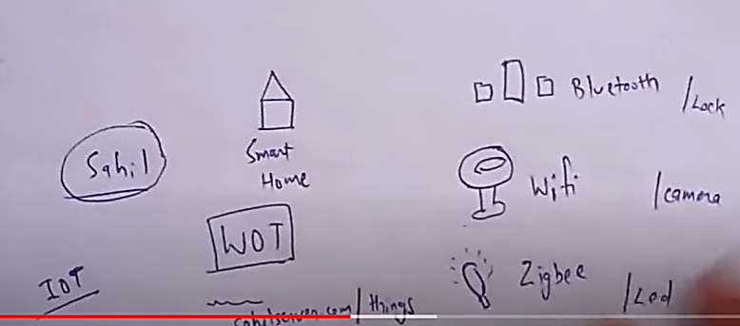

Here's a breakdown of what WoT offers:

* **Standardization:** WoT establishes common protocols and specifications for device communication, data exchange, and service discovery. This promotes compatibility and interoperability between various IoT devices and platforms from different vendors, overcoming fragmentation issues within the IoT ecosystem.
* **Web-based technologies:** WoT leverages existing web technologies like HTTP, RESTful APIs, and JSON for data exchange, making it easier for developers to build and integrate applications with IoT devices. This familiarity with web technologies reduces the learning curve for developers and fosters faster innovation.
* **Focus on interoperability:** The primary goal of WoT is to facilitate seamless communication and interaction between diverse devices and applications within the IoT ecosystem. This allows for efficient data exchange, collaboration, and automation across different platforms and domains.

**Key components of WoT:**

* **Thing Descriptions:** These act as digital passports for IoT devices, containing essential information like functionalities, interfaces, and data models. They enable standardized communication and interaction with devices.
* **Thing Directory:** This acts as a discovery mechanism, allowing applications to locate and identify available devices within the network based on their capabilities and functionalities.
* **Security:** WoT incorporates security considerations like authentication and authorization protocols to ensure secure communication and data protection within the network.

**Benefits of WoT:**

* **Reduced complexity:** Standardized protocols simplify development and integration efforts, leading to faster development cycles and easier management of IoT solutions.
* **Increased interoperability:** Allows seamless data exchange and interaction between devices and applications from different vendors, fostering a more diverse and interconnected IoT ecosystem.
* **Enhanced innovation:** Developers can leverage familiar web technologies and standardized approaches, enabling faster development of innovative IoT applications and services.

**Overall, WoT plays a crucial role in promoting interoperability and standardization within the complex world of IoT, laying the foundation for a more robust, interconnected, and innovative ecosystem of connected devices and applications.**

| **Aspect** | **Internet of Things (IoT)** | **Web of Things (WoT)** |
| --- | --- | --- |
| Interoperability | IoT focuses on connecting diverse devices and systems, often relying on proprietary or industry-specific protocols and standards. | WoT emphasizes interoperability by extending web technologies to IoT, enabling seamless communication and integration between devices using standard web protocols and interfaces. |
| Communication | IoT devices may communicate using a variety of protocols such as MQTT, CoAP, and Zigbee, tailored to specific use cases and requirements. | WoT devices communicate using web protocols such as HTTP, WebSocket, and RESTful APIs, making them accessible and interoperable with existing web technologies and frameworks. |
| Standards | IoT standards may vary between industries and applications, leading to fragmentation and interoperability challenges. | WoT promotes the use of standardized web technologies and protocols, facilitating interoperability and easing integration between devices and services. |
| Semantic Interoperability | IoT may lack semantic interoperability, making it challenging for devices to understand and interpret data exchanged between them. | WoT incorporates semantic technologies such as RDF and Linked Data, enabling devices to communicate based on shared meaning and semantics, enhancing interoperability and understanding. |
| Accessibility | IoT devices may have limited accessibility due to proprietary protocols and interfaces, requiring specialized tools and knowledge for development and integration. | WoT aims to make IoT devices and data more accessible by exposing them as web resources with uniform interfaces, enabling developers to interact with them using standard web development tools and techniques. |
| Security | Security in IoT may vary depending on the protocols and implementations used, leading to potential vulnerabilities and risks. | WoT leverages existing web security mechanisms such as HTTPS and OAuth for secure authentication and communication between devices and services, enhancing security and privacy in IoT deployments. |

In summary, while IoT focuses on connecting devices and systems using a variety of protocols and standards, WOT extends web technologies to IoT, promoting interoperability, accessibility, and security through standardized web protocols and interfaces. WOT aims to simplify the development and integration of IoT solutions by leveraging existing web infrastructure and principles.

|  |  |  |
| --- | --- | --- |
| Feature | IoT | WoT |
| **Focus** | Connecting physical devices to the internet | Standardizing communication and interaction within the IoT |
| **Scope** | Broader - encompasses devices, applications, functionalities | Specific - technical aspects of device communication |
| **Technical aspects** | Various protocols based on application and device | Standardized protocols (HTTP, RESTful APIs, JSON) |
| **Goal** | Data collection, device control, automation | Break down barriers to communication, ensure interoperability |
| **Analogy** | Network of connected roads | Standardized traffic rules and protocols |

IOT REFERENCE ARCHITECTURE

A reference architecture serves as a standardized blueprint that provides a clear structure and guidelines for designing and implementing an IoT system. It enables consistency, promotes best practices, and facilitates communication and collaboration among stakeholders. By leveraging a reference architecture, developers can reduce design complexity, ensure interoperability, and accelerate the development process, ultimately leading to more efficient and reliable IoT solutions.

## **Layers of IoT Reference Architecture**

IoT reference architectures typically consist of multiple layers that work together to enable the functioning of an IoT system. While the specific layering may vary based on different frameworks or standards, a commonly used layered structure includes the following:

* **Perception Layer:**This layer comprises the physical devices or sensors that collect data from the environment or interact with the physical world. These devices can include temperature sensors, motion detectors, cameras, and other IoT−enabled devices.
* **Network Layer:**The network layer facilitates the connectivity and communication between the IoT devices and the cloud or other data processing components. It includes protocols, gateways, routers, and other networking infrastructure to ensure seamless data transfer and reliable connections.
* **Data Processing Layer:** This layer involves processing and analyzing the data collected from IoT devices. It may include edge computing devices or cloud−based platforms where data is aggregated, filtered, transformed, and analyzed to derive valuable insights.
* **Application Layer:**The application layer encompasses the software applications or services that utilize the processed IoT data to provide specific functionalities or address specific use cases. These applications can range from real−time monitoring and control systems to predictive analytics, machine learning algorithms, and automation

## **Key Components of IoT Reference Architecture**

The key components of an IoT reference architecture include:

* **Devices:** These physical objects, ranging from sensors to smart appliances, play a crucial role in collecting data and transmitting it to the cloud.
* **Network:** The network infrastructure, which can be wired or wireless, connects the devices to the cloud, enabling seamless data transfer and communication.
* **Cloud:** The cloud serves as the centralized storage and processing hub for the data collected by the devices. It can be a public, private, or hybrid cloud, depending on specific requirements.
* **Applications:**Software applications leverage the data collected by devices to deliver insights and value. These applications can be tailored for various purposes, including monitoring, control, and automation.
* **Security:** Security measures are essential to protect the data collected by devices from unauthorized access. Techniques like encryption, authentication, and authorization ensure data security.
* **Privacy:** Privacy measures safeguard personal data collected by devices from unauthorized access. Anonymization, pseudonymization, and data minimization techniques contribute to maintaining privacy.
* **Governance:** Governance policies ensure responsible and ethical use of the IoT system. These policies address aspects such as data ownership, data sharing, and appropriate data usage.

By considering these key components, an IoT reference architecture provides a comprehensive framework for designing and implementing robust and secure IoT solutions.

## **Benefits of Using IoT Reference Architecture**

* **Common Framework:**IoT reference architecture provides a standardized framework for designing and implementing IoT solutions, ensuring consistency and interoperability across systems.
* **Security and Scalability:** The architecture serves as a foundation for implementing robust security and scalability measures, safeguarding IoT systems against threats and enabling future growth.
* **Cost Efficiency:** By leveraging a reference architecture, organizations can avoid reinventing the wheel and utilize existing technologies and expertise, reducing the cost of development and deployment.
* **Faster Time to Market:** Utilizing a reference architecture accelerates the implementation of IoT solutions, enabling organizations to get their systems up and running more quickly and efficiently.

*The 5-layer architecture is a simplified version of the Internet of Things (IoT) reference architecture that divides the IoT ecosystem into five distinct layers, each serving a specific purpose. While the exact composition of the layers may vary depending on the specific implementation and requirements, a common representation includes the following layers:*

1. ***Perception Layer (Sensing)****:*
   * *This layer represents the physical world where data is generated by sensors, actuators, and other IoT devices. Sensors collect data from the environment, such as temperature, humidity, motion, or pressure, while actuators enable devices to interact with the physical world by performing actions based on sensor data. The perception layer is responsible for capturing raw data from the physical environment and converting it into digital signals.*
2. ***Network Layer (Connectivity)****:*
   * *The network layer facilitates communication between IoT devices, gateways, and other components of the IoT system. It encompasses various communication protocols and technologies such as Wi-Fi, Bluetooth, Zigbee, LoRaWAN, cellular networks, or satellite communication. Gateways may be used to aggregate data from multiple devices and provide connectivity to higher-level systems such as the cloud or enterprise networks.*
3. ***Middleware Layer (Processing)****:*
   * *The middleware layer is responsible for processing, analyzing, and managing data generated by IoT devices. It includes components such as data ingestion, storage, processing, and integration. Data processing tasks may include data filtering, aggregation, transformation, normalization, and enrichment. Middleware components may be deployed at the edge (edge computing) or in the cloud, depending on the latency, bandwidth, and processing requirements of the application.*
4. ***Application Layer (Presentation)****:*
   * *The application layer encompasses software applications and services that leverage IoT data to provide value-added services and insights. This includes analytics, visualization tools, dashboards, and user interfaces for monitoring and controlling IoT devices. Applications may be tailored for specific verticals or use cases such as smart cities, industrial automation, healthcare, or agriculture.*
5. ***Business Layer (Decision-making)****:*
   * *The business layer focuses on leveraging IoT data to drive business value and decision-making. It includes business logic, rules engines, and decision support systems that analyze IoT data to derive actionable insights, optimize processes, and support strategic decision-making. This layer enables organizations to extract meaningful information from IoT data and translate it into business outcomes such as cost savings, revenue generation, or improved customer experience.*

*The 5-layer architecture provides a high-level framework for understanding the key components and functionalities of IoT systems, from data acquisition and communication to data processing, application development, and business integration. It serves as a guide for designing, deploying, and managing IoT solutions across various industries and applications.*

IOT NETWORK CONFIGURATION

## Configuring an IoT Network: Key Steps and Considerations

Configuring an IoT network involves setting up the various components (devices, gateways, and software) to enable them to communicate, collect data, and perform their intended functions. Here's a breakdown of the key steps and considerations:

**1. Define your network requirements:**

* **Purpose:** Clearly define the overall objective of your IoT network (e.g., environmental monitoring, asset tracking, smart home automation).
* **Application needs:** Understand the specific requirements of your applications (e.g., data volume, frequency of updates, latency requirements).
* **Device types:** Identify the types of devices you'll be using (sensors, actuators, gateways) and their communication protocols.
* **Network topology:** Decide on the network architecture (e.g., star, mesh, hierarchical) based on your coverage requirements and scalability needs.

**2. Choose your network hardware:**

* **Devices:** Select sensors and actuators compatible with your chosen communication protocol and network architecture.
* **Gateways:** Choose gateways that support the protocols of your devices and can handle the expected data volume.
* **Network infrastructure:** Depending on your application and coverage needs, you might need routers, switches, or other networking equipment.

**3. Configure communication protocols:**

* **Device communication:** Set up the chosen communication protocol (e.g., Wi-Fi, Bluetooth, cellular) on each device according to manufacturer instructions.
* **Gateway configuration:** Set up the gateway to communicate with devices and the network infrastructure using appropriate protocols.

**4. Secure your network:**

* **Implement strong passwords:** Use unique and complex passwords for all devices and network equipment.
* **Enable encryption:** Encrypt data transmission whenever possible to protect sensitive information.
* **Configure access control:** Restrict access to the network and devices only to authorized users and applications.

**5. Configure software and applications:**

* **Device management software:** Install and configure software for managing and monitoring your devices (if needed).
* **Data management platform:** Set up a platform for storing, managing, and analyzing data collected from your devices.
* **Application configuration:** Configure any applications that utilize data from your IoT network to ensure proper data access and processing.

**Additional considerations:**

* **Power supply:** Ensure a reliable power source for your devices and network infrastructure.
* **Scalability:** Consider future growth and choose components and configurations that can easily scale up as your network expands.
* **Troubleshooting:** Plan for potential problems by understanding common issues and having diagnostic tools and procedures in place.

There are several types of IoT networks, each with its own advantages and limitations, suitable for different applications. Here's an overview:

**1. Personal Area Network (PAN):**

* **Range:** Short range (up to 10 meters)
* **Technology:** Primarily uses Bluetooth and Zigbee protocols
* **Applications:** Wearables, smart home devices, short-range sensor networks
* **Configuration:** Relatively simple setup, often requiring device pairing or joining an existing network.
* **Benefits:** Low power consumption, suitable for battery-powered devices, easy to set up.
* **Limitations:** Limited range, not suitable for large-scale deployments.

**2. Local Area Network (LAN):**

* **Range:** Up to 100 meters (with wired connections) or more (with Wi-Fi extenders)
* **Technology:** Primarily uses Wi-Fi or Ethernet protocols
* **Applications:** Smart home systems, building automation, industrial control systems
* **Configuration:** Requires setting up a router or access point, configuring devices with network credentials.
* **Benefits:** Wider coverage compared to PAN, reliable data transfer, suitable for local data processing.
* **Limitations:** Security concerns in open networks, potential for interference from other Wi-Fi networks.

**3. Wide Area Network (WAN):**

* **Range:** Long range (nationwide or global)
* **Technology:** Cellular networks (2G, 3G, 4G, 5G), Low-Power Wide Area Networks (LPWAN) like LoRaWAN, Sigfox
* **Applications:** Asset tracking, remote monitoring, smart metering, connected vehicles
* **Configuration:** Requires choosing a cellular network provider, setting up data plans, and configuring device connectivity settings.
* **Benefits:** Extensive coverage, suitable for geographically dispersed devices, reliable data transfer.
* **Limitations:** Higher cost compared to other options, higher power consumption for some technologies.

**4. Mesh Network:**

* **Range:** Varies depending on network density
* **Technology:** Uses dedicated mesh networking protocols or modified versions of existing protocols (e.g., Wi-Fi mesh)
* **Applications:** Smart homes, industrial automation, sensor networks in difficult-to-reach locations
* **Configuration:** Requires setting up mesh nodes and configuring them to automatically connect and relay data.
* **Benefits:** Scalable and self-healing, provides redundancy and wider coverage compared to traditional networks.
* **Limitations:** Can be more complex to set up and manage compared to other options.

**Network Configuration:**

The specific configuration process varies depending on the chosen network type, devices, and software. However, some general steps often involve:

1. **Device configuration:** Setting up communication protocols, network credentials, and security settings on individual devices.
2. **Gateway configuration:** Configuring the gateway to communicate with devices and the chosen network infrastructure.
3. **Software configuration:** Setting up data management platforms, applications, and any device management software if needed.

IOT LAN An **IoT LAN (Local Area Network)** refers to a specific type of network used to connect various **Internet of Things (IoT) devices** within a relatively small geographical area. It serves as the foundation for communication and data exchange within an IoT system, enabling devices to interact with each other, collect data, and send it to other components for processing and control.

Here are some key characteristics of an IoT LAN:

* **Range:** Typically covers a limited range, usually up to 100 meters (wired connections) or potentially more with extenders (Wi-Fi).
* **Technology:** Primarily relies on established protocols like **Wi-Fi**, **Ethernet**, or **Zigbee**, depending on the specific application and device capabilities.
* **Applications:** Commonly used in smart homes, building automation systems, industrial control systems, and other scenarios where devices need to communicate and collaborate within a localized environment.
* **Benefits:**
  + **Reliable data transfer:** Provides a stable and predictable connection for data transmission within the network.
  + **Scalability:** Can be easily expanded by adding more devices within the coverage area.
  + **Lower power consumption:** Compared to wide-area networks (WANs), LANs generally require less power for devices to communicate due to shorter distances.
  + **Security:** Offers greater control and easier implementation of security measures compared to public networks.

**Here's an example of an IoT LAN in action:**

* In a smart home, various devices like smart lights, thermostats, and sensors are connected to a Wi-Fi LAN. These devices can send data (e.g., temperature readings) to a central hub or cloud platform for processing and control. Based on the received data, the system can automate tasks like adjusting temperature or turning on lights.
* **Network Infrastructure**:
  + **Wired**: Ethernet cables and switches can be used to connect IoT devices in environments where reliability and high bandwidth are essential.
  + **Wireless**: Wi-Fi is a common wireless technology used for IoT LANs, providing flexibility and mobility for connecting devices without physical cabling. Other wireless technologies such as Bluetooth, Zigbee, Z-Wave, and Thread can also be utilized based on specific requirements like range, power consumption, and data rate.
* **Network Topology**:
  + **Star Topology**: Devices connect to a central hub or switch, simplifying management and troubleshooting.
  + **Mesh Topology**: Devices are interconnected, allowing for redundancy and self-healing capabilities. Mesh networks are suitable for large-scale IoT deployments and environments with obstacles or dynamic conditions.

IOT WAN IoT WAN (Wide Area Network): Connecting Devices over Long Distances

An **IoT WAN (Wide Area Network)** is a type of network specifically designed to connect **Internet of Things (IoT) devices** over **extensive geographical areas**. Unlike LANs (Local Area Networks) that operate within a limited range, WANs offer long-range connectivity, enabling devices to communicate and transmit data across vast distances.

Here's a breakdown of key characteristics and considerations when using an IoT WAN:

**Range:**

* Covers significant distances, ranging from regional to nationwide or even global coverage.

**Technology:**

* Utilizes various technologies depending on the application needs:
  + **Cellular networks:** (2G, 3G, 4G, 5G) offer widespread coverage but can have higher costs and power consumption.
  + **Low-Power Wide Area Networks (LPWAN):** (e.g., LoRaWAN, Sigfox) provide extended range and low power consumption, suitable for battery-powered devices, but might have lower data rates.
  + **Satellite networks:** Offer global coverage but can be expensive and have higher latency (delay).

**Applications:**

* Ideal for scenarios where devices are dispersed over a wide area, such as:
  + Asset tracking and monitoring (e.g., shipping containers, vehicles)
  + Smart metering (e.g., electricity, water)
  + Remote environmental monitoring (e.g., agriculture, natural resources)
  + Connected vehicles

**Benefits:**

* **Extensive coverage:** Enables connection to devices regardless of location.
* **Scalability:** Supports a large number of geographically dispersed devices.
* **Flexibility:** Offers options based on cost, power requirements, and data rate needs.

**Challenges:**

* **Cost:** Depending on the chosen technology, WAN connectivity can be more expensive compared to LANs.
* **Power consumption:** Cellular networks and satellite connections might consume more power, impacting battery life of devices.
* **Security:** Securing communication over long distances requires careful consideration and implementation of appropriate measures.

| **S.NO** | **LAN** | **WAN** |
| --- | --- | --- |
| 1. | [LAN](https://www.geeksforgeeks.org/lan-full-form/) stands for Local Area Network. | Whereas [WAN](https://www.geeksforgeeks.org/wan-full-form/) stands for Wide Area Network. |
| 2. | LAN’s ownership is private. | But WAN’s ownership can be private or public. |
| 3. | The speed of LAN is high(more than WAN). | While the speed of WAN is slower than LAN. |
| 4. | The propagation delay is short in LAN. | Whereas the propagation delay in WAN is long(longer than LAN). |
| 5. | There is less congestion in LAN(local area network). | While there is more congestion in WAN(Wide Area Network). |
| 6. | There is more fault tolerance in LAN. | While there is less fault tolerance in WAN. |
| 7. | LAN’s design and maintenance is easy. | While it’s design and maintenance is difficult than WAN. |
| 8. | LAN covers small area i.e. within the building. | While WAN covers large geographical area. |
| 9. | LAN operates on the principle of [broadcasting](https://www.geeksforgeeks.org/difference-between-broadcast-and-multicast/). | While WAN works on the principle of point to point. |
| 10. | Transmission medium used in LAN is co-axial or [UTP cable](https://www.geeksforgeeks.org/what-is-utpunshielded-twisted-pair/). | Whereas WAN uses PSTN or satellite link as a transmission or communication medium. |
| 11. | LAN has a higher data transfer rate. | WAN has a lower data transfer rate as compared to LAN. |
| 12. | LANs technologies used like ethernet and token. | WANs technologies used like Frame Relay and X.25 for connectivity for longer distances. |
| 13. | LANs technologies is data transfer rate is 10mbps. | WANs technologies data transfer rate 150mbps |
| 14. | LANs is cheaply compared to WAN | WAN is costly compared to LAN. |
| 15. | In LAN Co-axial cables are generally used to connect the computer and other devices. | In WAN links are established using microwave or satellite. |
| 16. | Due to short distance short circuit error or other noise error are minimum. | In this network, shortcircuit errors, noise errors are higher than any other network. |
| 17. | For eg: A computer lab in a college. | For eg: pager |

IOT Node

An IoT node, also known as an IoT device, is a physical device that is part of the Internet of Things (IoT) network. It collects data from the physical world and transmits it to the internet, or it receives data from the internet and takes action in the physical world.

There are many different types of IoT nodes, but they all have some common features. They typically have:

* Sensors: These are used to collect data from the physical world, such as temperature, humidity, pressure, or motion.
* Processors: These are used to process the data collected by the sensors and prepare it for transmission.
* Communicators: These are used to transmit the data to the internet or receive data from the internet. This can be done using a variety of technologies, such as Wi-Fi, Bluetooth, or cellular networks.
* Power source: This can be a battery, mains power, or harvested energy from the environment.

IoT nodes are used in a wide variety of applications, including:

* **Smart homes:** IoT nodes can be used to control lights, thermostats, security systems, and other appliances.
* **Smart cities:** IoT nodes can be used to monitor traffic flow, air quality, and noise levels.
* **Wearable technology:** IoT nodes can be used in fitness trackers, smartwatches, and other wearable devices.
* **Industrial automation:** IoT nodes can be used to monitor and control industrial processes.
* **Agriculture:** IoT nodes can be used to monitor soil moisture, temperature, and other factors that affect crop growth.

As the IoT continues to grow, the number and variety of IoT nodes will continue to increase. This will have a profound impact on our lives, as it will allow us to connect and interact with the physical world in new and innovative ways.

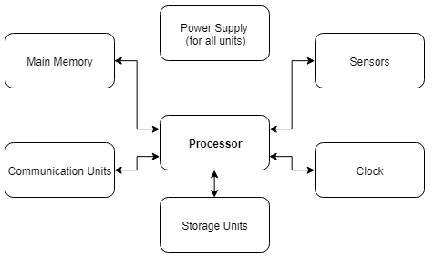

IOT GATEWAY

An **IoT gateway** acts as a central hub or bridge in the Internet of Things (IoT) network. It plays a crucial role in connecting various IoT devices and sensors to the cloud or other networks, facilitating communication and data exchange.

Here's a breakdown of the key functions of an IoT gateway:

**1. Connectivity:**

* **Acts as a bridge:** The gateway connects diverse IoT devices using different communication protocols (e.g., Wi-Fi, Bluetooth, Zigbee) to a common network, like Ethernet or cellular, enabling them to communicate with each other and the cloud.
* **Protocol translation:** It can translate data from various protocols used by different devices into a format compatible with the cloud or other networks, ensuring seamless communication.

**2. Data Management:**

* **Data filtering and aggregation:** The gateway can filter and aggregate data collected from multiple devices, reducing the amount of data transmitted and optimizing network bandwidth.
* **Preprocessing and local storage:** It can perform basic data processing like filtering, cleaning, and transformation before sending it to the cloud. In some cases, it can also store data locally for later analysis or backup purposes.

**3. Security:**

* **Provides a security layer:** The gateway acts as a security checkpoint, implementing access control, encryption, and other security measures to protect the network and connected devices from unauthorized access and cyberattacks.

**4. Additional functionalities:**

* **Device management:** Some gateways offer functionalities for managing connected devices, including firmware updates, configuration changes, and remote monitoring.
* **Edge computing:** Advanced gateways can perform edge computing, processing data locally before sending it to the cloud, reducing latency and improving efficiency for real-time applications.

Here's an analogy to understand the role of an IoT gateway: Imagine a city with various districts speaking different languages. An interpreter acts as a central hub, translating between languages and facilitating communication between different districts. Similarly, an IoT gateway translates communication protocols and facilitates data exchange between diverse devices in an IoT network.

Overall, IoT gateways are essential components of the IoT ecosystem, enabling efficient communication, secure data management, and improved functionality within the network.

The inner workings of a gateway can be broken down into several key steps:

**1. Device connection:** IoT devices within the gateway's range attempt to connect using their specific protocols, like Wi-Fi, Bluetooth, or Zigbee. The gateway acts as a bridge, receiving and interpreting the data from these various protocols.

**2. Protocol translation:** The gateway understands the different languages (protocols) spoken by the devices. It translates the received data into a format compatible with the network it's connected to, like Ethernet or cellular. This allows the data to be understood and processed by other devices and systems on the network.

**3. Data filtering and aggregation:** The gateway can act as a filter, sifting through the data stream from multiple devices. It can discard irrelevant information, reducing the overall data volume transmitted and saving bandwidth. Additionally, it can aggregate data from multiple devices, combining it into a single stream for further analysis or processing.

**4. Preprocessing and local storage (optional):** In some cases, the gateway might perform basic data processing tasks like filtering, cleaning, and transforming the data before sending it further. This can involve removing redundant information, correcting errors, or converting the data into a specific format required by the destination. Additionally, some gateways can store data locally for backup purposes or for later analysis at the edge, closer to the devices where the data originated.

**5. Security:** The gateway acts as a security checkpoint, safeguarding the network and connected devices. It can implement various security measures like:

* **Access control:** Restricting unauthorized access to the network and devices.
* **Encryption:** Scrambling data to protect its confidentiality during transmission.
* **Firewalls:** Filtering incoming and outgoing traffic based on predefined rules.

**6. Data transmission:** Once the data is processed, translated, and secured, the gateway transmits it to the designated recipient, which could be:

* The cloud: This is common for centralized processing, storage, and analysis.
* Another network: The data might be sent to a specific server or application within the organization.
* Other devices: In some cases, the gateway might forward the data to other devices within the network for further processing or actuation.

**7. Device management (optional):** Some advanced gateways offer functionalities for managing connected devices. This can include:

* **Firmware updates:** Updating the software on the devices to fix bugs, add new features, or improve security.
* **Configuration changes:** Remotely adjusting device settings and parameters.
* **Monitoring:** Keeping track of the health and status of connected devices.

By performing these steps, an IoT gateway acts as a central hub, bridging the gap between diverse devices and enabling them to communicate and exchange data effectively within the network, while ensuring security and optimizing efficiency.

IOT PROXY  
An IoT proxy, similar to a traditional web proxy, acts as an intermediary between IoT devices and the internet or other networks. It plays a crucial role in enhancing security, performance, and manageability within an IoT ecosystem. Here's a breakdown of its key functions:

**1. Security Enhancement:**

* **Access Control:** The proxy can act as a gatekeeper, restricting unauthorized access to the network and connected devices. It can implement authentication and authorization mechanisms to ensure only authorized devices and applications can communicate.
* **Data Encryption:** The proxy can encrypt data transmitted between devices and the network, protecting it from eavesdropping and tampering during communication. This is particularly important for sensitive data collected by IoT devices.
* **Traffic filtering:** The proxy can filter incoming and outgoing network traffic based on predefined security rules. This helps prevent malicious attacks and unauthorized data transfers.

**2. Performance Optimization:**

* **Data caching:** The proxy can cache frequently accessed data, reducing the need for devices to constantly fetch it from the internet. This can improve response times and reduce network bandwidth consumption, especially for resource-constrained devices.
* **Data compression:** The proxy can compress data before transmitting it, reducing the amount of data transferred and improving network efficiency. This is beneficial for situations with limited bandwidth or high latency connections.
* **Load balancing:** In scenarios with a large number of devices, the proxy can distribute the load across multiple servers or applications, preventing bottlenecks and ensuring smooth operation.

**3. Manageability and Control:**

* **Device management:** The proxy can act as a centralized point for managing and monitoring connected devices. It can provide functionalities like firmware updates, configuration changes, and device health monitoring.
* **Protocol translation:** Similar to gateways, some proxies can translate data between different communication protocols used by various devices. This simplifies communication and integration within diverse IoT networks.
* **Policy enforcement:** The proxy can enforce specific policies and regulations on data flow within the network. This could involve restricting access to certain websites or services for specific devices or filtering data based on content type.

**Deployment and Types:**

IoT proxies can be deployed in various ways, depending on the specific needs of the network. Some common deployment models include:

* **Cloud-based proxies:** These reside in the cloud and offer centralized management and scalability.
* **Edge proxies:** These are deployed closer to the devices, at the edge of the network, for improved performance and reduced latency, especially for real-time applications.
* **Hybrid proxies:** These combine elements of both cloud and edge deployments, offering a balance between centralized control and local processing.

**Overall, IoT proxies offer a valuable layer of functionality within the IoT ecosystem, improving security, performance, and manageability. They play a crucial role in ensuring the** smooth operation, reliability, and security of large-scale IoT deployments.

IPV4 VS IPV6

|  |  |  |
| --- | --- | --- |
| Feature | IPv4 | IPv6 |
| **Address Space** | 32-bit (approximately 4.3 billion addresses) | 128-bit (virtually limitless addresses) |
| **Structure** | Decimal numbers (e.g., 192.168.1.1) | Hexadecimal digits (e.g., 2001:0db8:85a3:0000:0000:8a2e:0370:7334) |
| **Header Structure** | Simpler, fewer fields | More complex, includes security features |
| **Security** | Relies on external mechanisms (firewalls, encryption) | Built-in security features (IPsec integration) |
| **Mobility** | Less efficient for frequent address changes | More efficient for mobile devices |
| **Fragmentation** | Allowed, can introduce inefficiencies and security vulnerabilities | Discouraged, larger packet sizes supported |
| **Routing** | Classful, potentially inefficient address allocation | Hierarchical and classless, more flexible address allocation |
| **Autoconfiguration** | Manual configuration required | Often supports stateless autoconfiguration |
| **Multicasting** | Separate class of addresses (Class D) | Integrated functionality within the main address space |
| **Performance** | Potentially limited by header and fragmentation | Potentially improved due to simpler header and efficient routing |
| **Future-proofing** | Limited address space, lacks built-in security | Vast address space, integrated security features |
| **Current Status** | Dominant protocol, but transitioning | Increasing deployment, transition ongoing |

## IPv4

[IPv4](https://www.geeksforgeeks.org/network-layer-introduction-ipv4/) address consists of two things that are the network address and the host address. It stands for **Internet Protocol version four.** It was introduced in 1981 by DARPA  and was the first deployed version in 1982 for production on SATNET and on the ARPANET in January 1983.

IPv4 addresses are 32-bit integers that have to be expressed in Decimal Notation. It is represented by 4 numbers separated by dots in the range of 0-255, which have to be converted to 0 and 1, to be understood by Computers. For Example, An IPv4 Address can be written as **189.123.123.90.**

### IPv4 Address Format

IPv4 Address Format is a 32-bit Address that comprises binary digits separated by a dot (.).

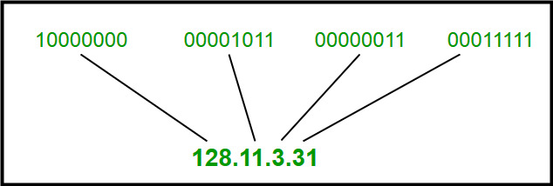

*IPv4 Address Format*

## IPv6

[IPv6](https://www.geeksforgeeks.org/internet-protocol-v6-ipv6/)is based on IPv4 and stands for Internet Protocol version 6. It was first introduced in December 1995 by Internet Engineering Task Force. IP version 6 is the new version of Internet Protocol, which is way better than IP version 4 in terms of complexity and efficiency. IPv6 is written as a group of 8 hexadecimal numbers separated by colon (:). It can be written as 128 bits of 0s and 1s.

### IPv6 Address Format

IPv6 Address Format is a 128-bit IP Address, which is written in a group of 8 hexadecimal numbers separated by colon (:).

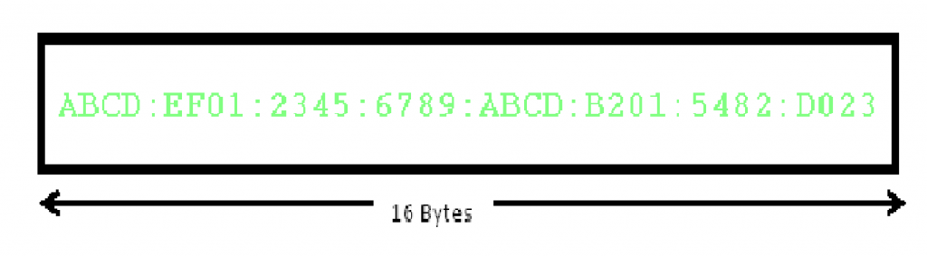

*IPv6 Address Format*

## Benefits of IPv6

The recent Version of IP IPv6 has a greater advantage over IPv4. Here are some of the mentioned benefits:

* **Larger Address Space:**IPv6 has a greater address space than IPv4, which is required for expanding the IP Connected Devices. IPv6 has 128 bit IP Address rather and IPv4 has a 32-bit Address.
* **Improved Security:**IPv6 has some improved security which is built in with it. IPv6 offers security like Data Authentication, Data Encryption, etc. Here, an Internet Connection is more Secure.
* **Simplified Header Format:**As compared to IPv4, IPv6 has a simpler and more effective header Structure, which is more cost-effective and also increases the speed of Internet Connection.
* **Prioritize:**IPv6 contains stronger and more reliable support for QoS features, which helps in increasing traffic over websites and increases audio and video quality on pages.
* **Improved Support for Mobile Devices:**IPv6 has increased and better support for Mobile Devices. It helps in making quick connections over other Mobile Devices and in a safer way than IPv4.

## **Difference Between IPv4 and IPv6**

| **IPv4** | **IPv6** |
| --- | --- |
| IPv4 has a 32-bit address length | IPv6 has a 128-bit address length |
| It Supports Manual and DHCP address configuration | It supports Auto and renumbering address configuration |
| In IPv4 end to end, connection integrity is Unachievable | In IPv6 end-to-end, connection integrity is Achievable |
| It can generate 4.29×109 address space | The address space of IPv6 is quite large it can produce 3.4×1038 address space |
| The Security feature is dependent on the application | IPSEC is an inbuilt security feature in the IPv6 protocol |
| Address representation of IPv4 is in decimal | Address Representation of IPv6 is in hexadecimal |
| Fragmentation performed by Sender and forwarding routers | In IPv6 fragmentation is performed only by the sender |
| In IPv4 Packet flow identification is not available | In IPv6 packet flow identification are Available and uses the flow label field in the header |
| In IPv4 checksum field is available | In IPv6 checksum field is not available |
| It has a broadcast Message Transmission Scheme | In IPv6 multicast and anycast message transmission scheme is available |
| In IPv4 Encryption and Authentication facility not provided | In IPv6 Encryption and Authentication are provided |
| IPv4 has a header of 20-60 bytes. | IPv6 has a header of 40 bytes fixed |
| IPv4 can be converted to IPv6 | Not all IPv6 can be converted to IPv4 |
| IPv4 consists of 4 fields which are separated by addresses dot (.) | IPv6 consists of 8 fields, which are separated by a colon (:) |
| IPv4’s  IP addresses are divided into five different classes. Class A , Class B, Class C, Class D , Class E. | IPv6 does not have any classes of the IP address. |
| IPv4 supports VLSM(Variable Length subnet mask). | IPv6 does not support VLSM. |
| Example of IPv4:  66.94.29.13 | Example of IPv6: 2001:0000:3238:DFE1:0063:0000:0000:FEFB |

UNIT-2

SENSOR

-Sensors play an important role in creating solutions using IoT. Sensors are devices that collect external information and convert it into an output that humans and machines can understand. Sensors have a very wide range, and there are many types, but at their root, sensor are devices that identify the characteristic quantity of a measuring item and convert it into a readable signal that is shown on an instrument. Simply described, sensor devices that applies sensors to obtain information by detecting physical, chemical, or biological property amounts and converting them into readable signals.

-A sensor is a device that acts as a transducer, converting a physical phenomenon like heat, light, sound, pressure, magnetism, or motion into a measurable electrical signal. This signal can then be used for various purposes, such as monitoring, recording, or controlling the phenomenon being measured.In simpler terms, a sensor is like an artificial sense organ that can perceive its environment and send the information to other devices.

As we know that human being collect information of the surroundings using their sense organs (senors) ,namely eyes, ears, nose, skin, etc ,in order to perform various tasks. Similarly , systems must interact with their environment to do useful tasks , so they use sensors and actuators. Without the use of sensors , there would be no automation.

Sensors can be embedded in our bodies, automobiles, airplanes , cellular telephone , radios , chemical plants and industrial plants and many other applications.

Sensor can be a device/module/machine/subsystem whose purpose is to detect events or changes in its environment and send information to other electronic devices.

A sensor is a device that measures a physical variable (ex- force, pressure, temperature , velocity , flow rate etc) and converts the physical quantity into another form (electrical form) which can be read by an observer or by an instrument.

Example – Heat is converted to electrical signals in a temperature sensor , Atmospheric pressure is converted to electrical signals in a barometer , A thermocouple converts temperature to an output voltage which can be read by a voltmeter

For accuracy , all sensors need to be calibrated against the known standards

Input-(mechanical,optical,magnetic,thermal)🡪 sensor(signal conversion)-> output(voltage/current)

sensor help translate physical world attributes into values that the computer/robot can use, senses the physical changes in the surrounding and covert it into readable quantity.

**Properties**

* It is only sensitive to the measured property Example- a temperature sensor senses the ambient temperature of a room.
* It is insensitive to any other property likely to be encountered in its application. Example- a temperature sensor does not bother about light or pressure while sensing the temperature.
* It does not influence the measured property example- measuring the temperature does not reduce or increase the temperature

BASIC COMPONENT AND CHALLENGES OF A SENSOR NODE

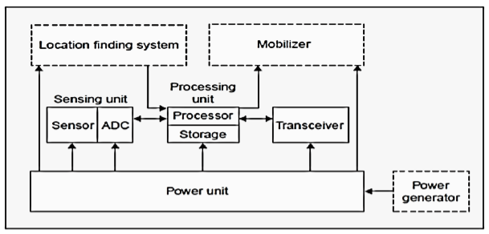

A sensor node is made up of four basic components:

i. Sensing Unit :

* It is usually composed of two subunits: sensors and Analog-to-Digital convertors (ADC’s).
* Analog signals produced by sensors based on observed phenomenon are converted to digital signals by ADC, and then fed into processing unit.

ii. Processing Unit :

* It manages the procedures that make the sensor node collaborate with other nodes to carry out assigned sensing tasks.
* It is generally associated with a small storage unit.

iii. Transceiver:

* It connects the node to the network.

iv. Power Unit:

* Since wireless sensor networks focus more on power conservation than ‘Quality of Service (QoS)’, it is one of the most important components of a sensing node.
* Power units may be supported by power scavenging units such as solar cells.
* A sensor node can only be equipped with limited power source. (<0.5 Ah, 1.2 V)

There are some other sub-units that are application dependent:

i. Location finding system:

* It is commonly required because most of the sensor network routing techniques and sensing tasks require knowledge of location with high accuracy.

ii. Mobilizer:

* It may sometimes be needed to move sensor nodes when it is required to carry out assigned
* ***Location finding system:****This represents the overall system that determines the location of a specific object or person.*
* ***Mobilizer:****This component is not typically included in the core functionality of a sensor node. It's likely specific to this particular location finding system and might be responsible for managing the mobility of the sensor nodes.*

*The core components of a sensor node, as detailed in the block diagram, include:*

* ***Sensing unit:****This block encompasses two sub-components:*
  + ***Sensors:****These are the devices that convert physical phenomena like temperature, pressure, light, or motion into electrical signals. The type of sensor depends on the specific environmental property being measured.*
  + ***ADC (Analog-to-Digital Converter):****This component transforms the analog signals from the sensors into digital signals that can be processed by the microcontroller.*
* ***Processing unit:****This is the brain of the sensor node, responsible for:*
  + ***Collecting data:****It gathers information from the connected sensors.*
  + ***Processing data:****It may perform calculations, filtering, or basic analysis on the collected data.*
  + ***Making decisions:****Based on programmed logic, it determines what actions to take with the data (e.g., transmit it, store it locally, trigger an event).*
  + ***Controlling other components:****It may control the operation of other components within the node, such as the transceiver. The processing unit is typically a low-power microcontroller, offering a balance between functionality and efficient power consumption.*
* ***Transceiver:****This component enables communication with other nodes in the network. It acts as:*
  + ***Transmitter:****It transmits the collected data or control signals to other nodes wirelessly or through a wired connection, depending on the network design.*
  + ***Receiver:****It receives data or control signals from other nodes, enabling communication within the network.*
* ***Storage:****This block represents memory that can be used to temporarily store data before transmission or for local processing needs.*

*The power unit, though not explicitly shown in the diagram, is another crucial component of a sensor node. It provides the energy required to operate the node and is often a battery. However, alternative options like solar panels or energy harvesting techniques are also becoming increasingly common, especially for deployments where long-term operation is necessary.*

CHALLENGES

Sensor nodes, despite their vast potential, face several challenges that hinder their widespread and seamless implementation. Here are some of the key challenges:

**1. Limited Resources:** Sensor nodes are often constrained by:

* **Power consumption:** They typically operate on batteries with limited capacity, requiring efficient design and operation to maximize battery life.
* **Processing power:** Sensor nodes often use low-power microcontrollers, limiting their computational capabilities for complex tasks like data processing and analysis.
* **Memory:** Sensor nodes have limited storage space for data, necessitating careful data management and transmission strategies.

**2. Harsh Environments:** Sensor nodes are often deployed in diverse and challenging environments, including:

* **Extreme temperatures:** These can affect sensor performance and reliability.
* **Physical stress and vibration:** These can damage delicate sensor components.
* **Exposure to chemicals and corrosive elements:** These can degrade sensor functionality over time.

**3. Communication and Networking:**

* **Reliability:** Wireless communication in sensor networks can be susceptible to interference, leading to data loss and unreliable transmission.
* **Scalability:** As the number of nodes in a network increases, communication overhead and network congestion become significant challenges.
* **Security:** Sensor networks are vulnerable to various security threats, such as hacking and data breaches, requiring robust security measures.

**4. Maintenance and Deployment:**

* **Accessibility:** Sensor nodes are often deployed in remote or difficult-to-reach locations, making maintenance and replacement challenging.
* **Scalability:** Deploying and managing large-scale sensor networks can be complex and labor-intensive.
* **Cost-effectiveness:** Balancing the cost of sensor nodes, network infrastructure, and ongoing maintenance can be a challenge, especially for large-scale deployments.

**5. Data Management:**

* **Data processing:** Sensor nodes may generate a large volume of data, requiring efficient processing and filtering techniques to extract meaningful information.
* **Data transmission:** Sending large amounts of data can consume significant power and network bandwidth, requiring data aggregation and compression techniques.
* **Data security and privacy:** Ensuring the security and privacy of sensitive data collected by sensor nodes is crucial.

Researchers and developers are continuously working to address these challenges. Advancements in miniaturization, energy-efficient technologies, improved communication protocols, and robust security solutions are paving the way for more efficient and reliable sensor nodes, paving the way for wider adoption and impactful applications.

SENSOR FEATUREs

**Sensors characteristics :**

1. Static
2. Dynamic

**1. Static characteristics :**  
It is about how the output of a sensor changes in response to an input change after steady state condition.

* **Accuracy:**Accuracy is the capability of measuring instruments to give a result close to the true value of the measured quantity. It measures errors. It is measured by absolute and relative errors. Express the correctness of the output compared to a higher prior system. Absolute error = Measured value – True value  
  Relative error = Measured value/True value
* **Range:**Gives the highest and the lowest value of the physical quantity within which the sensor can actually sense. Beyond these values, there is no sense or no kind of response.  
  e.g. RTD for measurement of temperature has a range of -200`c to 800`c.
* **Resolution:**Resolution is an important specification for selection of sensors. The higher the resolution, better the precision. When the accretion is zero to, it is called the threshold.  
  Provide the smallest changes in the input that a sensor is able to sense.
* **Precision:**It is the capacity of a measuring instrument to give the same reading when repetitively measuring the same quantity under the same prescribed conditions.  
  It implies agreement between successive readings, NOT closeness to the true value.  
  It is related to the variance of a set of measurements.  
  It is a necessary but not sufficient condition for accuracy.
* **Sensitivity:**Sensitivity indicates the ratio of incremental change in the response of the system with respect to incremental change in input parameters. It can be found from the slope of the output characteristics curve of a sensor. It is the smallest amount of difference in quantity that will change the instrument’s reading.
* **Linearity:**The deviation of the sensor value curve from a particularly straight line. Linearity is determined by the calibration curve. The static calibration curve plots the output amplitude versus the input amplitude under static conditions.   
  A curve’s slope resemblance to a straight line describes linearity.
* **Drift:**The difference in the measurement of the sensor from a specific reading when kept at that value for a long period of time.
* **Repeatability:**The deviation between measurements in a sequence under the same conditions. The measurements have to be made under a short enough time duration so as not to allow significant long-term drift.

**Dynamic Characteristics :**  
Properties of the systems

* **Zero-order system:**The output shows a response to the input signal with no delay. It does not include energy-storing elements.  
  Ex. potentiometer measure, linear and rotary displacements.
* **First-order system:**When the output approaches its final value gradually.  
  Consists of an energy storage and dissipation element.
* **Second-order system:**Complex output response. The output response of the sensor oscillates before steady state.

**1. Measurand:**

* This refers to the physical quantity a sensor is designed to detect and measure. Examples include temperature, pressure, light, sound, motion, and many others.

**2. Sensitivity:**

* This indicates the magnitude of the electrical signal output by the sensor in response to a change in the measurand. A higher sensitivity sensor produces a larger output signal for a smaller change in the measured quantity.

**3. Resolution:**

* This refers to the smallest **detectable** change in the measurand that the sensor can distinguish. A sensor with a higher resolution can detect and differentiate between smaller changes in the measured quantity.

**4. Accuracy:**

* This represents the closeness of the sensor's output signal to the true value of the measurand. A highly accurate sensor produces an output signal that closely reflects the actual value being measured.

**5. Linearity:**

* This signifies how closely the relationship between the sensor's output signal and the measurand is proportional. An ideal sensor exhibits perfect linearity, where the output signal changes proportionally with the measured quantity.

**6. Range:**

* This defines the minimum and maximum values of the measurand that the sensor can detect accurately. Sensors are designed to operate within a specific range, and measurements outside this range may be inaccurate or unreliable.

**7. Response time:**

* This is the time it takes for the sensor's output signal to reach a certain percentage (usually 90%) of its final value in response to a step change in the measurand. Sensors with faster response times are suitable for applications requiring real-time measurements.

**8. Selectivity:**

* This refers to the sensor's ability to respond specifically to the intended measurand and minimize interference from other environmental factors or external stimuli. A highly selective sensor can accurately measure the desired quantity even in the presence of other influences.

**9. Repeatability and reproducibility:**

* Repeatability refers to the sensor's ability to produce consistent output signals for repeated measurements of the same measurand under identical conditions. Reproducibility indicates the sensor's ability to produce consistent results even when measurements are performed by different individuals or under slightly different conditions.

**10. Power consumption:**

* This is the amount of power required by the sensor to operate. Low-power sensors are essential for battery-powered applications or situations where power consumption is a critical factor.

SENSOR RESOLUTION

Sensor resolution refers to the **smallest detectable change** a sensor can distinguish in the quantity it is measuring. It essentially determines the **fineness or detail** with which the sensor can perceive its environment.

Here are some key points to understand sensor resolution:

**1. Units:** The units of sensor resolution depend on the type of sensor and the quantity it measures.

* For **temperature sensors**: Resolution might be specified in degrees Celsius (°C) or Fahrenheit (°F).
* For **pressure sensors**: Resolution might be in Pascals (Pa), pounds per square inch (psi), or millimeters of mercury (mmHg).
* For **image sensors**: Resolution is often given in megapixels (MP), which represents the total number of pixels in the image.
* For **motion sensors**: Resolution might be in meters (m), centimeters (cm), or millimeters (mm), depending on the sensor's ability to detect the smallest movement.

**2. Importance:** Sensor resolution is crucial in various applications as it directly impacts the **accuracy and level of detail** obtained from the sensor's measurements. Here are some examples:

* A **high-resolution temperature sensor** in a laboratory experiment can detect minute temperature changes crucial for precise analysis, while a **low-resolution sensor** might suffice for monitoring room temperature.
* A **high-resolution image sensor** in a security camera captures clearer and sharper images with more details, aiding in better identification and recognition compared to a **low-resolution sensor**.
* A **high-resolution pressure sensor** in a weather monitoring system can detect subtle changes in air pressure, potentially providing more accurate weather forecasts compared to a **low-resolution sensor**.

**3. Not the same as Accuracy:** It's important to distinguish **resolution** from **accuracy**. While resolution defines the smallest detectable change, accuracy refers to how **close the sensor's reading is to the actual value** being measured. A sensor can have high resolution (detecting minute changes) but still be inaccurate (providing readings consistently deviating from the true value).

**4. Choosing the right sensor resolution:** Selecting the appropriate sensor resolution depends on the **specific needs of your application**. Consider:

* **The level of detail required in the measurements:** Do you need to detect very small changes, or is a general indication sufficient?
* **The cost and complexity of sensors:** Generally, higher resolution sensors tend to be more expensive and complex.
* **The power consumption of the sensor:** High-resolution sensors often require more power, which can be a limitation in battery-powered applications.
* ***High sensitivity, resolution, and accuracy: These ensure precise and reliable measurements.***
* ***Wide range: Allows the sensor to function in diverse situations.***
* ***Fast response time: Crucial for real-time applications.***
* ***High selectivity: Minimizes interference from other factors.***
* ***Low power consumption: Important for battery-powered applications.***
* ***Cost-effectiveness: Especially for large-scale deployments.***
* ***Robustness: Withstands harsh environments and operates reliably.***
* ***Ease of use: Simpler integration and maintenance are preferred.***

***pen_spark***

SENSOR CLASSES

* ANALOG- sensor that produces continuous analog output signal are called analog sensors .Analog sensor senses the external parameter (like wind speed , solar radiation , light intensity etc ) and give analog voltage as an output.

Analog sensors are a fundamental type of sensor that continuously measure physical quantities and convert them into **continuous electrical signals**. These signals vary constantly in an analog manner, directly reflecting the changes in the measured quantity.

Here's a breakdown of key features of analog sensors:

**Output:**

* **Continuous signal:** Unlike digital sensors with discrete output values (0s and 1s), analog sensors produce a **continuously varying voltage** that **mimics the variations** in the physical quantity being measured.
* **Signal range:** The output voltage typically falls within a specific **predefined range**, often between 0 and 5 volts (V) or -10V to +10V.

**Examples:**

* **Temperature sensors:** These sensors convert temperature variations into a continuously changing voltage. As the temperature increases, the voltage output also increases, and vice versa.
* **Pressure sensors:** These sensors translate pressure changes into a proportional voltage output. Higher pressure corresponds to a higher voltage signal.
* **Light sensors:** The intensity of light is reflected in the voltage output of these sensors. Brighter light leads to a higher voltage, while dimmer light results in a lower voltage.

**Applications:**

Analog sensors find application in various fields due to their ability to capture continuous changes:

* **Industrial automation:** Monitoring and controlling processes in factories, power plants, and refineries.
* **Environmental monitoring:** Measuring temperature, humidity, pressure, and other environmental parameters.
* **Consumer electronics:** Touchscreens, accelerometers in smartphones, and temperature sensors in thermostats.
* **Medical devices:** Monitoring vital signs like heart rate, blood pressure, and oxygen levels.

**Advantages:**

* **High resolution:** Analog sensors can capture **subtle changes** in the measured quantity due to the continuous nature of their output signal.
* **Simplicity:** Their design is often simpler compared to digital sensors, potentially making them **more cost-effective** in certain applications.

**Disadvantages:**

* **Susceptibility to noise:** Analog signals are **more prone to interference** from electrical noise and environmental factors, potentially affecting their accuracy.
* **Limited transmission distance:** Analog signals **degrade over long distances** due to factors like cable resistance, making them less suitable for long-range transmission.
* **Digital processing complexity:** Converting analog signals to a digital format for processing or analysis often requires additional circuitry, adding complexity to the system.

***DIGITAL***Digital sensors, unlike their analog counterparts, represent a distinct category that functions by converting physical quantities into **discrete electrical signals**. These signals consist of **binary values**, typically represented as **0s and 1s**, corresponding to specific states or ranges of the measured quantity.

Here's a deeper dive into the key features of digital sensors:

**Output:**

* **Discrete signal:** Digital sensors produce **distinct voltage levels** that represent specific values or ranges of the measured quantity. These voltage levels typically correspond to **0** (low voltage) and **1** (high voltage) in binary code.
* **Quantization:** The continuous variations of the physical quantity are **divided into discrete levels** during the conversion process. This discretization introduces a degree of **resolution**, which determines the smallest detectable change in the measured quantity.

**Examples:**

* **Temperature sensors (digital):** These sensors convert temperature into a digital signal, where each digital value might represent a specific temperature range (e.g., 0001 for 0-10°C, 0010 for 11-20°C, and so on).
* **Motion sensors:** These sensors detect movement and output a digital signal indicating either "motion detected" (1) or "no motion detected" (0).
* **Image sensors:** Digital cameras employ image sensors that capture light and convert it into a digital representation using a grid of pixels. Each pixel has a binary value (0 or 1) representing its brightness or color.

**Applications:**

Digital sensors are widely used in various fields due to their advantages and compatibility with modern digital processing systems:

* **Industrial automation:** Precise control and monitoring of processes in factories and assembly lines.
* **Consumer electronics:** Digital cameras, temperature sensors in smart thermostats, and fingerprint scanners in smartphones.
* **Communication systems:** Converting analog audio and video signals into digital formats for transmission and storage.
* **Medical devices:** Recording and analyzing vital signs like heart rate and blood pressure in digital form.

**Advantages:**

* **Noise immunity:** Digital signals are **less susceptible to noise and interference** compared to analog signals, leading to **improved accuracy and reliability**.
* **Long-distance transmission:** Digital signals can be **transmitted over longer distances** without significant degradation, making them suitable for various applications.
* **Ease of processing:** Digital signals are readily compatible with **digital processing systems and computers**, allowing for efficient data analysis and manipulation.

**Disadvantages:**

* **Lower resolution:** Due to quantization, digital sensors may have **lower resolution** compared to analog sensors, meaning they might not capture the most subtle changes in the measured quantity.
* **Increased complexity:** Digital sensors often require **more complex circuitry** compared to analog sensors for signal processing and conversion, potentially impacting cost and power consumption.

**In conclusion, digital sensors offer several advantages in terms of noise immunity, long-distance transmission, and compatibility with digital systems. However, they may have limitations in resolution compared to analog sensors. Choosing between analog and digital sensors depends on the specific application's requirements, considering factors like accuracy, resolution, transmission distance, and overall system complexity.**

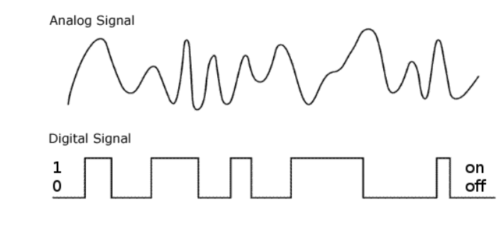

| **Feature** | **Analog Sensors** | **Digital Sensors** |
| --- | --- | --- |
| Output | Continuous voltage or current signal | Discrete binary signal (0s and 1s) |
| Conversion | Directly proportional to measured quantity | Conversion via analog-to-digital converter (ADC) |
| Resolution | Typically higher due to continuous signal | Limited by ADC resolution and sampling rate |
| Accuracy | High accuracy, especially in linear range | Accuracy may be limited by quantization errors |
| Interfacing | May require conditioning circuitry (e.g., filters, amplifiers) | Direct interfacing with digital systems |
| Noise Immunity | Susceptible to noise, may require shielding | More immune to noise, can be digitally filtered |
| Cost | Generally less expensive due to simpler design | May be more expensive due to additional components and digital processing |
| Complexity | Simpler circuitry design | More complex due to ADC, digital processing |
| Power Consumption | Lower power consumption in some cases | Higher power consumption due to digital processing and conversion |
| Response Time | Typically faster due to continuous signal | Response time may be affected by ADC sampling rate |
| Maintenance | Easier to troubleshoot and calibrate | May require software calibration and updates |
| Dynamic Range | Wide dynamic range due to continuous signal | Limited by ADC resolution and dynamic range |
| Application | Precision measurements, analog systems | Digital systems, signal processing applications |

* SCALAR

## Scalar Sensors: Measuring Magnitude, Not Direction

Scalar sensors are a fundamental type of sensor distinguished by their **output and the type of data they measure**.

**Key Characteristics:**

* **Output:** Scalar sensors produce a **continuous electrical signal** that **varies in magnitude** in direct proportion to the **changes in the measured quantity**. This signal typically falls within a specific predefined range, often between 0 and 5 volts (V) or -10V to +10V.
* **Data Type:** They measure **scalar quantities**, which are **physical properties with only magnitude and no direction**.
  + Examples of scalar quantities: temperature, pressure, distance (along a straight line), speed (without direction), volume, weight, and intensity of light.

**Working Principle:**

The specific working principle of a scalar sensor depends on the type of measurand it detects. However, they all share the common characteristic of converting changes in the physical quantity into a **proportional change in the electrical signal's magnitude**. This allows us to **quantify the strength or intensity** of the measured phenomenon.

**Examples:**

* **Temperature sensor:** As the temperature increases, the electrical resistance of the sensor material changes, leading to a **corresponding change in the voltage output**. The magnitude of the voltage directly reflects the temperature.
* **Pressure sensor:** As the pressure applied to the sensor increases, the diaphragm or other sensitive element deforms, causing a change in the sensor's internal resistance. This results in a **proportional change in the output voltage**, indicating the pressure magnitude.
* **Light sensor:** The intensity of light falling on the sensor's photodetector element (e.g., photodiode) determines the amount of current generated. The **magnitude of the current output** directly corresponds to the light intensity.

**Advantages:**

* **High resolution:** They can capture subtle changes in the measured quantity due to the continuous nature of their output signal.
* **Simplicity:** Their design is often simpler compared to sensors measuring direction, potentially making them **more cost-effective**.

**Disadvantages:**

* **Limited information:** They only provide information about the **magnitude** of the measured quantity and **lack directional information**.
* **Susceptibility to noise:** The output signal can be affected by electrical noise and environmental factors, potentially impacting accuracy.

**Applications:**

Scalar sensors find application in various fields due to their ability to capture the magnitude of diverse physical phenomena:

* **Industrial automation:** Monitoring and controlling processes in factories, power plants, and refineries.
* **Environmental monitoring:** Measuring temperature, humidity, pressure, and other environmental parameters.
* **Consumer electronics:** Touchscreens, accelerometers in smartphones (measuring acceleration magnitude, not direction), and temperature sensors in thermostats.
* **Medical devices:** Monitoring vital signs like heart rate (strength of the heartbeat) and blood pressure (magnitude of the force exerted on blood vessel walls).

**In conclusion, scalar sensors play a crucial role in various applications by providing continuous measurement of the magnitude of physical quantities. Understanding their characteristics and limitations is essential for choosing the right type of sensor for various applications where only the strength or intensity of a phenomenon needs to be determined.**

## VECTOR Vector Sensors: Capturing Magnitude and Direction

Vector sensors, unlike their scalar counterparts, go beyond simply measuring the **magnitude** of a physical quantity. They offer a more comprehensive understanding by providing information about both the **magnitude** and the **direction** of the measured phenomenon.

**Key Characteristics:**

* **Output:** Vector sensors produce an **electrical signal** that contains information about **both the magnitude and direction** of the measured quantity. This can involve multiple output channels or a single channel with encoded information.
* **Data Type:** They measure **vector quantities**, which possess both **magnitude** and **direction**.
  + Examples of vector quantities: force, acceleration (including direction), velocity (including direction), displacement, and magnetic field.

**Working Principle:**

The specific operation of a vector sensor depends on the type of measurand it detects. However, they all share the principle of utilizing multiple sensing elements or techniques to capture information about both the **strength** and the **orientation** of the phenomenon. This allows for a more complete picture of the measured quantity, providing valuable insights into its behavior.

**Examples:**

* **Three-axis accelerometer:** This sensor uses three internal accelerometers to measure the acceleration along **three orthogonal axes (X, Y, and Z)**. The combination of these measurements allows for determining the **magnitude and direction** of the overall acceleration experienced by the sensor.
* **Magnetometer:** This sensor measures the strength and direction of the magnetic field at its location. It often utilizes multiple magnetometer elements arranged in specific configurations to determine the **magnitude and three-dimensional orientation** of the magnetic field vector.
* **Gyroscope:** This sensor measures the **rate of rotation** (angular velocity) around **three axes**. It typically employs micromachined structures that sense the Coriolis force induced by the rotation, providing information about the **magnitude and direction** of the rotational motion.

**Advantages:**

* **Comprehensive information:** They offer a **richer understanding** of the measured phenomenon by providing both magnitude and direction, enabling more complex analysis and control tasks.
* **Wide range of applications:** They are valuable in various fields where understanding the **directional aspects** of physical quantities is crucial.

**Disadvantages:**

* **Complexity:** Compared to scalar sensors, vector sensors are often **more complex in design and operation**, potentially impacting cost and power consumption.
* **Data processing:** The output might require **additional processing** to extract the magnitude and direction information, increasing computational demands.

**Applications:**

Vector sensors find application in diverse areas due to their ability to capture both the magnitude and direction of various physical phenomena:

* **Robotics and autonomous systems:** Enabling robots to determine their movement, orientation, and interact with their environment more effectively.
* **Navigation and positioning systems:** Providing crucial information for navigation systems in autonomous vehicles, drones, and personal navigation devices.
* **Motion tracking and gesture recognition:** Used in wearables, gaming controllers, and virtual reality applications to track user movements and gestures.
* **Industrial automation and control systems:** Enabling precise control of machinery and processes by providing detailed information about forces, accelerations, and orientations.

**In conclusion, vector sensors offer a valuable tool for capturing a comprehensive understanding of various physical phenomena by measuring both their magnitude and direction. While they may be more complex than scalar sensors, their ability to provide richer data makes them essential in various applications requiring precise and directional information.**

|  |  |  |
| --- | --- | --- |
| Feature | Scalar Sensor | Vector Sensor |
| **Data Type** | Measures **scalar quantities** (magnitude only) | Measures **vector quantities** (magnitude and direction) |
| **Examples** | Temperature, pressure, distance (along a straight line) | Force, acceleration (including direction), velocity (including direction) |
| **Output** | Continuous electrical signal varying in **magnitude** | Electrical signal containing information about **both magnitude and direction** |
| **Complexity** | Generally simpler design and operation | Often more complex design and operation, potentially impacting cost and power consumption |
| **Applications** | Industrial automation, environmental monitoring, consumer electronics, medical devices (limited applications) | Robotics, navigation systems, motion tracking, industrial automation (more diverse applications) |

## **Active vs. Passive Sensors**

Sensors play a crucial role in various applications by capturing and converting physical phenomena into electrical signals. They can be broadly categorized into two main types based on their operation and interaction with the environment: **active** and **passive** sensors.

**1. Active Sensors:**

* **Definition:** These sensors emit their own form of energy, typically in the form of electromagnetic waves (light, sound, radar) or ultrasonic waves, and then measure the **reflected or scattered signals** to gather information about the target object or environment.
* **Operation:**
  + The sensor actively transmits a specific energy pulse or wave towards the target.
  + This emitted energy interacts with the target object or the surrounding environment, causing some of it to reflect or scatter back towards the sensor.
  + The sensor receives the reflected or scattered energy and measures its properties (e.g., intensity, time delay, frequency shift) to extract information about the target.
* **Examples:**
  + **Radar:** Emits radio waves and measures the reflected signals to determine the distance, direction, and speed of objects.
  + **LiDAR (Light Detection and Ranging):** Emits laser pulses and measures the reflected light to create detailed 3D maps of the environment.
  + **Sonar:** Emits sound waves and measures the reflected echoes to detect underwater objects and measure their properties.

**2. Passive Sensors:**

* **Definition:** These sensors **do not emit their own energy** and instead rely on detecting and measuring **existing energy** originating from the environment or the target object itself. This existing energy can be in various forms, such as light, heat, sound, or magnetic fields.
* **Operation:**
  + The sensor detects and measures the naturally occurring or emitted energy from the target or its surroundings.
  + The sensor's characteristics and design are tailored to be sensitive to specific types of energy and to effectively convert them into electrical signals.
* **Examples:**
  + **Camera:** Detects and measures the intensity and wavelength of light reflected from objects to create an image.
  + **Infrared sensor:** Detects and measures infrared radiation emitted by objects, often used for night vision applications or to detect temperature changes.
  + **Microphone:** Detects and measures sound waves (pressure variations) to capture audio information.

**Key Differences and Applications:**

|  |  |  |
| --- | --- | --- |
| Feature | Active Sensors | Passive Sensors |
| Energy Source | Emit their own energy (electromagnetic, sound, ultrasonic) | Rely on existing energy from environment or target |
| Operation | Transmit energy, measure reflected/scattered signal | Detect and measure existing energy |
| Advantages | Longer range, high precision, suitable for harsh environments | Simpler design, lower power consumption, covert operation |
| Disadvantages | More complex, higher cost, susceptible to interference from similar energy sources | Limited range, lower precision, reliant on ambient environment |
| Applications | Radar, LiDAR, Sonar, medical imaging (X-ray, CT scan) | Cameras, night vision, thermal imaging, microphones, motion sensors |

**Choosing the Right Sensor:**

The choice between using an active or passive sensor depends on various factors specific to your application, including:

* **Desired range:** Active sensors generally have a longer range due to their ability to transmit and receive their own energy.
* **Accuracy requirements:** Both types of sensors can achieve high accuracy, but active sensors might offer higher precision in certain applications.
* **Environmental conditions:** Active sensors can function in various environments due to their ability to control the emitted energy. Passive sensors might be limited by ambient conditions affecting the target's emissions.
* **Power consumption:** Passive sensors generally require less power as they don't emit their own energy, making them suitable for battery-powered applications.
* **Cost and complexity:** Active sensors are often more complex and expensive to develop and operate compared to passive sensors.
* **Covertness:** Passive sensors are more discreet as they don't emit any detectable energy, making them suitable for covert operations.

By understanding the distinct characteristics, functionalities, and limitations of both active and passive sensors, you can make informed decisions when selecting the most suitable sensor type for your specific needs and application requirements.

SENSOR TYPES

1. **Temperature Sensors:**
   * **Thermocouples:** Suitable for high-temperature measurements, they exploit the Seebeck effect where a temperature difference between two dissimilar metals generates a voltage.
   * **Resistance Temperature Detectors (RTDs):** Made of pure metals like platinum, they exhibit a predictable change in resistance with temperature, offering high accuracy and stability.
   * **Thermistors:** Available as NTC (Negative Temperature Coefficient) or PTC (Positive Temperature Coefficient), they offer high sensitivity but are less linear compared to RTDs.
2. **Pressure Sensors:**
   * **Strain Gauge Pressure Sensors:** Typically use metal strain gauges bonded to a diaphragm, where pressure-induced deformation changes the resistance of the strain gauge.
   * **Capacitive Pressure Sensors:** Employ capacitive elements whose capacitance changes with diaphragm deflection due to applied pressure.
   * **Piezoresistive Pressure Sensors:** Utilize piezoresistive materials whose resistance changes with applied pressure, offering good linearity and sensitivity.
3. **Force Sensors:**
   * **Load Cells:** Comprise strain gauges bonded to a structure deformed by the applied force, allowing measurement of force or weight.
   * **Piezoelectric Sensors:** Generate electrical charge in response to applied force due to the piezoelectric effect, offering high sensitivity and wide frequency response.
4. **Position Sensors:**
   * **Potentiometers:** A wiper moves along a resistive element, generating a voltage or resistance proportional to linear or angular displacement.
   * **Optical Encoders:** Consist of a rotating disc with transparent and opaque regions, coupled with optical sensors to detect changes in position.
   * **Hall Effect Sensors:** Detect changes in magnetic field strength using the Hall effect, often used for position sensing in proximity switches and speed detection in automotive applications.
5. **Motion Sensors:**
   * **Accelerometers:** Measure acceleration along one or more axes, commonly used in inertial navigation systems, motion detection, and vibration monitoring.
   * **Gyroscopes:** Detect angular velocity or rotational motion, crucial for navigation systems, stabilization, and robotics.
   * **Inertial Measurement Units (IMUs):** Combine accelerometers and gyroscopes to provide comprehensive motion tracking in three-dimensional space.
6. **Light Sensors:**
   * **Photodiodes:** Convert incident light into current or voltage, commonly used in light meters, solar cells, and optical communication systems.
   * **Phototransistors:** Offer higher sensitivity and gain compared to photodiodes, suitable for applications requiring low-light detection.
   * **Light Dependent Resistors (LDRs):** Vary resistance with light intensity, employed in light-sensitive applications such as streetlights, cameras, and automatic lighting systems.
7. **Humidity Sensors:**
   * **Capacitive Humidity Sensors:** Use a humidity-sensitive dielectric material whose capacitance changes with humidity, offering fast response times and high accuracy.
   * **Resistive Humidity Sensors:** Change resistance with humidity by employing materials like polymers or salts, used in industrial and environmental monitoring applications.
8. **Gas Sensors:**
   * **Electrochemical Gas Sensors:** Detect gases through electrochemical reactions, offering high sensitivity and selectivity for specific gases, commonly used in safety and environmental monitoring.
   * **Metal Oxide Gas Sensors:** Change resistance in the presence of specific gases due to surface reactions, suitable for detecting a wide range of gases in industrial and automotive applications.
9. **Biometric Sensors:**
   * **Fingerprint Sensors:** Capture and analyze unique fingerprint patterns using various technologies like capacitive or optical sensing, widely used in security systems and smartphones.
   * **Iris Scanners:** Utilize iris recognition for secure authentication, offering high accuracy and reliability for access control and identity verification.
   * **Heart Rate Sensors:** Measure heart rate by detecting pulse signals, typically using photoplethysmography (PPG), found in fitness trackers, smartwatches, and medical devices.

A main challenge to using sensors in activity recognition is the different types of error and noises their measurements or signal suffer from .Such error can mislead an activity recognition module from recognizing which activity the sensor signals measures correspond or do not correspond to . There are different types of deterministic errors in sensors which can be estimated and compensated through laboratory calibration .Some error are-

Offset error or bias, drift , hysteresis error and quantization error

Input-refer to actual true quantity , output -refers to the measurement reading of the sensor

BIAS /offset:

It is the value of the constant non zero output when the input is 0.

If the output signals differs from the correct value by a constant ,the sensor has an offset error or bias.

Sensor bias refers to a systematic error in a sensor's output, causing it to consistently deviate from the true value being measured. It's essentially a constant offset that affects readings even when the sensor isn't actively detecting anything. There are two main categories of sensor bias:

1. **Internal Sensor Bias:** This arises from physical limitations within the sensor itself. Manufacturing imperfections, temperature fluctuations, or aging components can all contribute to internal bias.

For instance:

* An accelerometer might show a slight tilt even when laying perfectly flat.
* A thermometer might read a temperature a few degrees off due to internal heating of its components.

1. **External Sensor Bias:** This originates from external factors affecting the sensor's environment. Magnetic fields, vibrations, or even sunlight exposure can influence some sensors and cause a bias in their readings.

Here are some ways to identify and address sensor bias:

* **Calibration:** Most sensors can be calibrated to account for internal bias. This involves exposing the sensor to known reference values and adjusting its output accordingly. Regular calibration is crucial for maintaining sensor accuracy.
* **Data Filtering:** Techniques like averaging multiple readings or using statistical methods can help filter out some random variations caused by bias.
* **Sensor Selection:** Choosing sensors less susceptible to specific environmental factors that might cause bias in your application is important.

Sensor bias can significantly impact the data collected by IoT devices. By understanding the types of bias and implementing mitigation strategies, you can ensure your sensors provide accurate and reliable measurements.

DRIFT if the output signal slowly changes independent of the measured property that is defined as drift.

Drift error in a sensor refers to a gradual change in its output over time, even when the actual quantity it's measuring remains constant. It's different from sensor bias, which is a fixed offset in readings. Drift causes the sensor's output to slowly deviate from the true value, making measurements less accurate as time progresses.

Here are some common causes of drift error in sensors:

* **Material aging:** Sensors are made of physical components that can degrade over time. This can cause the sensor's sensitivity to change, leading to drift.
* **Temperature fluctuations:** Many sensors are sensitive to temperature variations. Extreme heat or cold can cause their internal components to expand or contract, impacting their output.
* **Environmental exposure:** Exposure to dust, humidity, or corrosive elements can damage a sensor's internal mechanisms and contribute to drift.
* **Vibration:** Constant vibrations can cause physical stress on the sensor, leading to gradual changes in its performance.

The effects of drift error can vary depending on the sensor type and application. In some cases, minor drift might be negligible. However, in applications requiring high precision, even small amounts of drift can significantly impact results.

Here's how to manage drift error in sensors:

* **Regular Calibration:** Performing periodic calibrations using known reference values helps identify and adjust for drift. The frequency of calibration depends on the sensor's specifications and how critical accuracy is for your application.
* **Choosing High-Stability Sensors:** Sensors with better long-term stability specifications are less prone to drift and might require calibration less often.
* **Monitoring Sensor Performance:** Tracking sensor outputs over time can help detect signs of drift before it significantly affects measurements.
* **Redundant Sensors:** Using multiple sensors to measure the same quantity can help identify and compensate for drift in individual sensors by comparing readings.

By understanding drift error and implementing these mitigation strategies, you can ensure your sensors provide reliable data over a longer lifespan.

HYSTERSIS ERROR **–** A hysteresis error causes the sensor output value to vary depending on the sensor’s previous value. Hystersis is an error in which sensor’s output for the same input value changes depending on whether the input is increasing or decreasing.

Usually in magnetic compass and pressure sensor

In sensor measurement, hysteresis error refers to the difference in a sensor's output when the measured quantity is increasing compared to when it's decreasing. Imagine a sensor like a light switch with a built-in dimmer.

Here's how hysteresis works:

1. **Increasing Measurement:** As you slowly turn the dimmer knob up (increasing light), the sensor output (brightness reading) increases accordingly.
2. **Hysteresis Loop:** There's a point where the dimmer clicks on, but the sensor reading might not immediately reflect the full brightness. This is because the sensor has a "memory" of its previous state.
3. **Decreasing Measurement:** Now, as you slowly turn the knob down (decreasing light), the sensor reading might stay at the higher value for a while, even though the light is getting dimmer. The sensor "remembers" the previous higher state.
4. **Click Point:** Eventually, the dimmer clicks off at a point lower than the click-on point. The sensor reading will then finally drop to zero.

This creates a loop in the sensor's output graph, hence the term "hysteresis" (Greek for "lagging behind"). The size of the loop represents the hysteresis error.

Here are some common causes of hysteresis error:

* **Mechanical Parts:** Many sensors have internal mechanical components that can exhibit friction or play (slight looseness). This can cause a delay in the sensor's response to changes in the measured quantity.
* **Material Properties:** The materials used in the sensor itself might have inherent hysteresis characteristics. For example, certain magnetic materials can exhibit a lag in their magnetization when an external magnetic field is applied and removed.

The impact of hysteresis error depends on the application. In some cases, it might be negligible. However, for applications requiring high precision control or switching between states (like the light dimmer example), hysteresis can introduce unwanted delays or inconsistencies.

Here are some ways to manage hysteresis error in sensors:

* **Sensor Selection:** Choosing sensors with lower inherent hysteresis characteristics is ideal for applications demanding high precision.
* **Digital Signal Processing (DSP):** Applying DSP techniques can sometimes compensate for predictable hysteresis behavior in the sensor's output.
* **Calibration:** While it won't eliminate hysteresis entirely, calibration can help identify the hysteresis loop and potentially adjust the sensor's output to account for it.

By understanding hysteresis error and these mitigation strategies, you can select appropriate sensors and implement techniques to minimize its impact on your measurements.

QUANTIZATION ERROR this type of error exist in digital system and is caused by conversion from analog to digital values.

In sensor applications, quantization error arises from the conversion of analog signals from the real world into digital data usable by computers. Sensors themselves deal with continuous analog quantities like temperature, pressure, or light. However, these analog variations need to be translated into discrete digital values for processing and storage. This conversion process introduces quantization error.

Here's how quantization error works:

1. **Analog Input:** Imagine a sensor measuring temperature. It outputs a continuous voltage signal that varies based on the actual temperature.
2. **Analog-to-Digital Converter (ADC):** The sensor connects to an Analog-to-Digital Converter (ADC). This chip acts like a ruler with finite markings. It divides the possible voltage range (representing the entire temperature range the sensor can measure) into discrete steps.
3. **Limited Steps:** The number of steps on the ADC's ruler determines the resolution of the conversion. With fewer steps (lower resolution), larger voltage ranges are mapped to a single digital value. With more steps (higher resolution), smaller voltage variations can be distinguished.
4. **Rounding or Truncation:** When the sensor's analog voltage falls between two steps on the ADC's ruler, it gets rounded or truncated (depending on the conversion method) to the nearest digital value. This rounding or truncation introduces the quantization error.

The key takeaway is that quantization error is the inherent uncertainty or "fuzziness" in representing a continuous analog value with a limited number of discrete digital steps.

Here are some factors affecting quantization error:

* **ADC Resolution (Number of bits):** The number of bits in the ADC directly determines the quantization error. Higher resolution (more bits) translates to more steps on the ADC's ruler, leading to smaller errors.
* **Sensor Range:** The range of voltages the sensor outputs compared to the ADC's range also plays a role. A wider sensor range mapped to a limited ADC range will result in larger quantization errors.

The impact of quantization error depends on the application's needs. In some cases, a small amount of error might be acceptable. However, for high-precision measurements, quantization error can significantly affect the accuracy of the data.

Here are ways to manage quantization error in sensor applications:

* **Choosing Higher Resolution ADCs:** Using ADCs with more bits reduces the size of each step, minimizing the potential error for each analog value.
* **Signal Conditioning:** Techniques like amplification can adjust the sensor's output voltage range to better match the ADC's range, reducing the impact of quantization error.
* **Oversampling and Averaging:** Taking multiple sensor readings and averaging them can sometimes help reduce the random variations introduced by quantization error.

By understanding quantization error and these mitigation strategies, you can select appropriate ADCs and processing techniques to achieve the desired level of accuracy in your sensor data.

ACTUATOR Actuator are devices used to produce action or motion.

Actuator is a device that starts or stops mechanical equipment with the help of hydraulic fluid , electric current , air or other sources. Actuator are usually used in automation to control the motion of moving member in any machine.An actuator requires a control signal and as source of energy. After receiving a control signal actuator responds by converting the energy into mechanical motion.

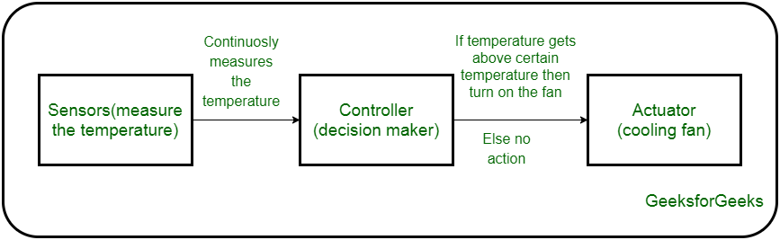

In the realm of the Internet of Things (IoT), actuators play a critical role as the movers and shakers. They bridge the gap between the digital world of data and the physical world of action. Here's how actuators function within the IoT ecosystem:

**The Bridge Between Data and Action:**

* **Sensor Data as Input:** IoT devices typically collect data using sensors that monitor environmental conditions or equipment status.
* **Actuators as Output:** Actuators receive instructions based on the analyzed sensor data or user commands. These instructions are often transmitted wirelessly through the network.
* **Taking Physical Action:** Using the received control signals, actuators translate them into physical movements or force. This allows them to control valves, adjust positions, turn on/off devices, or initiate various actions in the real world.

**Examples of Actuators in IoT:**

* **Smart Homes:** Thermostats with integrated actuators adjust room temperature based on sensor readings. Smart plugs can turn electronics on or off remotely.
* **Industrial Automation:** Actuators operate valves in pipelines based on pressure or flow sensor data. Robots in factories use actuators for precise movements based on control signals.
* **Agriculture:** Irrigation systems use actuators to control water flow based on soil moisture sensor readings.
* **Wearable Tech:** Smart fitness trackers might use tiny vibration motors (actuators) to provide notifications.

**Impact of Actuators in IoT:**

Actuators empower IoT systems to:

* **Automate Tasks:** Repetitive or pre-programmed actions can be automated, improving efficiency and reducing manual intervention.
* **Remote Control:** Systems can be controlled and manipulated from anywhere with an internet connection.
* **Optimize Processes:** Sensor data and actuator responses can be used to create feedback loops, allowing for continuous optimization of operations.

**Choosing Actuators for IoT Applications:**

Selecting the appropriate actuator for an IoT application requires considering factors like:

* **Power Source:** Electricity, battery, compressed air, or hydraulics, depending on the application's needs.
* **Connectivity:** Wired or wireless connection to the IoT network for receiving control signals.
* **Size and Form Factor:** Compact size and lightweight design might be crucial for space-constrained applications.
* **Force or Torque Requirements:** The actuator needs to generate enough force or torque to perform the intended action.

ACTUATOR TYPES(depending on source of power_

* HYDRAULIC
* PNEUMATIC
* ELECTRICAL
* THERMAL/MAGNETIC
* MECHANICAL ACTUATORS
* SOFT ACTUATORS

Hydraulic actuators play a vital role in the Internet of Things (IoT) by enabling physical interaction and control of devices and systems. They are essentially machine components that convert hydraulic energy, transmitted by pressurized fluids, into mechanical motion. This motion can be linear, rotary, or oscillatory, depending on the design of the actuator.

Here's how hydraulic actuators fit into IoT applications:

* **Sensors and control signals:** Sensors collect data from the environment, and control units use this data to generate signals for the actuators.
* **Actuator response:** Based on the control signals, the actuators perform specific actions, such as opening or closing valves, adjusting positions, or applying forces.
* **Remote control and monitoring:** IoT connectivity allows for remote control and monitoring of hydraulic actuators. This enables real-time adjustments, preventive maintenance, and data-driven optimization of operations.

Benefits of using hydraulic actuators in IoT:

* **High force generation:** Hydraulic actuators can generate massive amounts of force, making them ideal for heavy-duty applications.
* **Precise control:** Sophisticated control systems can precisely regulate the movement and force of hydraulic actuators.
* **Durability:** Hydraulic systems are known for their robustness and ability to withstand harsh environments.

Examples of hydraulic actuators in IoT:

* **Smart agriculture:** Hydraulic actuators can control irrigation systems, adjust planter positions, and operate harvesting equipment.
* **Industrial automation:** They are used in robotic arms, assembly lines, and material handling systems.
* **Construction machinery:** Hydraulic actuators power excavators, bulldozers, and other heavy equipment.
* **Smart grids:** They can be used to control valves and adjust power flow in electricity distribution systems.

While hydraulic actuators offer significant advantages, their size, complexity, and maintenance requirements can be drawbacks in some IoT applications. In such cases, other types of actuators, such as electric or pneumatic actuators, might be more suitable.

A hydraulic actuator uses hydraulic power to perform a mechanical operation. They are actuated by a cylinder or fluid motor. The mechanical motion is converted to rotary, linear, or oscillatory motion, according to the need of the IoT device. Ex- construction equipment uses hydraulic actuators because hydraulic actuators can generate a large amount of force.

**Advantages :**

* Hydraulic actuators can produce a large magnitude of force and high speed.
* Used in welding, clamping, etc.
* Used for lowering or raising the vehicles in car transport carriers.

**Disadvantages :**

* Hydraulic fluid leaks can cause efficiency loss and issues of cleaning.
* It is expensive.
* It requires noise reduction equipment, heat exchangers, and high maintenance systems.

1. **Pneumatic Actuators –**

in the realm of IoT (Internet of Things), pneumatic actuators play a key role by providing a way to initiate physical actions based on signals. They function by converting compressed air or gas into mechanical motion, typically linear or rotary. Here's a breakdown of how pneumatic actuators contribute to IoT systems:

* **Energy source:** Compressed air acts as the fuel for pneumatic actuators, making them a cost-effective option.
* **Movement types:** They can generate either linear motion (think pushing or pulling in a straight line) or rotary motion (think turning).
* **IoT integration:** By incorporating sensors and control units, pneumatic actuators can be integrated into IoT systems. Sensors gather data, and control units use this information to send signals to the actuators, triggering specific actions.
* **Remote control and monitoring:** The beauty of IoT is remote control and monitoring capabilities. This allows for adjustments, preventative maintenance, and data-driven optimization of pneumatic actuator operations from a distance.

Here are some of the advantages of using pneumatic actuators in IoT applications:

* **Cost-effective:** Compressed air is a readily available and relatively inexpensive power source.
* **Simplicity:** The design of pneumatic actuators is generally simpler compared to hydraulic systems, making them easier to maintain and manage.
* **Safety:** Since they rely on air, pneumatic actuators are ideal for environments where sparks or electrical hazards are a concern.
* **Fast operation:** Pneumatic actuators can start and stop motions quickly, making them suitable for applications requiring rapid actuation.

Examples of pneumatic actuators being utilized in IoT:

* **Smart factories:** They can be used to operate assembly line equipment, control valves in production processes, and power robotic grippers.
* **HVAC systems:** Pneumatic actuators can adjust dampers to regulate airflow and temperature in buildings.
* **Food and beverage industry:** They are used in packaging machinery, filling equipment, and bottling lines.
* **Environmental monitoring:** Pneumatic actuators can be used to deploy sensors or operate weather monitoring stations.

However, it's important to consider some limitations of pneumatic actuators as well:

* **Force limitations:** Compared to hydraulic actuators, pneumatic systems generally provide less force output.
* **Air consumption:** Depending on the application, compressed air usage can be significant, impacting energy efficiency.
* **Moisture sensitivity:** In some cases, moisture in the compressed air can affect the performance of pneumatic actuators.

Overall, pneumatic actuators offer a compelling choice for various IoT applications due to their affordability, simplicity, safety, and fast operation. But, for tasks requiring high force or where compressed air efficiency is critical, other types of actuators might be a better fit.

A pneumatic actuator uses energy formed by vacuum or compressed air at high pressure to convert into either linear or rotary motion. Example- Used in robotics, use sensors that work like human fingers by using compressed air.

**Advantages :**

* They are a low-cost option and are used at extreme temperatures where using air is a safer option than chemicals.
* They need low maintenance, are durable, and have a long operational life.
* It is very quick in starting and stopping the motion.

**Disadvantages :**

* Loss of pressure can make it less efficient.
* The air compressor should be running continuously.
* Air can be polluted, and it needs maintenance.

**3. Electrical Actuators –**

An electric actuator uses electrical energy, is usually actuated by a motor that converts electrical energy into mechanical torque. An example of an electric actuator is a solenoid based electric bell.

**Advantages :**

* It has many applications in various industries as it can automate industrial valves.
* It produces less noise and is safe to use since there are no fluid leakages.
* It can be re-programmed and it provides the highest control precision positioning.

**Disadvantages :**

* It is expensive.
* It depends a lot on environmental conditions.

Electrical actuators are the workhorses of the actuator world in IoT (Internet of Things) applications. They bridge the gap between the digital world of sensors and control systems and the physical world by converting electrical signals into precise mechanical motion.

Here's how electrical actuators power the Internet of Things:

* **Versatility:** Electrical actuators come in a wide range of designs, offering linear, rotary, and even more complex motions to suit various needs.
* **Precise control:** Sophisticated electronic controls enable highly accurate positioning and force control of the actuator.
* **Integration with IoT:** Electrical actuators seamlessly integrate with sensors and control units in IoT systems. Sensors collect data, and control units process it to send signals to the actuator, triggering specific actions.
* **Remote control and monitoring:** A core advantage of IoT is remote management. Electrical actuators can be controlled and monitored remotely, allowing for real-time adjustments, preventive maintenance, and data-driven optimization.

Electrical actuators offer several benefits for IoT applications:

* **Clean and efficient:** They rely on electricity, a clean and efficient energy source, which can be advantageous in environmentally conscious designs.
* **Quiet operation:** Compared to pneumatic or hydraulic systems, electrical actuators generate minimal noise, making them ideal for noise-sensitive environments.
* **Scalability:** Electrical actuators come in various sizes and force capabilities, making them suitable for a wide range of applications, from small-scale adjustments to heavy-duty operations.

Let's explore some real-world examples of electrical actuators in IoT:

* **Smart homes:** They adjust thermostats, control lighting, open and close curtains, and operate automatic doors.
* **Smart agriculture:** Electrical actuators manage irrigation systems, regulate greenhouse ventilation, and precisely position harvesting equipment.
* **Industrial automation:** They power robots, conveyor belts, and assembly line equipment.
* **Medical devices:** Electrical actuators are used in adjustable beds, robotic surgery equipment, and medication delivery systems.

While electrical actuators provide numerous advantages, it's important to consider some limitations:

* **Force limitations:** Compared to hydraulic actuators, electrical actuators may have limitations in terms of maximum force output.
* **Cost:** Depending on the complexity and power requirements, electrical actuators can sometimes be more expensive than pneumatic options.

Overall, electrical actuators are a versatile and powerful choice for a vast array of IoT applications due to their clean operation, precise control, scalability, and ease of integration with control systems. They are a key component in creating a connected world where physical devices respond and adapt based on real-time data and user control.

Other actuators are –

**4)Thermal/Magnetic Actuators –**  
These are actuated by thermal or mechanical energy. Shape Memory Alloys (SMAs) or Magnetic Shape‐Memory Alloys (MSMAs) are used by these actuators. An example of a thermal/magnetic actuator can be a piezo motor using SMA.

Thermal and magnetic actuators bring a unique set of advantages to the table in the realm of IoT (Internet of Things). They differ from the more common electric, pneumatic, and hydraulic actuators by relying on thermal energy or magnetic fields for actuation.

Here's a breakdown of how thermal/magnetic actuators function in IoT:

* **Actuation principles:**
  + **Thermal actuators:** These utilize materials that exhibit shape memory properties, like shape memory alloys (SMAs). When heated, the material contracts or expands, generating linear motion.
  + **Magnetic actuators:** These employ electromagnets or permanent magnets to create a pulling or pushing force based on magnetic field manipulation.
* **Integration with IoT:** Similar to other actuators, they can be integrated with sensors and control units. Sensors provide data, and control units use this information to regulate temperature (thermal) or magnetic fields (magnetic) to trigger specific movements.
* **Remote control and monitoring:** The beauty of IoT applies here too. Thermal/magnetic actuators can be controlled and monitored remotely, enabling adjustments and data-driven optimization.

While not as widely used as their electrical or pneumatic counterparts, thermal and magnetic actuators offer some distinct benefits for specific IoT applications:

* **Simplicity:** The design of these actuators is often simpler, making them potentially more compact and lower maintenance.
* **Energy efficiency:** Thermal actuators can be efficient if waste heat is utilized, and magnetic actuators require no ongoing power consumption to hold a position.
* **Silent operation:** Both thermal and magnetic actuators generate minimal noise, making them ideal for noise-sensitive environments.

Here are some examples of how thermal/magnetic actuators are being used in IoT:

* **Smart buildings:** Thermal actuators can be used in self-regulating vents or deployable sunshades. Magnetic actuators could control smart locks or friction brakes in dampers.
* **Medical devices:** Thermal actuators could be used in controlled-release drug delivery systems. Magnetic actuators have potential applications in micro-pumps for medical devices.
* ** Aerospace applications:** Deployable antennas or heat shields could utilize thermal actuators. Magnetic actuators might be used for small, precise positioning adjustments in satellites.

It's important to acknowledge some limitations of thermal/magnetic actuators as well:

* **Limited force and speed:** Generally, they provide lower force output and slower response times compared to other actuator types.
* **Temperature sensitivity:** Performance of thermal actuators can be affected by ambient temperature fluctuations.
* **Control complexity:** In some cases, controlling thermal or magnetic fields precisely can be more intricate than electrical actuation.

Overall, thermal and magnetic actuators offer a unique solution for specific IoT applications where their inherent advantages, like simplicity, silent operation, and potential energy efficiency, outweigh the limitations in force and speed. As IoT technology continues to evolve, we can expect to see these actuators play an increasingly innovative role in creating a more interconnected and responsive world.

**5)Mechanical Actuators –**   
A mechanical actuator executes movement by converting rotary motion into linear motion. It involves pulleys, chains, gears, rails, and other devices to operate. Example – A crankshaft.

Mechanical actuators form the backbone of various motion-control systems in the Internet of Things (IoT) realm. Unlike their electrical, pneumatic, or hydraulic counterparts, they rely purely on mechanical principles to convert one form of motion into another, enabling precise physical manipulation in IoT devices.

Here's how mechanical actuators contribute to the world of IoT:

* **Motion transformation:** These actuators excel at transforming rotary motion (think motors) into linear motion (think pistons) or vice versa, crucial for many IoT applications.
* **Integration with sensors and controls:** Mechanical actuators seamlessly integrate with sensors and control units within an IoT system. Sensors collect data, and control units process it to trigger specific movements via the actuator based on pre-programmed logic or user commands.
* **Remote control and monitoring:** An advantage of IoT is remote management. Mechanical actuators can be monitored and controlled remotely, allowing for adjustments and data-driven optimization of their operation.

Mechanical actuators offer several benefits for IoT applications:

* **Simplicity and reliability:** The mechanical design is often straightforward, leading to high reliability and potentially lower maintenance requirements compared to more complex actuator types.
* **Cost-effectiveness:** They can be a cost-efficient solution for applications requiring moderate force and precise positioning.
* **Versatility:** A wide variety of mechanical actuator designs exist, offering a range of motion capabilities (linear, rotary, oscillatory) to suit diverse IoT needs.

Let's delve into some examples of mechanical actuators in action within the IoT landscape:

* **Smart homes:** Geared motors can adjust thermostats, while rack and pinion mechanisms open and close blinds or windows.
* **Industrial automation:** Cams and linkages can precisely position robotic arms or control conveyor belts.
* **Security systems:** Solenoid valves can lock or unlock doors, and crank mechanisms can adjust security cameras.
* **Agricultural equipment:** Screw jacks can raise and lower planting equipment, and linkages can adjust the angle of harvesting tools.

However, it's important to consider some limitations of mechanical actuators as well:

* **Force limitations:** They may not be suitable for applications requiring very high force output.
* **Speed limitations:** Some mechanical actuator designs might have limitations in terms of speed of movement compared to other types.
* **Potential for wear and tear:** Moving parts can be prone to wear and tear over time, requiring maintenance or replacement.

Overall, mechanical actuators are a dependable and versatile choice for a wide range of IoT applications where precise motion control and cost-efficiency are priorities. Their simple design and diverse capabilities make them a cornerstone for creating a connected world where physical devices can adapt and respond based on real-time data and user control.

**6) Soft Actuators**

Shape Memory Polymers

Light Activated Polymers

With the expanding world of IoT, sensors and actuators will find more usage in commercial and domestic applications along with the pre-existing use in industry.

In the realm of IoT (Internet of Things), soft actuators stand out for their unique properties and growing range of applications. Unlike traditional rigid actuators, they are made from soft, flexible materials that can deform and change shape in response to external stimuli. This opens doors for innovative actuation in various IoT scenarios.

Here's how soft actuators come into play in IoT:

* **Biomimetic design:** Inspired by nature (think muscles!), soft actuators can mimic biological movement, offering a level of compliance and safety when interacting with delicate objects or humans.
* **Stimuli-responsive materials:** These actuators can respond to various stimuli, such as electricity, light, air pressure, or even changes in temperature or moisture. This versatility allows for diverse actuation methods within IoT systems.
* **Integration with sensors and controls:** Similar to other actuators, they can be integrated with sensors and control units in IoT. Sensors provide data, and control units use this information to trigger specific deformations in the soft actuator material based on pre-programmed logic or user commands.

Soft actuators offer distinct advantages for specific IoT applications:

* **Safety:** Their soft, compliant nature makes them ideal for tasks involving interaction with people or fragile objects, minimizing the risk of injury or damage.
* **Conformability:** The ability to deform and adapt their shape allows them to handle uneven surfaces or delicate objects more effectively than rigid actuators.
* **Lightweight and compact:** Soft actuators can be lightweight and compact, making them suitable for integration into smaller IoT devices.

Let's explore some promising applications of soft actuators in IoT:

* **Wearable technology:** Soft actuators can be incorporated into comfortable and adaptive haptic feedback gloves or exoskeletons for rehabilitation or industrial applications.
* **Biomedical devices:** Microbots for minimally invasive surgery or soft robotic arms for delicate procedures could utilize soft actuators.
* **Smart homes:** Soft grippers in robotic vacuum cleaners or pressure sensors in smart mattresses could benefit from soft actuator technology.

However, soft actuators are still under development and come with some limitations:

* **Force limitations:** Generally, they cannot generate the same level of force as traditional rigid actuators.
* **Control complexity:** Precise control of deformation and movement in soft actuators can be more intricate compared to some other actuator types.
* **Durability:** The long-term durability of soft actuator materials under constant stress or environmental factors is still being explored.

Despite these limitations, the field of soft actuators is rapidly evolving. As the technology matures, we can expect to see them play a more prominent role in shaping the future of IoT by enabling safe, adaptable, and innovative interactions in various applications.

UNIT -3

BASICS OF IOT NETWORKING

The internet of things (IoT) is all about connecting physical things to the internet. But how do all these devices talk to each other and share information? That's where IoT networking comes in.

Here's a breakdown of the basics:

* **Components:** An IoT network is like a mini-ecosystem. You've got sensors embedded in devices that collect data about their environment. There are also smart devices that can perform actions based on that data. Then you need a way for all these devices to communicate - that's where networking comes in. Finally, software like cloud computing and edge computing can be used to analyze the data collected by the devices.
* **Communication:** IoT devices use a variety of technologies to connect. For short-range communication inside a home or building, common options are Bluetooth, Zigbee, and Wi-Fi. For wide-area communication, cellular networks are often used. There are also specialized protocols designed for IoT devices that use less power, like LPWAN (Low-Power Wide-Area Network).
* **Choosing the right network:** The ideal network for your IoT application depends on several factors. Consider how much data your devices need to transmit, the distance between them, and battery life. Security is another important aspect. For example, if your devices are constantly sending large amounts of data, Wi-Fi might be a good choice. But if your devices are spread out over a wide area and need to conserve battery life, a low-power network like LPWAN might be a better option. Security is also a major consideration. Cellular networks typically offer a high level of security, while some low-power networks may be less secure.

IOT COMPONENTS

## **Major Components of IoT (Internet of Things)**

There are 5 major components of IoT (Internet of Things) - Devices or Sensors, Gateway, Cloud, Analytics and User Interface:

### ****1. Sensors or Devices****

Sensors or Devices are basically used to collect and transmit the data and also perform actions based on those data. For example, the sensors can be used for measuring temperature and humidity. There are different types of sensors; here are as follows: Temperature Sensors, Humidity Sensors, Proximity Sensors, Motion Sensors, Light Sensors, Pressure Sensors, Gas Sensors, and GPS Sensors

### ****2. Gateway****

Gateway is also a device component that basically acts as an intermediate between the sensors and the central cloud. Gateway is one of the essential components of IoT that offers communication, management, and data processing. Here are some of the functions of Gateway in IoT: Data Aggregation, Communication, Security, Protocol Translation, Load Balancing, and Latency Reduction.

### ****3. Cloud****

Cloud in IoT refers to the service that provides the management, storage, and processing of the data that is generated by IoT (Internet of Things) devices. Here are some key aspects of Cloud in IoT: Data Storage, Data Collection, Security, Connectivity, Integration, and Cost Efficiency.

### ****4. Analytics****

This is the crucial component of IoT that basically harness the potential of IoT. In analytics, meaningful insights are analyzed that are generated by IoT devices and sensors. There are some functions included in Analytics, such as data processing, machine learning, and statistical analysis. Here are some of the applications of analytics in IoT: Anomaly Detection, Environmental Monitoring, Energy Management, Smart Cities, and Agriculture.

### ****5. User Interface****

User Interface, also known as UI in the Internet of Things (IoT) and provides an interface by which the users can interact with the applications and systems. Here are some of the key points in the user interface of IoT (Internet of Things): Data Visualization, User-Friendly Design, Personalization, Remote Management, Integration, Authentication, and Security.

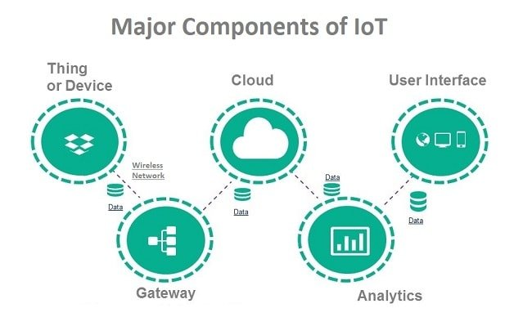

FUNCTIONAL COMPONENTS OF IOT

1. **Component for Interaction and Communication with Other IoT Devices:** This component involves the hardware and software necessary for IoT devices to communicate with each other. It includes protocols, communication modules (such as Wi-Fi, Bluetooth, Zigbee, LoRa), and interfaces that enable devices to exchange data and commands seamlessly. For example, a smart thermostat communicating with smart lighting systems to adjust brightness based on room temperature.
2. **Component for Processing and Analysis of Operations:** This component handles the processing and analysis of data collected from IoT devices. It involves microcontrollers, processors, and software algorithms responsible for interpreting raw sensor data, detecting patterns, making decisions, and executing actions based on predefined rules or machine learning models. This processing can happen locally on the device or in the cloud.
3. **Component for Internet Interaction:** This component facilitates the connection of IoT devices to the internet, enabling them to send and receive data to and from remote servers or cloud platforms. It encompasses networking protocols, security mechanisms, and communication gateways that ensure secure and reliable data transfer over the internet. This component enables remote monitoring, control, and management of IoT devices.
4. **Component for Handling Web Services of Applications:** This component involves the development and management of web services that interact with IoT devices. It includes APIs (Application Programming Interfaces) for accessing device functionalities, managing data streams, and integrating IoT capabilities into web applications or other software systems. These web services enable developers to build applications that interact with and control IoT devices remotely.
5. **Component to Integrate Application Services:** This component focuses on integrating IoT functionalities into existing software applications or services. It involves middleware platforms, SDKs (Software Development Kits), and integration tools that allow developers to incorporate IoT capabilities seamlessly into their applications. This integration enables diverse applications, such as home automation systems, industrial monitoring solutions, or healthcare management platforms, to leverage IoT data and functionalities.
6. **User Interface to Access IoT:** This component provides users with interfaces to interact with and control IoT devices and applications. It includes user interfaces (UI) such as mobile apps, web portals, voice assistants, or physical interfaces like buttons and displays. These interfaces enable users to monitor device status, set preferences, receive notifications, and perform actions remotely, enhancing user experience and usability of IoT systems.

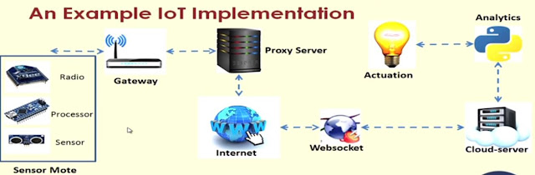

The functional components of an IoT system are the building blocks that allow it to gather information from the physical world, process it, and take actions. Here's a closer look at each one:

* **Sensors and Actuators:** These are the physical devices that interact with the environment. Sensors act like eyes and ears, capturing data such as temperature, pressure, or motion. Actuators are the hands and feet, taking physical actions based on that data. For instance, a thermostat sensor might read the room temperature and trigger an actuator to turn on the heater.
* **Connectivity:** This is the communication network that enables devices to talk to each other and transmit data. The choice of network depends on factors like range and power requirements. Common options include:
  + **Wi-Fi:** Ideal for short-range, high-bandwidth communication within a building.
  + **Bluetooth:** Another short-range option, often used for connecting mobile devices to sensors.
  + **Cellular networks:** Used for wide-area communication, enabling devices to connect over long distances.
  + **Low-Power Wide-Area Networks (LPWAN):** Designed for long-range communication with low power consumption, ideal for battery-powered devices.
* **Data Processing:** The raw data collected by sensors needs analysis to be useful. This processing can occur in two main places:
  + **Edge computing:** Processing happens on the devices themselves or on gateways (local devices that aggregate data from multiple sensors). This is suitable for real-time actions or situations where cloud connectivity is limited.
  + **Cloud computing:** Data is sent to a cloud platform for storage, processing, and advanced analytics. Cloud computing offers more powerful resources and scalability for complex analysis.
* **User Interface (UI):** This is the interface that allows users to interact with the entire IoT system. It can take various forms:
  + **Mobile app:** A user-friendly app for smartphones or tablets to monitor data, control devices, and adjust settings remotely.
  + **Web dashboard:** A web-based interface accessible from any computer with an internet connection.
  + **Physical control panel:** A physical interface with buttons, knobs, or a touchscreen for local control of devices.
* **Security:** Securing an IoT system is crucial to protect devices, data, and user privacy. Security measures include authentication, authorization, and encryption to prevent unauthorized access and data breaches.

IOT SERVICE ORIENTED ARCHITECTURE

IOT aims to connect different things over the network . As a key technology in integrating heterogenous system or devices , SOA can be applied to support IOT. SOA efficiently combines individual units of software to provide higher level of functionality, SOA is an architecture based on reusable,well defined .services implemented by IT components. SOA provides platform, technology and language independent

A service is a function that is well defined, self contained and does not depend on the context or state of other service.

In the realm of the Internet of Things (IoT), Service-Oriented Architecture (SOA) provides a powerful approach to designing and developing systems that connect devices, collect data, and deliver valuable insights. Here's a breakdown of how SOA works in the context of IoT:

**Core Principles:**

* **Modular Services:** Functionality is broken down into independent, reusable services that communicate with each other using standardized interfaces. This allows for greater flexibility and scalability.
* **Loose Coupling:** Services are not tightly coupled, meaning changes in one service don't necessarily impact others. This simplifies maintenance and integration with new technologies.
* **Standardized Communication:** Services communicate through well-defined protocols like HTTP, MQTT, or CoAP, ensuring seamless interaction between devices and platforms.

**Benefits of SOA for IoT:**

* **Scalability:** As the number of devices and data volume grows, SOA allows for easy system expansion by adding new services or scaling existing ones.
* **Interoperability:** Different devices and applications can communicate and share data regardless of their underlying technologies.
* **Reusability:** Reusable services avoid redundant development efforts and accelerate time-to-market.
* **Maintainability:** Modular services make troubleshooting and updates easier.

**Components of an IoT SOA System:**

* **Sensors and Actuators:** These physical devices interact with the environment, collecting data (sensors) and performing actions (actuators).
* **Connectivity:** Networks like Wi-Fi, Bluetooth, cellular, or LPWANs enable devices to transmit data.
* **Data Processing:** Raw data is processed, analyzed, and transformed into meaningful insights on devices (edge computing) or the cloud.
* **Service Layer:** This layer consists of independent services that perform specific tasks, such as data management, device management, and analytics.
* **User Interface (UI):** Users interact with the system through mobile apps, web dashboards, or physical control panels to monitor data and control devices.
* **Security:** Security measures like authentication, authorization, and encryption are crucial to protect devices, data, and user privacy.

IOT SOA consist of 4 layers

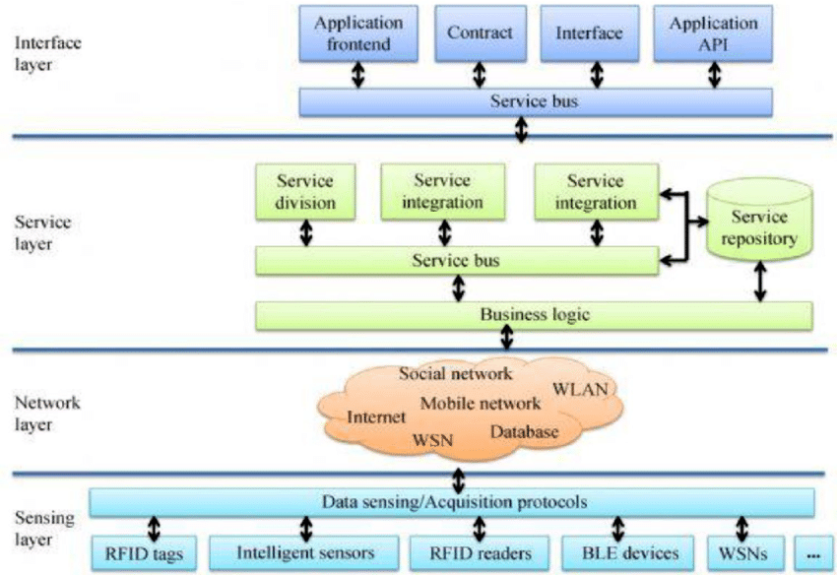

* **Sensing Layer:** This layer consists of physical devices that interact with the environment using sensors and actuators. Sensors collect data like temperature, pressure, or motion, while actuators can perform actions based on instructions received. Examples of sensors include those in smart thermostats or security systems, and actuators include smart light bulbs or valves that automatically adjust water flow.
* **Network Layer:** This layer is responsible for transmitting data between devices and the other layers of the system. It essentially acts as the communication channel. Various network technologies can be used here, including short-range options like Wi-Fi, Bluetooth, and Zigbee, or long-range options like cellular networks and LPWAN (Low-Power Wide-Area Networks).
* **Service Layer:** This layer plays a crucial role in processing and managing data. It consists of independent services that handle specific tasks. Some examples include device management services (registering, configuring, and monitoring devices), data management services (storing, retrieving, and managing sensor data), analytics services (processing data to generate insights), and integration services (connecting the IoT system with other business applications).
* **Interface Layer:** This layer serves as the user interface, providing a way for users to interact with the system. Mobile apps, web dashboards, and physical control panels are all examples of user interfaces within the interface layer. Through the interface layer, users can see data visualizations (presented in charts or graphs), control devices remotely, and receive alerts and notifications.

IOT CHALLENGES

**Security Challenges in IoT:**

1. **Lack of Encryption:**
   * Without encryption, data transmitted between IoT devices and servers is vulnerable to interception and manipulation by malicious actors.
   * Encryption ensures that data is encoded in a way that only authorized parties can access and understand it.
2. **Insufficient Testing and Updating:**
   * Many IoT devices are rushed to market without thorough security testing, leaving them susceptible to known vulnerabilities.
   * Additionally, IoT devices often lack mechanisms for receiving and installing security updates, leaving them permanently vulnerable to exploits.
3. **Brute Forcing and Default Passwords:**
   * Weak or default passwords on IoT devices make them easy targets for brute force attacks, where attackers systematically guess passwords until they gain access.
   * Manufacturers often ship devices with default credentials, which many users neglect to change, leaving their devices wide open to attack.
4. **IoT Malware and Ransomware:**
   * The proliferation of IoT devices has led to an increase in malware and ransomware targeting these devices.
   * Attackers can use malware to compromise IoT devices and use them as part of botnets to launch large-scale attacks or demand ransom payments from device owners.
5. **IoT Botnets Aiming at Cryptocurrency:**
   * IoT botnets can be used to manipulate data privacy, posing significant risks to open cryptocurrency markets.
   * Hackers can exploit vulnerabilities in IoT devices to compromise their security and use them to mine cryptocurrencies or manipulate cryptocurrency markets.
6. **Inadequate Device Security:**
   * Many IoT devices lack basic security features such as secure boot, data encryption, and firmware signing.
   * This lack of security makes it easy for attackers to compromise IoT devices and gain unauthorized access to sensitive data.
7. **Lack of Standardization:**
   * The absence of agreed-upon standards and best practices in IoT device security makes it difficult to ensure consistent security across different devices and manufacturers.
   * This lack of standardization leads to fragmentation and inconsistency in security measures, making it easier for attackers to find and exploit vulnerabilities.
8. **Vulnerability to Network Attacks:**
   * IoT devices are often connected to the internet or local networks, making them vulnerable to network-based attacks such as denial-of-service (DoS) attacks.
   * Attackers can exploit vulnerabilities in network protocols or infrastructure to disrupt service or gain unauthorized access to devices.
9. **Unsecured Data Transmission:**
   * Many IoT devices transmit sensitive data over unencrypted channels, leaving it vulnerable to interception and eavesdropping by attackers.
   * Without proper encryption and data protection measures, sensitive information such as passwords, personal identifiers, and proprietary data can be easily compromised.
10. **Privacy Concerns:**
    * The vast amount of data collected by IoT devices raises significant privacy concerns, as it can include sensitive information about individuals' habits, preferences, and behaviors.
    * Unauthorized access to this data can lead to identity theft, blackmail, or other forms of exploitation, highlighting the importance of robust privacy protections in IoT systems.
11. **Software Vulnerabilities:**
    * Software vulnerabilities in IoT devices can be exploited by attackers to gain unauthorized access, install malware, or steal sensitive information.
    * These vulnerabilities can arise from insecure coding practices, outdated software libraries, or inadequate patch management processes.
12. **Insider Threats:**
    * Insider threats pose a significant security risk to IoT systems, as employees or contractors with access to sensitive information or systems may intentionally or unintentionally compromise security.
    * This could include leaking sensitive data, installing malware, or providing unauthorized access to attackers.

**Design Challenges in IoT:**

1. **Interoperability:**
   * Ensuring that different IoT devices and systems can communicate and work together seamlessly, regardless of manufacturer or protocol.
   * Lack of interoperability can lead to fragmentation and inefficiency in IoT ecosystems, hindering the adoption and scalability of IoT solutions.
2. **Security:**
   * Designing IoT systems with robust security features to protect against cyber threats, data breaches, and unauthorized access.
   * This includes implementing encryption, authentication, access control, and secure communication protocols throughout the IoT ecosystem.
3. **Scalability:**
   * Designing IoT systems to handle increasing numbers of devices, data volume, and user interactions without sacrificing performance or reliability.
   * This requires scalable architectures, distributed computing solutions, and efficient data management strategies to accommodate growth.
4. **Reliability:**
   * Ensuring that IoT systems perform reliably and consistently under various conditions and usage scenarios.
   * This includes designing for fault tolerance, redundancy, and resilience to mitigate the impact of failures or disruptions.
5. **Power Consumption:**
   * Minimizing the power consumption of IoT devices to extend battery life, reduce costs, and minimize environmental impact.
   * This involves optimizing hardware and software designs for energy efficiency, implementing power management techniques, and leveraging low-power technologies.
6. **Privacy:**
   * Incorporating privacy-enhancing features and practices into IoT designs to protect sensitive information and user privacy.
   * This includes data anonymization, user consent mechanisms, and transparent data handling practices to build trust and compliance with privacy regulations.
7. **Cost:**
   * Balancing the cost of designing, developing, and deploying IoT systems with the value they deliver to users and stakeholders.
   * This requires optimizing resource allocation, prioritizing features based on cost-benefit analysis, and adopting cost-effective technologies and solutions.

**Deployment Challenges in IoT:**

1. **Connectivity:**
   * Ensuring reliable and robust connectivity between IoT devices, networks, and cloud platforms to enable seamless data exchange and communication.
   * This involves addressing challenges such as network coverage, bandwidth limitations, signal interference, and latency.
2. **Cross-Platform Capability:**
   * Designing IoT applications and solutions that are compatible with a wide range of devices, operating systems, and platforms.
   * This requires interoperable protocols, standardized data formats, and cross-platform development frameworks to ensure compatibility and flexibility.
3. **Data Collection and Processing:**
   * Establishing efficient and scalable data collection, storage, and processing pipelines to handle large volumes of data generated by IoT devices.
   * This includes implementing data aggregation, filtering, and analysis techniques to extract actionable insights and value from IoT data.
4. **Lack of Skill Set:**
   * Overcoming the shortage of skilled professionals with expertise in IoT technologies, including hardware design, software development, data analytics, and cybersecurity.
   * This requires investing in training and education programs, recruiting experienced talent, and fostering collaboration and knowledge sharing within the IoT community.
5. **Integration:**
   * Integrating IoT devices and systems with existing technology infrastructure, applications, and business processes to maximize interoperability and functionality.
   * This involves addressing compatibility issues, data synchronization challenges, and legacy system integration complexities to ensure seamless operation and value delivery.
6. **Network Infrastructure:**
   * Building and maintaining the network infrastructure needed to support IoT deployments, including connectivity, bandwidth, and network security.
   * This requires robust network planning, deployment, and management practices to ensure reliability, scalability, and security.
7. **Device Management:**
   * Implementing effective device management solutions to provision, monitor, update, and maintain a large number of IoT devices deployed in the field.
   * This involves remote device management capabilities, over-the-air firmware updates, and lifecycle management

6LowPAN 6LoWPAN stands for "IPv6 over Low-Power Wireless Personal Area Networks". It's a networking protocol designed to enable communication between tiny, low-power devices using the Internet Protocol (IPv6) over networks based on the IEEE 802.15.4 standard you just asked about.

Here's a breakdown of 6LoWPAN:

* **Purpose:** Integrates low-power devices into the Internet of Things (IoT) by allowing them to communicate using the widely-used IPv6 protocol.
* **Benefits:**
  + Enables direct connection to the internet for these small devices.
  + Offers features like mesh networking for scalability and reliability.
  + Lowers power consumption by putting devices in sleep mode for extended periods.
  + Provides security through mechanisms like AES-128 encryption.
* **Applications:**
  + Smart home devices ( thermostats, light bulbs, sensors)
  + Industrial sensor networks (monitoring equipment, temperature control)
  + Wearable devices (fitness trackers, smartwatches)
* It combines the latest version of the Internet Protocol (ipv6) and Low power wireless personal area network.(provide many address)
* Therefore 6LowPAN allows for the smallest devices with limited processing ability to transmit information wirelessly using an internet protocol IPV6.
* 6lowpan is low cost, short range , low memory usage ,low bit rate and comprises of edge routers and sensor nodes.
* Using 6LowPan , the smallest of the IOT devices can be the part of the network and can talk to the outside world ( eg .LED strret lights – almost consume 0 power)
* 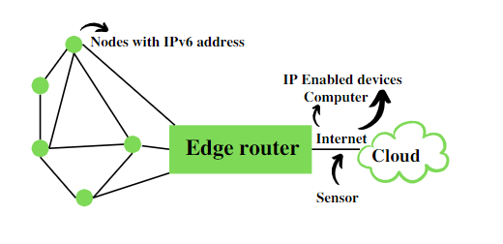
* Edge Router is the core of 6LOwPan network that link 6LowPan network to the other IP internet. It is responsible for routing 6lowPan packet to the IPV6 packet and assigning IPV6 packet and assigning IPV6 prefixes in the 6lowPAn
* It is a technology that makes the individual nodes IP enabled.
* 6LoWPAN  can interact with 802.15.4 devices and also other types of devices on an IP Network. For example, [Wi-Fi.](https://www.geeksforgeeks.org/what-is-wi-fiwireless-fidelity/)
* It uses [AES](https://www.geeksforgeeks.org/advanced-encryption-standard-aes/)128 link layer security, which AES is a block cipher having key size of 128/192/256 bits and encrypts data in blocks of 128 bits each. This is defined in IEEE 802.15.4 and provides link authentication and encryption.
* It uses mesh network- which is reliable

### ****Basic Requirements of 6LoWPAN:****

1. The device should be having sleep mode in order to support the battery saving.
2. Minimal memory requirement.
3. Routing overhead should be lowered.

### ****Features of 6LoWPAN:****

1. It is used with IEEE 802.15,.4 in the 2.4 GHz band.
2. Outdoor range: ~200 m (maximum)
3. Data rate: 200kbps (maximum)
4. Maximum number of nodes: ~100

### ****Advantages of  6LoWPAN:****

1. 6LoWPAN is a mesh network that is robust, scalable, and can heal on its own.
2. It delivers low-cost and secure communication in IoT devices.
3. It uses IPv6 protocol and so it can be directly routed to cloud platforms.
4. It offers one-to-many and many-to-one routing.
5. In the network, leaf nodes can be in sleep mode for a longer duration of time.

### ****Disadvantages of 6LoWPAN:****

1. It is comparatively less secure than Zigbee.
2. It has lesser immunity to interference than that Wi-Fi and Bluetooth.
3. Without the mesh topology, it supports a short range.

### ****Applications of 6LoWPAN:****

1. It is a wireless sensor network.
2. It is used in home-automation,
3. It is used in smart agricultural techniques, and industrial monitoring.
4. It is utilised to make IPv6 packet transmission on networks with constrained power and reliability resources possible.

### ****Security and Interoperability with 6LoWPAN:****

* **Security**: 6LoWPAN security is ensured by the AES algorithm, which is a link layer security, and the transport layer security mechanisms are included as well.
* **Interoperability:**6LoWPAN is able to operate with other wireless devices as well which makes it interoperable in a network.

IEEE 802.15.4—The institute of Electrical and Electronics Engineers(IEEE) supports many working groups to develop and maintains wireless and wired communication standards.

802.3 is wired Ethernet

802.11 is Wireless LAN (WLAN’S/WIFI)

802.15 -group of standard specifies a variety of wireless personal area network( WPAN) for different applications

802.15.1-bluetooth 802.15.3 -high data rate category for ultra wide band(UNB) technologies

802.15.6-Body Area Network 802.15.4- Largest standard for low data rate WPANs

IEEE 802.15.4 is the standard which is the basis for many low power Wireless Connectivity solutions industry -zigBee,6lowPAn and many more.

|  |
| --- |
| APPLICATION LAYER -ZIGBEE,6LOWPAN |
| NETWORK LAYER- ZIGBEE,6LOWPAN |
| MEDIUM ACCESS CONTROL -defined in 802.15.4 |
| PHYSICAL LAYER -defined in 802.15.4 |

It provides a framework and the lower layer(Physical and Mac) in the OSI model for low cost ,low power wireless connectivity networks.

Low Power is one of the key element of 802.15.4 as it is used in many areas where remote sensors nned to operate on battery power , possibly for years with attention

Used for low power, low cost and low speed communication between devices

IEEE 802.15.4 is a widely used standard for low-rate wireless personal area networks (LR-WPANs). It defines the lower layers of communication, specifically the physical layer and the media access control (MAC) layer, for these networks. LR-WPANs are designed for low-power operation and typically have a range of up to 10 meters. They are ideal for applications that require communication between devices in close proximity, such as home automation systems, industrial sensor networks, and wearable devices.

Here are some of the key features of IEEE 802.15.4:

* **Low-power consumption:** This is one of the most important features of IEEE 802.15.4. Devices that use this standard can operate on batteries for extended periods of time.
* **Low data rate:** LR-WPANs are not designed for high-speed data transfer. The maximum data rate defined by IEEE 802.15.4 is 250 kbps.
* **Low cost:** IEEE 802.15.4 is a relatively simple standard to implement, which makes it a cost-effective solution for many applications.
* **Mesh networking:** IEEE 802.15.4 supports mesh networking, which allows devices to relay data for other devices that are not within direct range of a coordinator. This can extend the range of a network and improve its reliability.(peer to peer topology) /also uses star topology.

IEEE 802.15.4 itself does not define the upper layers of the network protocol stack. Instead, it provides a foundation upon which other standards, such as Zigbee and Thread, can be built. These higher-level standards define the network layer, transport layer, and application layer protocols that are used by devices to communicate with each other

Physical layer defines frequency band ,transmission power and modulation scheme of the link

MAC defines issues such as medium access and flow control(various protocol- ALOHa etc)

IEEE 802.15.4 utilizes direct sequence spread spectrum (dsss) coding scheme to transit information , dsss uses phase shift keying modulation to encode information. DSSS makes the standard highly tolerant to network and interference , there by improving link reliability.

The preferred nature of transmission is LOS (line of sight) ,The standard range of transmission -10 to 75 m. The transmission of data uses CSMA-CA( Carrier sense multiple access protocol with collision avoidance) scheme.

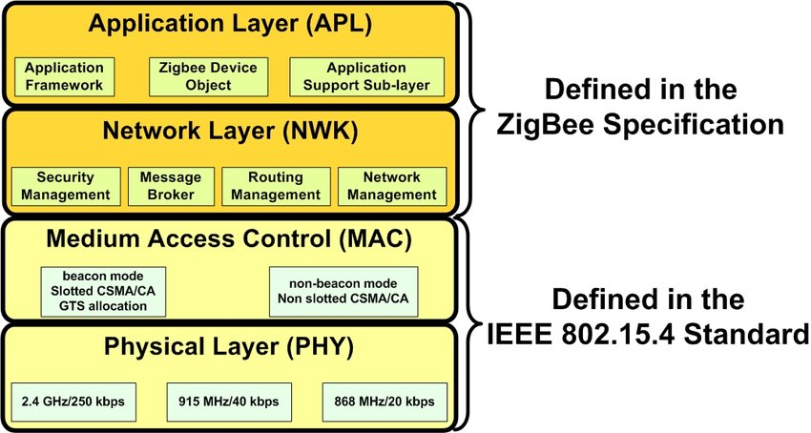

ZIGBEE AND ITS TYPES

It is created by the ZigBee Alliance . It is a wireless technology developed as an open global standard to address the unique needs of low cost , low power wireless IOT network (such as for home automation , medical device , data collection etc)

It is based on IEEE 802.15.4 standard that defines the physical and medium access control layer for Zigbee.

It is simple and less expensive than other Wirless Personal Area Network (WPAN) such as Bluetooth or Wifi. Operates in unlicensed bands including -2.4 Ghz, 915Mhz and 868 Mhz.

Zigbee has shorter range of about 10-20 m indoors because it uses less power and this increases battery life of Zigbee device

It is used in low data rate applications that requires long battery life and secure networking.

Zigbee is a wireless communication technology based on the IEEE 802.15.4 standard you previously asked about. It defines a set of high-level protocols that build on top of the physical and MAC layers provided by 802.15.4. Here's what Zigbee is all about:

* **Focus:** Low-power, low-data rate wireless networking for battery-powered devices.
* **Applications:**
  + Home automation (lighting control, thermostats, sensors)
  + Building automation (HVAC systems, security)
  + Industrial automation (sensor networks, asset tracking)
  + Medical device data collection
* **Key Features:**
  + **Mesh Networking:** Zigbee networks can operate in a mesh topology, where devices can relay messages for each other, extending the overall range and improving reliability.
  + **Low Power Consumption:** Zigbee devices are designed to be very energy efficient, allowing them to operate on batteries for months or even years.
  + **Security:** Zigbee offers built-in security features to protect data communication.
  + **Standardization:** Backed by the Connectivity Standards Alliance (CSA), ensuring interoperability between devices from different manufacturers.

Here's a comparison between Zigbee and 802.15.4:

* IEEE 802.15.4 defines the basic building blocks for communication, like radio and data access.
* Zigbee builds upon 802.15.4, adding higher-level protocols for networking, security, and application functionality.

Think of 802.15.4 as the foundation and Zigbee as a complete house built on that foundation.

Zigbee devices come in three main types, each playing a specific role in the network:

1. **Zigbee Coordinator (ZC):**
   * **Function:** The central hub of a Zigbee network.
   * **Responsibilities:**
     + Creates and manages the network.
     + Assigns unique identifiers to devices.
     + Controls how devices join the network.
     + Routes data between devices if they are not in direct range.
     + Acts as a bridge to other networks (optional).
   * **Power:** Typically mains-powered for continuous operation.
   * **Quantity:** There can only be one coordinator per Zigbee network.
2. **Zigbee Router (ZR):**
   * **Function:** Extends the network's reach by relaying data between devices.
   * **Responsibilities:**
     + Receives and forwards data packets for other devices.
     + Can also perform specific application functions depending on the model (e.g., temperature sensor with routing capabilities).
   * **Power:** Can be mains-powered for extended range or battery-powered for more flexible placement.
   * **Quantity:** Multiple routers can exist in a network to improve overall coverage and redundancy.
3. **Zigbee End Device (ZED):**
   * **Function:** The most basic and energy-efficient devices in the network.
   * **Responsibilities:**
     + Collect data or perform simple actions based on commands received.
     + Communicate directly with a coordinator or router to send/receive data.
   * **Examples:** Sensors (temperature, motion, etc.), switches, light bulbs, buttons.
   * **Power:** Typically battery-powered for low power consumption.
   * **Quantity:** Zigbee networks can have a large number of end devices due to their low power requirements.

**Why another short-range communication standard??**

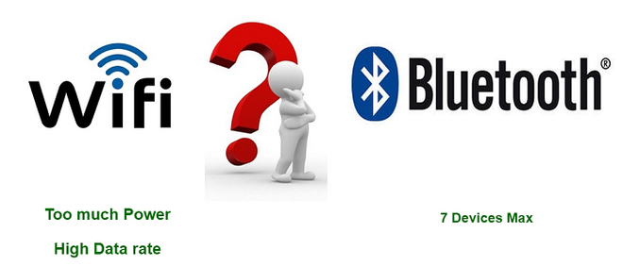

**Types of ZigBee Devices:**

* **Zigbee Coordinator Device:** It communicates with routers. This device is used for connecting the devices.
* **Zigbee Router:** It is used for passing the data between devices.
* **Zigbee End Device:** It is the device that is going to be controlled.

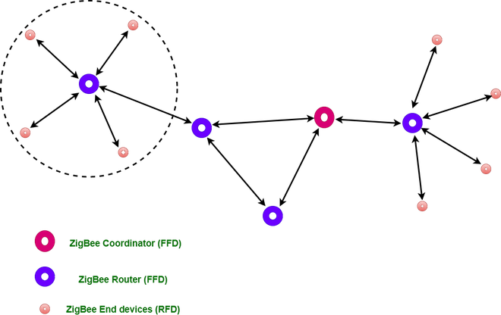

**General Characteristics of Zigbee Standard:**

* Low Power Consumption
* Low Data Rate (20- 250 kbps)
* Short-Range (75-100 meters)
* Network Join Time (~ 30 msec)
* Support Small and Large Networks (up to 65000 devices (Theory); 240 devices (Practically))
* Low Cost of Products and Cheap Implementation (Open Source Protocol)
* Extremely low-duty cycle.
* 3 frequency bands with 27 channels.

**Operating Frequency Bands** (Only one channel will be selected for use in a network):

1. **Channel 0**: 868 MHz (Europe)
2. **Channel 1-10**: 915 MHz (the US and Australia)
3. **Channel 11-26**: 2.4 GHz (Across the World)

**Features of Zigbee:**

**1. Stochastic addressing:** A device is assigned a random address and announced. Mechanism for address conflict resolution. Parents node don’t need to maintain assigned address table.

**2. Link Management:**Each node maintains quality of links to neighbors. Link quality is used as link cost in routing.

**3. Frequency Agility:**Nodes experience interference report to channel manager, which then selects another channel

**4. Asymmetric Link:**Each node has different transmit power and sensitivity. Paths may be asymmetric.

**5. Power Management:** Routers and Coordinators use main power. End Devices use batteries.

**Advantages of Zigbee:**

1. Designed for low power consumption.
2. Provides network security and application support services operating on the top of IEEE.
3. Zigbee makes possible completely networks homes where all devices are able to communicate and be
4. Use in smart home
5. Easy implementation
6. Adequate security features.
7. **Low cost**: Zigbee chips and modules are relatively inexpensive, which makes it a cost-effective solution for IoT applications.
8. **Mesh networking:** Zigbee uses a mesh network topology, which allows for devices to communicate with each other without the need for a central hub or router. This makes it ideal for use in smart home applications where devices need to communicate with each other and with a central control hub.
9. **Reliability:** Zigbee protocol is designed to be highly reliable, with robust mechanisms in place to ensure that data is delivered reliably even in adverse conditions.

**Disadvantages of Zigbee :**

1. **Limited range:** Zigbee has a relatively short range compared to other wireless communications protocols, which can make it less suitable for certain types of applications or for use in large buildings.
2. **Limited data rate:** Zigbee is designed for low-data-rate applications, which can make it less suitable for applications that require high-speed data transfer.
3. **Interoperability:** Zigbee is not as widely adopted as other IoT protocols, which can make it difficult to find devices that are compatible with each other.
4. **Security:** Zigbee’s security features are not as robust as other IoT protocols, making it more vulnerable to hacking and other security threats.

**Zigbee Network Topologies:**

* **Star Topology** (ZigBee Smart Energy): Consists of a coordinator and several end devices, end devices communicate only with the coordinator.
* **Mesh Topology** (Self Healing Process): Mesh topology consists of one coordinator, several routers, and end devices.
* **Tree Topology**: In this topology, the network consists of a central node which is a coordinator, several routers, and end devices. the function of the router is to extend the network coverage.

**Architecture of Zigbee:**

Zigbee architecture is a combination of 6 layers.

1. Application Layer
2. Application Interface Layer
3. Security Layer
4. Network Layer
5. Medium Access Control Layer
6. Physical Layer

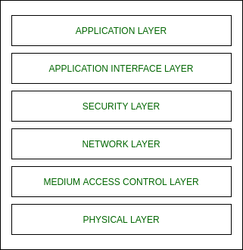

* **Physical layer:**The lowest two layers i.e the physical and the MAC (Medium Access Control) Layer are defined by the IEEE 802.15.4 specifications. The Physical layer is closest to the hardware and directly controls and communicates with the Zigbee radio. The physical layer translates the data packets in the over-the-air bits for transmission and vice-versa during the reception.
* **Medium Access Control layer (MAC layer):**The layer is responsible for the interface between the physical and network layer. The MAC layer is also responsible for providing PAN ID and also network discovery through beacon requests.
* **Network layer:**This layer acts as an interface between the MAC layer and the application layer. It is responsible for mesh networking.
* **Application layer:**The application layer in the Zigbee stack is the highest protocol layer and it consists of the application support sub-layer and Zigbee device object. It contains manufacturer-defined applications.

**Channel Access:**

1. **Contention Based Method** (Carrier-Sense Multiple Access With Collision Avoidance Mechanism)
2. **Contention Free Method** (Coordinator dedicates a specific time slot to each device (Guaranteed Time Slot (GTS)))

|  |  |  |
| --- | --- | --- |
| Category | 6LoWPAN | Zigbee |
| Purpose | Integrate low-power devices into the IoT using IPv6 | Creates a dedicated low-power network |
| Connectivity | Direct connection to the internet | Operates in a closed network (internet via gateway) |
| Network Structure | Supports star and mesh networking | Primarily uses mesh networking |
| Security | Leverages IPv6 security mechanisms | Built-in security features for Zigbee protocol |
| Applications | Ideal for applications requiring internet connectivity (smart home, sensor networks, wearables) | Suited for closed network applications (home automation, building automation, some industrial sensor networks) |
| Maturity | Relatively newer technology with a growing device base | More mature technology with a wider range of devices |
| Complexity | May require more complex configuration | Simpler setup and configuration |

RFID FEATURES RFID WORKING PRINCIPLE AND APPLICATIONS

**Radio Frequency Identification (RFID)** is a form of wireless communication that incorporates the use of electromagnetic or electrostatic coupling in the radio frequency portion of the electromagnetic spectrum to uniquely identify an object, animal or person. It uses radio frequency to search ,identify, track and communicate with items and people. it is a method that is used to track or identify an object by radio transmission uses over the web. Data digitally encoded in an RFID tag which might be read by the reader. This device work as a tag or label during which data read from tags that are stored in the database through the reader as compared to traditional barcodes and QR codes. It is often read outside the road of sight either passive or active RFID.

* **Unique Identification:** Each RFID tag has a unique identifier, enabling precise tracking of individual items. Unlike barcodes, which can be replicated, RFID tags provide a more secure and reliable way to identify objects.
* **Automatic and Contactless Reading:** RFID tags can be read automatically by RFID readers without requiring physical contact. This makes them ideal for applications where scanning large numbers of items quickly and efficiently is necessary, such as supply chain management for tracking inventory movement within warehouses.
* **Long Read Range:** RFID tags can be read from a distance, depending on the type of tag and reader being used. This eliminates the need for specific item positioning for scanning, saving time.
* **Durability:** RFID tags are made from durable materials that can withstand harsh environments, resistant to dirt, dust, moisture, and extreme temperatures. This makes them suitable for various applications, including asset tracking in manufacturing plants and access control in secure areas.
* **Read/Write Capability:** Some RFID tags can be written to, not just read. This allows for storing additional information on the tag, such as product details, location data, or sensor readings. This data can then be used for more effective item tracking and task automation.
* **Penetration Through Materials:** RFID signals can penetrate some materials, such as cardboard and plastic. This allows tags to be read even if they are not directly visible to the reader, beneficial for applications like tracking library books or pharmaceutical products.

pen_spark

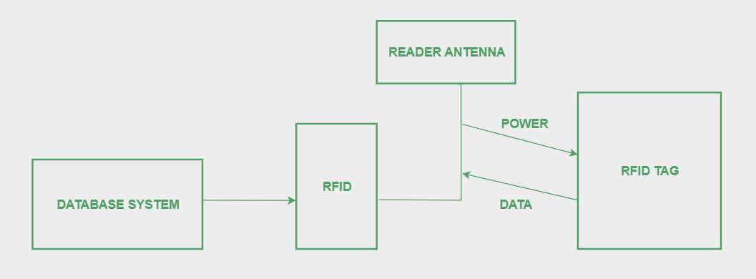

Radio Fequency Identification – RFID is a form of wireless communication that uses radio waves to identify and track objects (like books, vehicles , money etc) . RFID uses electromagnetic fields to automatically identify and track tags attached to objects. RFID can also be used to track animals and birds by implementing RFID tags into them.

RFID tags contain electronically stored information.

**Kinds of RFID :**  
There are many kinds of RFID, each with different properties, but perhaps the most fascinating aspect of RFID technology is that most RFID tags have neither an electric plug nor a battery. Instead, all of the energy needed to operate them is supplied in the form of radio waves by RFID readers. This technology is called passive RFID to distinguish it from the(less common) active RFID in which there is a power source on the tag.

**UHF RHID ( Ultra-High Frequency RFID )**. It is used on shipping pallets and some driver’s licenses. Readers send signals in the 902-928 MHz band. Tags communicate at distances of several meters by changing the way they reflect the reader signals; the reader is able to pick up these reflections. This way of operating is called backscatterute

**HF RFID (High-Frequency RFID ).** It operates at 13.56 MHz and is likely to be in your passport, credit cards, books, and noncontact payment systems. HF RFID has a short-range, typically a meter or less because the physical mechanism is based on induction rather than backscatter.

There are also other forms of RFID using other frequencies, such as LF RFID(Low-Frequency RFID), which was developed before HF RFID and used for animal tracking  
  
**There are two types of RFID :**

1. **Passive RFID –**   
   Passive RFID tags does not have their own power source. It uses power from the reader. In this device, RF tags are not attached by a power supply and passive RF tag stored their power. When it is emitted from active antennas and the RF tag are used specific frequency like 125-134KHZ as low frequency, 13.56MHZ as a high frequency and 856MHZ to 960MHZ as ultra-high frequency.
2. **Active RFID –**   
   In this device, RF tags are attached by a power supply that emits a signal and there is an antenna which receives the data. means, active tag uses a power source like battery. It has it’s own power source, does not require power from source/reader.

**Working Principle of RFID :**   
Generally, RFID uses radio waves to perform AIDC function. AIDC stands for Automatic Identification and Data Capture technology which performs object identification and collection and mapping of the data.   
  
An antenna is an device which converts power into radio waves which are used for communication between reader and tag. RFID readers retrieve the information from RFID tag which detects the tag and reads or writes the data into the tag. It may include one processor, package, storage and transmitter and receiver unit. 

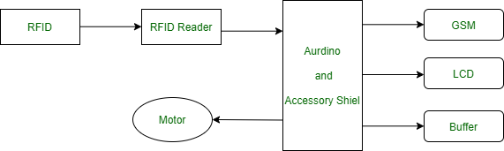

**Working of RFID System :**

Every RFID system consists of three components: a scanning antenna, a transceiver and a transponder. When the scanning antenna and transceiver are combined, they are referred to as an RFID reader or interrogator. There are two types of RFID readers — fixed readers and mobile readers. The RFID reader is a network-connected device that can be portable or permanently attached. It uses radio waves to transmit signals that activate the tag. Once activated, the tag sends a wave back to the antenna, where it is translated into data.

The transponder is in the RFID tag itself. The read range for RFID tags varies based on factors including the type of tag, type of reader, RFID frequency and interference in the surrounding environment or from other RFID tags and readers. Tags that have a stronger power source also have a longer read range.  
  
**Features of RFID :**

* An RFID tag consists of two-part which is an microcircuit and an antenna.
* This tag is covered by protective material which acts as a shield against the outer environment effect.
* This tag may active or passive in which we mainly and widely used passive RFID.

RFID (Radio Frequency Identification) works through a wireless communication system using radio waves to identify objects. Here's a breakdown of the working principle:

An RFID system operates using **three core components** working together:

1. **RFID Tags:** These are small electronic devices attached to the objects you want to identify. They typically consist of two parts:
   * **Microchip:** This tiny chip stores the unique identifier of the tag and potentially additional data like product details or sensor readings.
   * **Antenna:** This component transmits and receives radio waves to communicate with the RFID reader.

There are two main types of RFID tags based on power source: * **Passive Tags:** They rely on the radio waves from the reader to power their microchip and transmit data. These tags are smaller, cheaper, and have a shorter read range. * **Active Tags:** They contain an internal battery that powers the microchip, enabling them to transmit data over a longer range and offer more functionality, but they are also more expensive.

1. **RFID Reader:** This device acts like a transceiver. It emits radio waves at a specific frequency to activate RFID tags within its range. The reader then captures the signals sent back by the tags' antenna. There are two main types of readers:
   * **Stationary Readers:** These are typically fixed at doorways, checkpoints, or along conveyor belts for automated reading of tags as objects pass by.
   * **Handheld Readers:** These portable devices allow for manual scanning of tags on individual items.
2. **Software:** This is the brains of the operation. The software application processes the data received from the RFID tags by the reader. It can be used for various purposes depending on the application, such as:
   * **Tracking items:** The software can track the movement of objects tagged with RFID throughout a supply chain or within a facility.
   * **Managing inventory:** Real-time information on tagged items allows for better inventory control, stock level monitoring, and automated reordering.
   * **Controlling access:** The software can be integrated with access control systems to grant or deny access based on the information encoded in the RFID tag, such as employee badges or security tags.
   * . 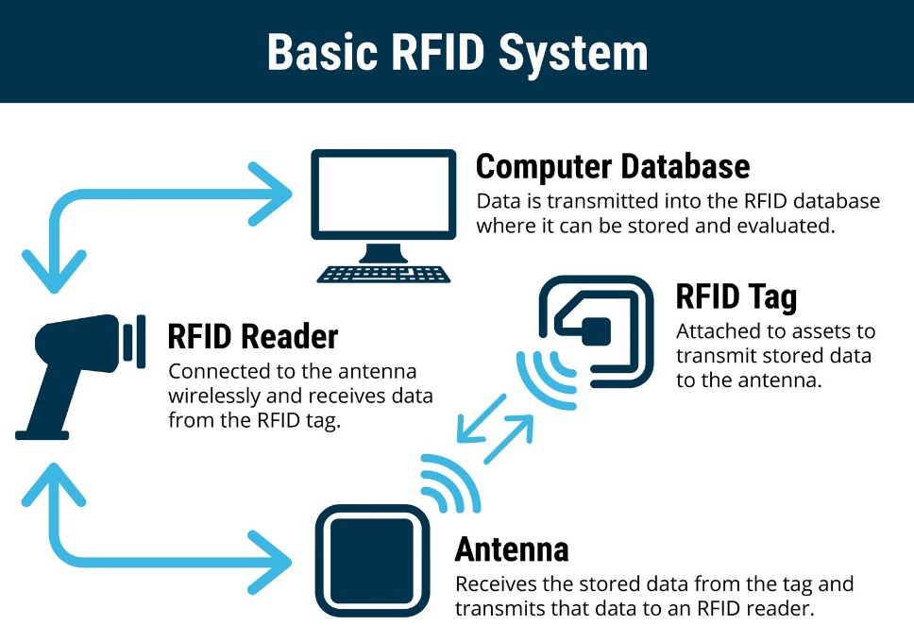
3. **Communication Process:**
   * The reader transmits radio waves at a specific frequency.
   * When an RFID tag within the reader's range detects the radio waves, its microchip is activated using the energy from the signal.
   * The activated tag transmits its data back to the reader using radio waves.
   * The reader receives the data from the tag and decodes it.
   * The software then processes the decoded data and performs actions based on the information received.
4. **Powering the Tag:**
   * There are two main types of RFID tags based on how they are powered:
     + **Passive Tags:** These tags rely on the radio waves from the reader to power their microchip and transmit data. They have a shorter read range but are smaller and cheaper.
     + **Active Tags:** These tags have an internal battery that powers their microchip and can transmit data over a longer range. They are more expensive but offer greater functionality.

**Advantages of RFID :**

* It provides data access and real-time information without taking to much time.
* RFID tags follow the instruction and store a large amount of information.
* The RFID system is non-line of sight nature of the technology.
* It improves the Efficiency, traceability of production.
* In RFID hundred of tags read in a short time.

**Disadvantages of RFID :**

* It takes longer to program RFID Devices.
* RFID intercepted easily even it is Encrypted.
* In an RFID system, there are two or three layers of ordinary household foil to dam the radio wave.
* There is privacy concern about RFID devices anybody can access information about anything.
* Active RFID can costlier due to battery.

RFID technology finds applications across various industries due to its unique features. Here are some prominent examples:

* **Supply Chain Management:** RFID tags are used to track inventory movement throughout the supply chain, improving efficiency and visibility. This allows for better control over stock levels, reduced shrinkage, and faster product delivery.
* **Retail:** In retail stores, RFID tags can be attached to clothing items to streamline checkout processes, prevent shoplifting, and enable real-time inventory tracking. Customers can also use RFID-enabled devices for self-checkout or personalized shopping experiences.
* **Asset Tracking:** Companies can use RFID tags to track valuable assets like equipment, tools, and machinery. This helps to locate assets quickly, prevent loss or theft, and schedule maintenance efficiently.
* **Access Control:** RFID tags can be integrated into security systems for access control in buildings, restricted areas, or events. Employees or authorized personnel can use RFID badges for secure entry, enhancing security and streamlining access management.
* **Library Management:** Libraries often use RFID tags on books and other materials to automate borrowing and returning processes. This reduces manual work for librarians and improves patron experience.
* **Payment Systems:** Contactless payment systems like credit cards and transit passes often utilize RFID technology for secure and convenient transactions.
* **Animal Tracking:** RFID tags are used to track livestock, pets, and wildlife for monitoring their movement, health, and safety.
* **Healthcare:** Hospitals can use RFID tags to track medications, patient records, and medical equipment, improving patient care and reducing errors.
* **Counterfeit Detection:** RFID tags with unique identifiers and embedded security features can be used to verify the authenticity of products, helping to combat counterfeiting in industries like pharmaceuticals, luxury goods, and electronics.
* **Smart Packaging:** RFID tags integrated into packaging can provide real-time data on product temperature, location, and tampering during transportation. This can improve food safety, ensure proper storage conditions for sensitive items, and optimize logistics.
* **Waste Management:** RFID tags on waste containers can streamline collection routes, optimize waste disposal processes, and even track the type and amount of waste generated.
* **Perishable Goods Tracking:** RFID tags can be used to monitor the temperature and freshness of perishable goods throughout the supply chain. This helps to ensure food safety and reduce spoilage.
* **Event Management:** RFID wristbands with embedded chips can be used for contactless access control, cashless payments, and attendee tracking at events.
* **Augmented Reality:** RFID tags can be integrated with augmented reality applications to provide additional information about products or objects when scanned with a smartphone.
* **Internet of Things (IoT):** RFID plays a crucial role in IoT by enabling seamless communication and data exchange between physical objects and digital systems. This opens doors for innovative applications in areas like smart homes, connected factories, and automated inventory management.

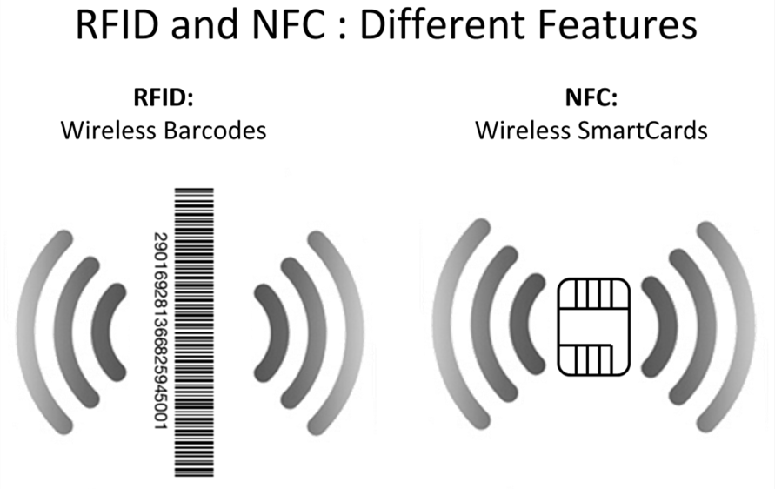

NFC (NEAR FIELD COMMUNICATIONS)

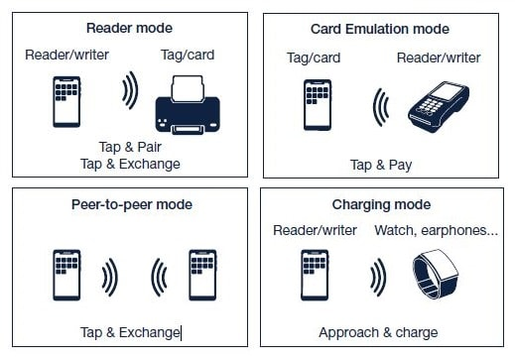

After 20 years of RFID, NXP, sony and Nokia introduced NFC to add contactless data transfer to low power mobile devices.

Today NFC is standard hardware on all major smartphones making technology easily accessible. NFC is the number one technology driving the adoption of the IOT.

**NFC Explained in Detail**

Near Field Communication (NFC) is essentially a short-distance wireless connection method allowing devices to interact by touching or bringing them very close (usually within 4 centimeters). It offers a low-speed data transfer but excels in convenience and security for various applications.

**How NFC Works**

NFC relies on inductive coupling, where two coils (one in each device) generate a magnetic field when close together. This field transmits data and even powers passive NFC tags that lack their own battery.

There are three main modes of operation for NFC-enabled devices:

1. **Reader/Writer Mode:** The device can read data from and write data to passive NFC tags, often used for product information, smart posters, or even business cards with embedded chips.
2. **Peer-to-Peer (P2P) Mode:** Two NFC-enabled devices can exchange data directly, perfect for sharing contact information, photos, or small files.
3. **Card Emulation Mode:** The device itself acts like an NFC card, such as emulating your credit card for contactless payments using services like Apple Pay or Google Pay.

**Benefits and Uses of NFC**

* **Convenience:** NFC eliminates the need for physical contact or complex pairing processes, making interactions quicker and easier.
* **Security:** Data transmission is encrypted, offering a secure way to share information or make transactions.
* **Versatility:** NFC has numerous applications beyond payments, including:
  + Access control for buildings, transportation systems, or events
  + Data exchange for sharing contact details, website links, or business cards
  + Pairing devices like Bluetooth headsets or speakers
  + Product information retrieval with smart tags on items
  + Mobile marketing with interactive experiences triggered by NFC tags

**Real-World Examples of NFC**

* Using your phone for contactless payments at stores.
* Tapping your phone to enter a gym or office building.
* Scanning an NFC tag at a bus stop to get real-time arrival information.
* Bumping phones with a friend to share your social media profile.

Overall, NFC is a powerful and secure technology transforming how devices interact, offering a glimpse into a future of seamless data exchange and convenient contactless experiences.

RFID and NFC, while both using radio waves for contactless communication, have some key differences:

**Core Function:**

* **RFID (Radio Frequency Identification):** Primarily for automatic identification and tracking of objects. Works like a barcode, but with radio waves.
* **NFC (Near Field Communication):** Enables two-way communication and data exchange between devices. Think of it as a contactless tap-and-share or tap-to-pay method.

**Range:**

* **RFID:** Reading range varies depending on the type of tag (passive, active) and frequency used. It can range from a few centimeters to hundreds of meters.
* **NFC:** Short-range communication, typically requiring devices to be within a few centimeters of each other.

**Communication:**

* **RFID:** Usually one-way communication, with the reader fetching data from the tag.
* **NFC:** Enables two-way communication, allowing data exchange between devices.

**Data Storage:**

* **RFID:** Tags typically store smaller amounts of data, like identification codes or product information.
* **NFC:** Can store more complex data compared to RFID tags, including contact information, URLs, or even small files.

**Applications:**

* **RFID:** Inventory management, supply chain tracking, access control for vehicles, toll booths, asset tracking.
* **NFC:** Contactless payments (Apple Pay, Google Pay), data exchange (contacts, photos), pairing devices (Bluetooth), access control (buildings, events), mobile marketing (triggered by NFC tags).

**Analogy:**

Imagine RFID as a librarian scanning barcodes on books to track them. NFC is like two friends tapping phones to share contact info.

**In Short:**

* RFID: Reads data from tags for identification and tracking.
* NFC: Enables two-way communication and data exchange between devices in close proximity.

BLUETOOTH

# What is Bluetooth?

Bluetooth is used for short-range wireless voice and data communication. It is a Wireless Personal Area Network (WPAN) technology and is used for data communications over smaller distances. This generation changed into being invented via Ericson in 1994. It operates within the unlicensed, business, scientific, and clinical (ISM) bands from 2.4 GHz to 2.485 GHz. Bluetooth stages up to 10 meters. Depending upon the version, it presents information up to at least 1 Mbps or 3 Mbps. The spreading method that it uses is FHSS (Frequency-hopping unfold spectrum). A Bluetooth network is called a piconet and a group of interconnected piconets is called a scatternet.

## What is Bluetooth?

Bluetooth simply follows the principle of transmitting and receiving data using [radio waves](https://www.geeksforgeeks.org/radio-waves/). It can be paired with the other device which has also Bluetooth but it should be within the estimated communication range to connect. When two devices start to share data, they form a network called piconet which can further accommodate more than five devices.

## **Key Features of Bluetooth**

* The transmission capacity of Bluetooth is 720 kbps.
* Bluetooth is a wireless device.
* Bluetooth is a Low-cost and short-distance radio communications standard.
* Bluetooth is robust and flexible.
* The basic architecture unit of Bluetooth is a piconet.

## Architecture of Bluetooth

The architecture of Bluetooth defines two types of networks:

**Piconet:** Piconet is a type of Bluetooth network that containsone primary node called the master node and seven active secondary nodes called slave nodes. Thus, we can say that there is a total of 8 active nodes which are present at a distance of 10 meters. The communication between the primary and secondary nodes can be one-to-one or one-to-many. Possible communication is only between the master and slave; Slave-slave communication is not possible. It also has 255 parked nodes, these are secondary nodes and cannot take participation in communication unless it gets converted to the active state.

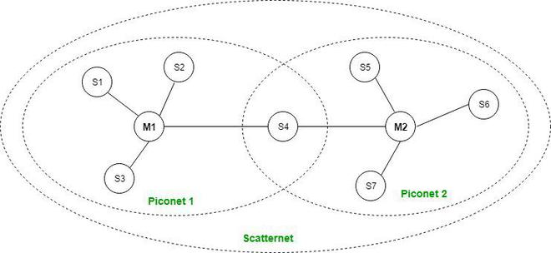

*Bluetooth Architecture*

**Scatternet:**It is formed by using various piconets. A slave that is present in one piconet can act as master or we can say primary in another piconet. This kind of node can receive a message from a master in one piconet and deliver the message to its slave in the other piconet where it is acting as a master. This type of node is referred to as a bridge node. A station cannot be mastered in two piconets.

aBluetooth Protocol Stack

1. **Radio (RF) layer:** It specifies the details of the air interface, including frequency, the use of frequency hopping and transmit power. It performs modulation/demodulation of the data into [RF signals](https://www.geeksforgeeks.org/introduction-of-radio-frequency-identification-rfid/). It defines the physical characteristics of Bluetooth transceivers. It defines two types of physical links: connection-less and connection-oriented.
2. **Baseband Link layer:** The baseband is the digital engine of a Bluetooth system and is equivalent to the [MAC](https://www.geeksforgeeks.org/mac-address-in-computer-network/) sublayer in LANs.  It performs the connection establishment within a piconet, addressing, packet format, timing and power control.
3. **Link Manager protocol layer:** It performs the management of the already established links which includes authentication and encryption processes. It is responsible for creating the links, monitoring their health, and terminating them gracefully upon command or failure.
4. **Logical Link Control and Adaption (L2CAP) Protocol layer:** It is also known as the heart of the Bluetooth protocol stack. It allows the communication between upper and lower layers of the Bluetooth protocol stack. It packages the data packets received from upper layers into the form expected by lower layers. It also performs segmentation and [multiplexing](https://www.geeksforgeeks.org/multiplexing-channel-sharing-in-computer-network/).
5. **Service Discovery Protocol (SDP) layer:** It is short for Service Discovery Protocol. It allows discovering the services available on another Bluetooth-enabled device.
6. **RF comm layer:** It is a cabal replacement protocol. It is short for Radio Frontend Component. It provides a serial interface with [WAP](https://www.geeksforgeeks.org/wireless-application-protocol/)and OBEX. It also provides emulation of serial ports over the logical link control and adaption protocol(L2CAP). The protocol is based on the ETSI standard TS 07.10.
7. **OBEX:** It is short for Object Exchange. It is a communication protocol to exchange objects between 2 devices.
8. **WAP:** It is short for Wireless Access Protocol. It is used for internet access.
9. **TCS:** It is short for [Telephony Control Protocol](https://www.geeksforgeeks.org/internet-telephony-protocol-h-323/). It provides telephony service. The basic function of this layer is call control (setup & release) and group management for the gateway serving multiple devices.
10. **Application layer:** It enables the user to interact with the application.

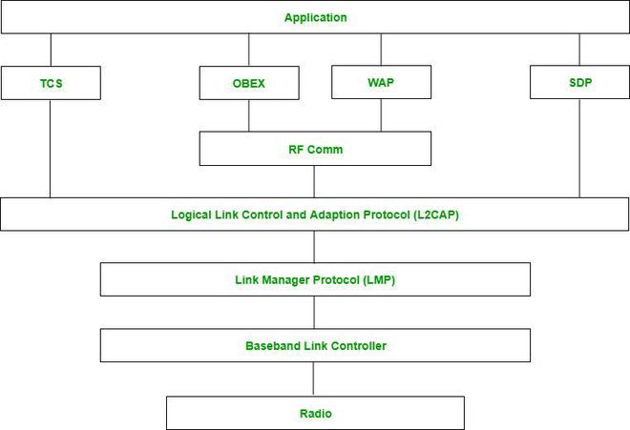

*Bluetooth Protocol Stack*

## Types of Bluetooth

Various types of Bluetooth are available in the market nowadays. Let us look at them.

* **In-Car Headset:**One can make calls from the car speaker system without the use of mobile phones.
* **Stereo Headset:** To listen to music in car or in music players at home.
* **Webcam:** One can link the camera with the help of Bluetooth with their laptop or phone.
* **Bluetooth-equipped Printer:** The printer can be used when connected via Bluetooth with mobile phone or laptop.
* **Bluetooth Global Positioning System (GPS):** To use [Global Positioning System (GPS)](https://www.geeksforgeeks.org/gps-full-form/) in cars, one can connect their phone with car system via Bluetooth to fetch the directions of the address.

## Advantages of Bluetooth

* It is a low-cost and easy-to-use device.
* It can also penetrate through walls.
* It creates an [Ad-hoc connection](https://www.geeksforgeeks.org/applications-of-ad-hoc-network-and-its-problems/) immediately without any wires.
* It is used for voice and data transfer.

## Disadvantages of Bluetooth

* It can be hacked and hence, less secure.
* It has a slow data transfer rate of 3 Mbps.
* Bluetooth communication does not support [routing](https://www.geeksforgeeks.org/types-of-routing/).

## Applications of Bluetooth

* It can be used in wireless headsets, wireless [PANs, and LANs.](https://www.geeksforgeeks.org/types-of-area-networks-lan-man-and-wan/)
* It can connect a digital camera wireless to a mobile phone.
* It can transfer data in terms of videos, songs, photographs, or files from one cell phone to another cell phone or computer.
* It is used in the sectors of Medical healthcare, sports and fitness, Military.

WIRELESS SENSORS AND ITS APPLICATIONS

A Wireless Sensor Network (WSN) is a network of miniature sensor nodes deployed to cooperatively monitor physical or environmental conditions. Imagine a team of tiny spies working together to gather and transmit data wirelessly. Here's a deeper dive with a diagram:

**Components of a WSN:**

1. **Sensor Nodes:** These are the heart of the network, equipped with:
   * Sensors: To detect and measure environmental parameters like temperature, pressure, humidity, light, or even movement.
   * Microcontroller: For basic processing of the sensor data.
   * Radio Transceiver: For wireless communication with other nodes or the base station.
   * Power Source: Usually a battery, but some nodes may harvest energy from the environment (solar, vibration).
2. **Base Station/Sink:** Acts as the central hub, responsible for:
   * Collecting data from sensor nodes.
   * Performing initial data processing and aggregation (optional).
   * Relaying data to a computer system for further analysis, storage, or visualization.
   * Potentially sending instructions to sensor nodes.

**WSN Communication (refer to the diagram):**

1. **Data Collection:** Sensor nodes collect data from their surroundings using their built-in sensors.
2. **Data Transmission:**
   * Depending on the network design:
     + Nodes may transmit data directly to the base station if within range.
     + More commonly, nodes transmit data to nearby nodes in a multi-hop fashion. Each node acts as a relay, passing the data on until it reaches the base station.

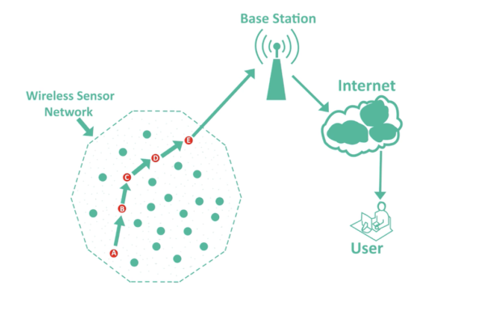

**Advantages of WSNs:**

* **Scalability:** Easy to add or remove sensor nodes to adapt to the monitoring area.
* **Cost-effective:** Relatively inexpensive sensor nodes make WSNs a viable option for large-scale monitoring.
* **Remote Monitoring:** Deployment in hard-to-reach locations where traditional monitoring is difficult.
* **Real-time Data:** Continuous data collection enables real-time monitoring and analysis.

**Disadvantages of WSNs:**

* **Limited Power:** Sensor node batteries limit operational lifespan. Energy-efficient protocols and harvesting techniques are crucial.
* **Security Concerns:** WSNs can be vulnerable to hacking if not properly secured with encryption and authentication mechanisms.
* **Data Overload:** Managing and processing large amounts of data can be challenging, especially with a high number of nodes and frequent data collection.

WSNs are a rapidly evolving technology with the potential to revolutionize various fields. As sensor technology improves, data processing becomes more efficient, and security measures advance, WSNs are poised to play an even greater role in shaping the future of interconnected monitoring and data collection.

Wireless sensor networks (WSNs) have a vast range of applications due to their versatility and ability to function in harsh or remote environments. Here are some key areas where WSNs are transforming various industries:

**Environmental Monitoring:**

* **Air and Water Quality:** Sensor nodes can track pollutants, toxins, and other parameters to ensure clean air and water.
* **Weather Monitoring:** Real-time data collection on temperature, humidity, pressure, and wind speed helps predict weather patterns and manage natural disasters.
* **Forest Fire Detection:** Early detection of wildfires is crucial, and WSNs can monitor for smoke, temperature spikes, and dryness levels to trigger alerts.

**Precision Agriculture:**

* **Irrigation Optimization:** Sensor nodes monitor soil moisture levels, allowing for targeted irrigation and water conservation.
* **Soil Condition Monitoring:** Tracking factors like nutrient levels and pH helps farmers optimize crop growth and yield.
* **Crop Health Tracking:** Sensors can detect pests, diseases, and stress levels in crops, enabling early intervention and improved crop health.

**Industrial Monitoring:**

* **Machine Health Monitoring:** Sensors can monitor vibration, temperature, and other parameters in industrial machinery to predict failures and prevent downtime.
* **Equipment Failure Detection:** Early detection of equipment issues helps prevent major breakdowns and costly repairs.
* **Process Optimization:** Real-time data from WSNs allows for adjustments to industrial processes, improving efficiency and product quality.

**Smart Buildings:**

* **HVAC System Regulation:** Sensors can monitor temperature and occupancy to optimize heating, ventilation, and air conditioning (HVAC) usage, reducing energy consumption.
* **Energy Usage Monitoring:** Tracking energy consumption patterns helps identify areas for improvement and promote sustainable practices.
* **Security Enhancement:** WSNs can be integrated with security systems for intrusion detection, access control, and perimeter monitoring.

**Structural Health Monitoring:**

* **Bridge and Building Monitoring:** Sensors can detect cracks, stress, and strain in bridges, buildings, and other structures, preventing potential collapses.
* **Infrastructure Inspection:** WSNs can be deployed in hard-to-reach areas of infrastructure for continuous monitoring and early detection of damage.

**Additional Applications:**

* **Healthcare:** Patient monitoring, medication management, and asset tracking in hospitals.
* **Logistics and Supply Chain Management:** Tracking goods and optimizing delivery routes.
* **Smart Cities:** Traffic management, noise monitoring, and waste collection optimization.

The potential applications of WSNs are constantly expanding as sensor technology advances and data processing becomes more efficient. These versatile networks are shaping the future of data collection and monitoring in various fields.

|  |  |  |  |  |
| --- | --- | --- | --- | --- |
| Technology | Purpose | Range | Power Consumption | IP Support |
| Zigbee | Low-power networks | Short (10-100m) | Low | Mesh, star, tree |
| 6LoWPAN | Low-power networks | Short (10-100m) | Low | Star |
| WiFi | High-speed data | Long (up to 100m) | High | Star |
| Bluetooth | Short-range communication | Moderate (up to 100m) | Variable (Classic vs. BLE) | Point-to-point, star |

UNIT -4

MQTT

MQTT, which stands for Message Queuing Telemetry Transport, is a messaging protocol designed for the Internet of Things (IoT). It's a lightweight publish-subscribe system that allows devices to communicate with each other in a simple and efficient way.

Here are some key features of MQTT:

* **Lightweight:** MQTT is designed to be used with devices that have limited resources, such as battery-powered sensors.
* **Publish-subscribe:** Devices can publish data to topics, and other devices can subscribe to those topics to receive the data. This decoupled approach means that devices don't need to know about each other directly.
* **Reliable delivery:** MQTT can ensure that messages are delivered reliably, even if there are network interruptions.
* **Scalable:** MQTT can handle millions of devices communicating with each other.

Because of these features, MQTT is a popular choice for a variety of IoT applications, including:

* Smart home automation
* Industrial automation
* Sensor data collection
* Asset tracking

MQTT stands for message queuing Telemetry Transport

IT is a machine to machine (M2M) or IOT connectivity protocol. It is a published-subscribe -based messaging protocol that transport messages between devices. It usually runs over TCP/IP protocol. It is very lightweight and thus suitable for M2M , WSN and IOT scenarios where sensor nodes communicate with application through MQTT message broker.

MQTT was initially developed by IBM and Euratech in 1999. It was designed for limited devices and network with high latency and low bandwidth.

MQTT METHODS AND COMPONENTS

MQTT communication relies on these four key components working together:

**PUBLISHER -PUBLISH MESSAGES**

**SUBSCRIBER- RECEIVES MESSAGE THAT INTENDED FOR IT**

**PUBLISH-IS A PROCESS A DEVICES DOES TO SEND ITS MESSAGE TO THE BROKER.**

**SUBSCRIBE- WHERE A DEVICE DOES TO RETRIEVE A MESSAGE FROM THE BROKER**

**MQTT CLIENT- A client can be either publisher or subscriber or both. That is a client publishes the message and receives another message at the same time. Client subscribe to topics to publish and receive messages .A MQTT Client is any device ( eg a computer or a mobile phone) that connects to the broker. A client that sends message is a publisher . A client that receives message is a subscriber. To receive a message , the client must subscribe to the topic of that message.**

**MQTT BROKER- IT is a central point of communication .It is responsible for dispatching all messages between the client . It receives message from client and forward these messages based on clients subscription to interested clients**

**Topics- A topic is an identifier used by MQTS broker to identify rightful clients for delivering messages.Each client that wants to send messages publishes them on a certain topic and each client that wants to receive message subscribe to a certain topic. Topics are case sensitive. A topic is a string and can consist of one or more topic levels and each level is separated by a forward slash(/)**

**Example- building/floor-1/sensor/temperature,building/floor-2/sensor/temperature, building/+/sensors,building/floor-1/# (+=single level wildcard, #= multilevel wild)**

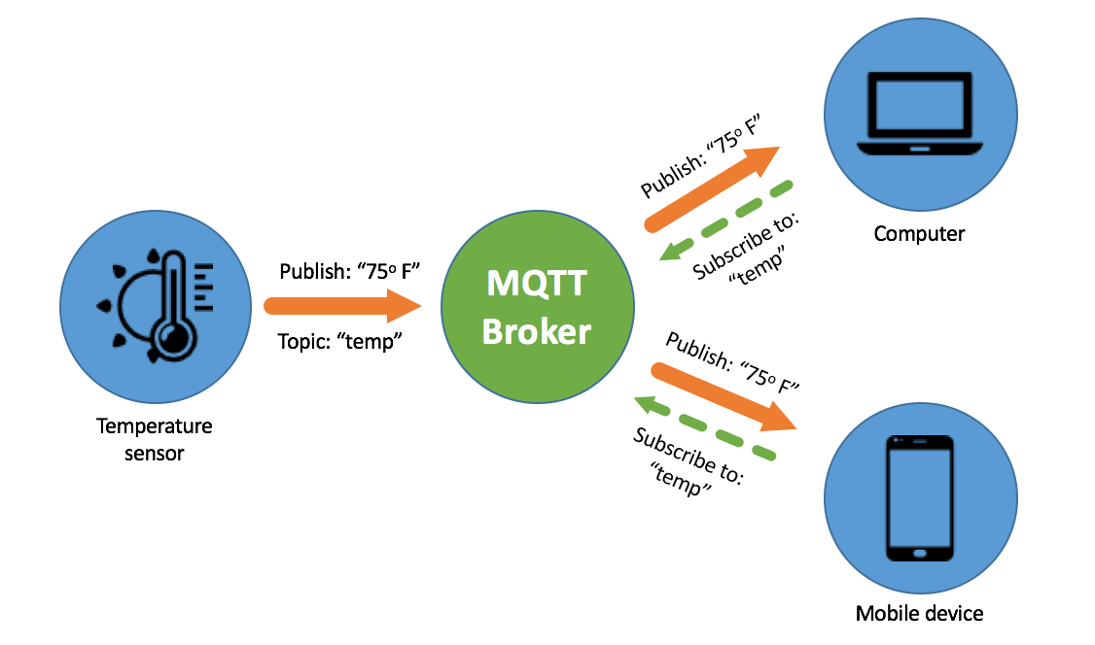

**1. MQTT Broker:**

* Imagine the broker as a central message exchange or post office.
* Clients (publishers and subscribers) connect to the broker.
* The broker doesn't understand the message content, it simply routes messages based on topics.
* Brokers can be software running on a server or even embedded devices with enough processing power.

**2. MQTT Client (Publisher and Subscriber):**

* These are the devices or applications that send and receive messages using MQTT.
* A client can act as both a publisher and a subscriber depending on its role.
* Publishers send data (messages) to specific topics.
* Subscribers indicate their interest in specific topics to receive relevant messages.
* Clients can be anything from smartphones and laptops to tiny sensor nodes, as long as they have an MQTT library.

**3. MQTT Topic:**

* Think of topics as labels or categories for messages.
* They help categorize and organize data on the broker.
* Topics are hierarchical strings separated by forward slashes ("/").
  + For example: home/kitchen/temperature or sensor/humidity/bathroom.
* Subscribers specify the topics they're interested in, and the broker filters messages accordingly.

**4. MQTT Message:**

* This is the actual data being exchanged between publishers and subscribers.
* It consists of two parts:
  + The **topic**, which tells the broker where to deliver the message.
  + The **payload**, which is the actual content of the message. It can be text, JSON, or any other data format.

Here's a quick analogy to solidify these concepts:

* Imagine a smart home system. A temperature sensor (publisher) publishes a message to the topic home/kitchen/temperature with the payload being "22°C".
* Devices subscribed to that topic, like a smart thermostat (subscriber), would receive this message and potentially adjust the temperature accordingly.

MQTT working- 1) first of all a subscriber subscribes to one or more topics(eg computer and mobile are the subscriber. 2) The temperature sensor is the publisher .Then one or more publisher publish message to a server (MQTT broker)(local or remote).The temperature sensor publishes its temperature value to the broker 3)The server publishes the message to the subscriber which have subscribed to the topic specified by the publisher .

MQTT doesn't have methods in the traditional programming sense, but it offers functionalities achieved through interactions between the clients and the broker. Here's a breakdown of the key functionalities:

**Client Functionalities:**

* **Connect:** Clients initiate a connection to the broker using a specific TCP/IP port (default: 1883).
* **Disconnect:** Clients gracefully close the connection with the broker.
* **Publish:** Clients send messages to a specific topic with a payload containing the data.
* **Subscribe:** Clients express interest in receiving messages for specific topics.
* **Unsubscribe:** Clients cancel their interest in receiving messages for a particular topic.

**Broker Functionalities:**

* **Accept/Reject Connection:** The broker determines if a client connection is valid based on authentication and authorization mechanisms (optional).
* **Receive Message:** The broker receives published messages from clients.
* **Route Message:** The broker uses the topic to determine which clients are subscribed and forwards the message to them.

**Additional Functionalities:**

* **Quality of Service (QoS):** MQTT offers different levels of message delivery guarantees (at most once, at least once, exactly once) to suit the needs of the application (configurable by publishers).
* **Last Will and Testament (LWT):** Clients can specify a message to be published by the broker in case of an unexpected disconnect. This allows other clients to be notified of the issue.

MQTT COMMUNIACTIONS

MQTT communication is a publish-subscribe messaging protocol designed for efficient data exchange between devices in the Internet of Things (IoT) world. It functions with a lightweight approach, making it ideal for resource-constrained devices and networks. Here's a breakdown of how MQTT communication works:

**The Players:**

* **Clients (Publishers & Subscribers):** These are the devices or applications that send and receive data. A single client can act as both a publisher and subscriber depending on its role. Publishers send data (messages) to specific topics. Subscribers indicate their interest in specific topics to receive messages relevant to them. Clients can range from smartphones to tiny sensor nodes, as long as they have an MQTT library.
* **Broker:** This acts as the central message exchange or post office. Clients connect to the broker. The broker doesn't understand the message content, it simply routes messages based on topics. Brokers can be software running on servers or even powerful embedded devices.

**The Flow:**

1. **Connection:** Clients establish a connection with the broker using TCP/IP.
2. **Publication:** A publisher sends a message containing two parts:
   * **Topic:** This labeled category (like a folder path) tells the broker where to deliver the message (e.g., home/kitchen/temperature).
   * **Payload:** The actual data being sent, often in JSON or text format (e.g., "22°C").
3. **Subscription:** Subscribers inform the broker about the topics they're interested in.
4. **Routing:** The broker acts like a post office, receiving messages from publishers and filtering them based on topics.
5. **Delivery:** The broker forwards the published messages to all the clients subscribed to the matching topics.

**Key Features:**

* **Lightweight:** Optimized for devices with limited resources.
* **Publish-Subscribe:** Decoupled communication, publishers and subscribers don't need to know about each other directly.
* **Reliable Delivery:** Offers different levels of message delivery guarantees (QoS).
* **Scalable:** Can handle a large number of devices communicating simultaneously.

**Benefits:**

* **Efficient Data Exchange:** Reduces network traffic by only sending data to interested parties.
* **Flexible Communication:** Devices can easily publish and subscribe to relevant information.
* **Scalability:** Suitable for large-scale IoT deployments.

TOPICS AND APPLICATIONS

MQTT topics are fundamental to how devices communicate in an MQTT system. They act as labels or categories that categorize and organize the data flowing through the broker. Here's a detailed explanation of MQTT topics:

**Structure:**

* MQTT topics are hierarchical strings, similar to folders in a file system.
* They use forward slashes (/) to separate levels within the topic hierarchy.
* For example: home/kitchen/temperature or sensor/humidity/bathroom.
* Topic names are case-sensitive and must be UTF-8 encoded strings.
* There's a minimum length of one character and a maximum length defined by the broker (typically 65535 bytes).

**Functionality:**

* Topics are used by clients (publishers and subscribers) to target and receive specific data.
* Publishers send their data messages to a particular topic.
* Subscribers indicate their interest in specific topics to receive relevant messages.
* The broker leverages topics to filter and route messages efficiently.

**Best Practices:**

* Choose clear and descriptive topic names that reflect the data they carry.
* Maintain a consistent hierarchy structure for easy organization and understanding.
* Avoid overly complex topic structures with unnecessary levels.
* Standardize topic naming conventions within your MQTT application for clarity.

**Wildcards:**

* MQTT provides wildcard characters that allow subscribers to express interest in a broader range of topics.
* The wildcard characters are:
  + #: Matches any number of levels within a topic (multi-level wildcard).
    - Example: home/# subscribes to all messages under the home topic, including nested levels like home/kitchen/appliance.
  + +: Matches a single level within a topic (single-level wildcard).
    - Example: sensor/+/temperature subscribes to messages about temperature from any sensor (e.g., sensor/livingroom/temperature or sensor/bedroom/temperature).

**Examples:**

* In a smart home system:
  + home/kitchen/temperature: A sensor might publish temperature data to this topic.
  + home/kitchen/appliance/status: An appliance might publish its status updates here.
  + #: A central monitoring system could subscribe to # to receive all messages in the system for overall monitoring.
* In a sensor network:
  + sensor/humidity/outdoor: An outdoor humidity sensor might publish readings here.
  + sensor/+/battery: Devices can subscribe to sensor/+/battery to monitor battery levels of any sensor.

By effectively using MQTT topics, you can establish a well-organized and efficient communication structure for your MQTT-based application

MQTT, due to its lightweight nature and publish-subscribe architecture, is a popular choice for a variety of applications, particularly in the realm of the Internet of Things (IoT). Here are some of the prominent applications of MQTT:

**Smart Homes:**

* **Automation and Control:** MQTT enables communication between various smart home devices like thermostats, lights, appliances, and sensors. This allows for creating automated routines based on sensor data (e.g., adjusting lights based on occupancy sensors).
* **Monitoring and Diagnostics:** Smart home devices can publish data on temperature, energy usage, and appliance status to MQTT topics. A central hub or smartphone app can subscribe to these topics for monitoring and diagnostics purposes.

**Industrial Automation:**

* **Machine-to-Machine Communication (M2M):** Factories and industrial plants can leverage MQTT for efficient data exchange between machines on the production line. Sensors can publish data on machine health, production status, and potential issues. Controllers can subscribe to these topics and take corrective actions.
* **Remote Monitoring and Control:** Production managers can remotely monitor and control industrial processes through MQTT. Sensors publish real-time data on equipment performance, while control systems can subscribe and send adjustments as needed.

**Sensor Networks:**

* **Data Collection and Aggregation:** MQTT is well-suited for collecting data from various sensors deployed in a network. Sensors can publish readings on temperature, humidity, pressure, or other environmental factors to specific topics. A central server can subscribe to these topics and aggregate the data for analysis.
* **Real-time Monitoring and Alerts:** Sensor data published via MQTT can be used for real-time monitoring of environmental conditions or asset status. Thresholds can be set, and if sensor data exceeds these limits, alerts can be triggered and sent to designated subscribers.

**Asset Tracking:**

* **Location Tracking:** Devices like GPS trackers or RFID tags can leverage MQTT to publish their location data to specific topics. Logistics companies can subscribe to these topics to track the movement of vehicles, goods, or equipment in real-time.
* **Condition Monitoring:** Sensors attached to assets can publish data on temperature, vibration, or other relevant factors. Monitoring systems can subscribe to these topics and identify potential issues with the assets before they become critical.

**Other Applications:**

* **Connected Vehicles:** MQTT can facilitate communication between vehicles and infrastructure, enabling features like traffic management, remote diagnostics, and in-vehicle software updates.
* **Agriculture:** Smart agriculture applications can use MQTT for sensor data collection from soil moisture sensors, weather stations, and irrigation systems.
* **Wearables and Fitness Trackers:** Wearable devices can publish health data like heart rate or activity levels to MQTT topics, allowing users to monitor their health and fitness on smartphones or dashboards.

SMQTT SMQTT stands for Secure Message Queue Telemetry Transport. It's considered an extension of the standard MQTT protocol, specifically designed to address security concerns. Here's a breakdown of SMQTT:

**Building on MQTT:**

* SMQTT inherits the core functionalities and publish-subscribe architecture of MQTT.
* It maintains the lightweight nature and efficiency of MQTT, making it suitable for resource-constrained devices.

**Security Focus:**

* The key differentiator of SMQTT is its emphasis on secure communication.
* It utilizes a technique called lightweight attribute-based encryption (ABE) to encrypt messages before they are published to the broker.

**Encryption Process:**

1. **Setup:** Both publishers and subscribers register with the broker and receive a secret master key.
2. **Encryption:** When a publisher sends data, the broker encrypts the message using the master key and attributes associated with the topic.
3. **Delivery:** The encrypted message is delivered to subscribers who possess the appropriate decryption keys.

**Benefits of SMQTT:**

* **Confidentiality:** Only authorized subscribers with the correct decryption keys can understand the message content.
* **Data Integrity:** Ensures that messages haven't been tampered with during transmission.
* **Secure Communication:** Offers a more secure alternative to standard MQTT, especially for sensitive data exchange.

**Trade-offs:**

* The encryption process adds some overhead compared to standard MQTT, potentially impacting performance on very low-resource devices.
* SMQTT adoption is not as widespread as MQTT, so finding compatible libraries and tools might be more challenging.

**Use Cases:**

* SMQTT is particularly suitable for scenarios where data security is critical, such as:
  + Industrial control systems
  + Smart grids
  + Healthcare applications transmitting sensitive patient data
  + Financial transactions

**In Conclusion:**

SMQTT provides a secure alternative to MQTT for applications where data confidentiality and integrity are paramount. While it adds some complexity compared to standard MQTT, the security benefits can be worthwhile for sensitive data exchange in the realm of IoT.

It's important to consider the trade-offs between security and performance when choosing between MQTT and SMQTT for your specific application.

COAP constrained application protocol

The Constrained Application Protocol, or CoAP, is a web transfer protocol designed for devices and networks with limited resources. Here's a breakdown of what CoAP is and why it's important:

* **Purpose:** CoAP caters to environments with limitations on bandwidth, memory, and processing power. Unlike traditional protocols that can be resource-heavy, CoAP is minimalist, balancing functionality with efficient resource consumption.
* **Applications:** CoAP is a key player in the Internet of Things (IoT) ecosystem. It enables communication between devices with limited capabilities, such as sensors and actuators, allowing them to seamlessly participate in the IoT.
* **Benefits:**
  + **Lightweight:** CoAP messages are smaller and require less processing power compared to HTTP, making it ideal for resource-constrained devices.
  + **Efficient:** Designed to operate on unreliable networks like low-power wireless connections, CoAP can still function effectively even with congestion or limited connectivity.
  + **Web-like:** Borrowing concepts from HTTP, CoAP uses similar methods (GET, POST, PUT, DELETE) for data exchange, making it familiar for developers.

In simpler terms, CoAP acts like a lightweight HTTP for constrained devices, enabling them to communicate and contribute data within the IoT landscape.

It is an IOT protocol. It is defined to allow simple and small devices to join the IOT through low bandwidth network. The protocol is designed for M2M and IOT applications . Such as smart energy and building automation. It is an application layer protocol follows the request-response pattern/method.

It runs over UDP protocol. It also uses RESTFUL Architecture. It uses less resource than HTTP . In CoAp client can use GET, PUT, DELETE method during request

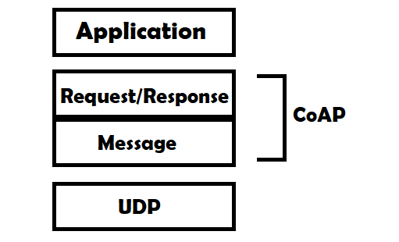

* **Application:** This represents the layer where user applications interact with CoAP.
* **Request/Response (COAP):** This signifies the CoAP protocol layer, which is responsible for building and handling CoAP messages.
* **Message:** This represents the CoAP message itself, which encapsulates the data being exchanged.
* **UDP:** This indicates the User Datagram Protocol, which is the underlying transport layer protocol used by CoAP for network transmission.

In essence, the diagram portrays a simplified flow of communication between two devices using CoAP:

1. **Application sends request:** An application on a device initiates the process by sending a request to the CoAP layer.
2. **CoAP builds message:** The CoAP layer takes the request and constructs a CoAP message containing the request details.
3. **CoAP sends via UDP:** The CoAP message is then transmitted over the network using the UDP protocol.
4. **Receive message (other device):** The UDP layer on the receiving device delivers the CoAP message.
5. **CoAP processes message:** The CoAP layer on the receiving device interprets the CoAP message.
6. **CoAP sends response:** The CoAP layer prepares a response message based on the request.
7. **Send response via UDP:** The CoAP response message is sent back through UDP.
8. **Receive response (original device):** The UDP layer on the original device receives the response message.
9. **CoAP delivers to application:** The CoAP layer extracts the response data and delivers it to the application on the original device.

COAP MESSAGE TYPES

CoAP defines four message types that cater to different communication needs and reliability requirements:

1. **Confirmable (0):** This message type guarantees reliable delivery. The sender expects an acknowledgement (message type 2) from the receiver to confirm successful message reception. If no acknowledgement is received within a timeout period, the sender retransmits the message with exponential backoff (waiting for increasingly longer durations before retrying). This ensures important data reaches the receiver even on unreliable networks.
2. **Non-confirmable (1):** This message type prioritizes efficiency over guaranteed delivery. The sender transmits the message but doesn't expect an acknowledgement. This is suitable for situations where data loss is tolerable or retransmission mechanisms are implemented at the application layer. It reduces processing overhead compared to confirmable messages.
3. **Acknowledgement (2):** This message type serves as a confirmation for a previously received confirmable message (type 0). It acknowledges successful reception and informs the sender that no further action is required.
4. **Reset (3):** This message type signals an error or unexpected condition during message processing. It indicates that the receiver couldn't process the received message and requests the sender to reset the communication (potentially retransmitting with a different approach).

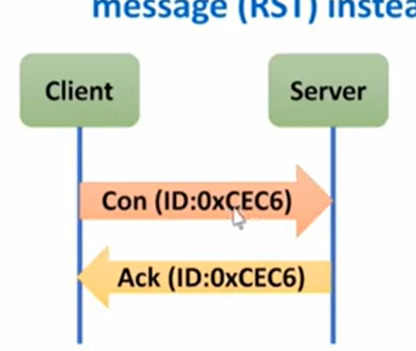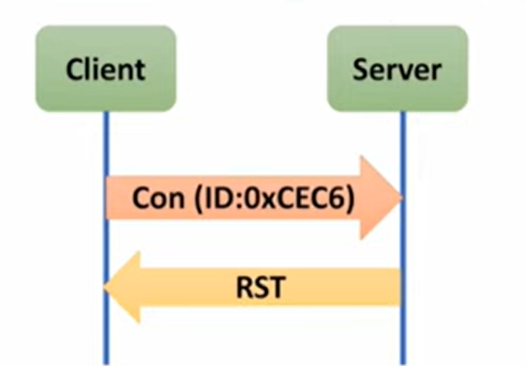

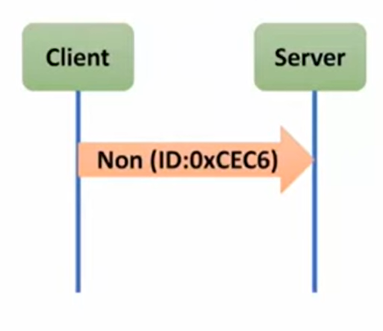//unreliable but have unique id

COAP REQUEST-RESPONSE MODEL-

# CoAp Request/Response Model

This is Second layer in the abstraction layer. Here request is sent using a Confirmable (CON) or Non-Confirmable (NON) message. There are several scenarios depending on if the server can answer immediately to the client request or the answer if not available:

* If the server can answer immediately to the client request then if the request is carried using a Confirmable message (CON) then the server sends back to the client an Acknowledge message containing the response or the error code:

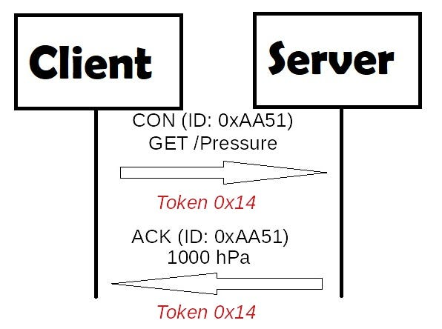

Here Token is different from the Message ID and it is used to match the request and the response.

* If the server can’t answer to the request, then server sends an Acknowledge with an empty response. As soon as the response is available then the server sends a new Confirmable message to the client containing the response. At this point the client sends back an Acknowledge message:

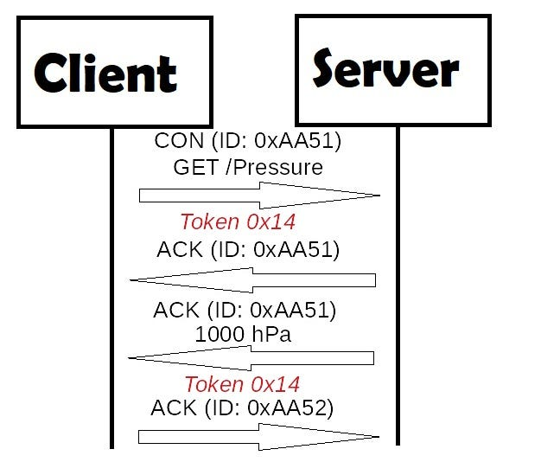

If the request coming from the client is carried using a NON-confirmable message then the server answer using a NON-confirmable message.

XMPP

XMPP is a short form for Extensible Messaging Presence Protocol. It’s protocol for streaming [XML elements](https://www.geeksforgeeks.org/xml-basics/) over a network in order to exchange messages and presence information in close to real time. This protocol is mostly used by instant messaging applications like WhatsApp. Let’s dive into each character of word **XMPP**:

* **X :** It means eXtensible. XMPP is a open source project which can be changed or extended according to the need.
* **M :** XMPP is designed for sending messages in real time. It has very efficient push mechanism compared to other protocols.
* **P :** It determines whether you are online/offline/busy. It indicates the state.
* **P :** XMPP is a protocol, that is, a set of standards that allow systems to communicate with each other.

These are the basic requirements of any Instant Messenger which are fulfilled by XMPP:

1. Send and receive messages with other users.
2. Check and share presence status
3. Manage subscriptions to and from other users.
4. Manage contact list
5. Block communications(receive message, sharing presence status, etc) to specific users.

Other XMPP features: **Decentralised –** XMPP is based on client-server architecture, i.e. clients don’t communicate directly, they do it with the help of server as intermediary. It is decentralised means there is no centralised XMPP server just like email, anyone can run their own XMPP server. Each XMPP client is identified by JID (Jabber ID).

#JID

{

user,

server,

resource

}

For example, I’m a whatsApp user and I’m identified by my mobile number, so

user = "8767898790"

server = "whatsapp.com"

resource = "mobile"

JID : "8767898790@whatsapp.com/mobile"

**resource** is used in case the application support mobile as well as desktop or web application, so it can be optional in case a Instant Messenger Application support only single kind of resource. **XMPP implementation –** The original protocol for XMPP is [Transmission Control Protocol](https://www.geeksforgeeks.org/computer-network-tcpip-model/), using open ended XML streams over long lived TCP connections. In some cases, there are restricted firewalls, XMPP(port 5222) is blocked, so it can’t be used for web applications and users behind restricted firewalls, to overcome this, XMPP community also developed a HTTP transport. And as the client uses HTTP, most firewalls allow clients to fetch and post messages without any problem. Thus, in scenarios where the TCP port used by XMPP is blocked, a server can listen on the normal HTTP port and the traffic should pass without problems

XMPP, which stands for Extensible Messaging and Presence Protocol, is an open standard communication protocol designed for instant messaging (IM), presence information (like whether someone is online or offline), and contact list management. Here's a breakdown of what XMPP offers:

* **Open standard:** Unlike closed messaging systems, XMPP follows an open standard, meaning anyone can develop software compatible with it. This allows for innovation and interoperability between different XMPP services.
* **Decentralized network:** XMPP doesn't rely on a single central server. Instead, users connect to individual servers, similar to email. This gives users more control over their data and privacy.
* **Extensible:** As the name suggests, XMPP is extensible, meaning it can be expanded to support new features and functionalities beyond basic messaging. This makes it suitable for various applications beyond just IM.

Some common uses of XMPP include:

* Instant messaging apps: Several messaging applications like Gajim, Psiphon, and Conversations use XMPP.
* Social media: Some social media platforms leverage XMPP for real-time communication features.
* Voice and video calls: XMPP can be used for making voice and video calls through integrated applications.
* Online gaming: Some online games use XMPP for in-game communication between players.

AMQP FEATURES AND COMPONENTS

**AMQP (Advanced Message Queuing Protocol)** is an open-standard application layer protocol designed for reliable and secure message exchange between applications. It acts as a messaging middleware, enabling applications to communicate asynchronously through a central server called a **message broker**.

Here's a breakdown of key features of AMQP:

* **Message-oriented:** Communication happens by exchanging messages instead of direct data streams.
* **Queuing:** Messages are placed in queues within the message broker. This allows applications to send and receive messages at their own pace, ensuring delivery even if the recipient is unavailable.
* **Routing:** Messages are routed based on predefined rules (bindings) to specific destinations (queues or exchanges). This enables flexible message distribution.
* **Reliability:** AMQP offers different delivery guarantees depending on the need. Options include at-least-once (ensures delivery but might be duplicated), at-most-once (delivered maximum once), and exactly-once (guaranteed single delivery).
* **Security:** AMQP supports authentication and encryption to protect message confidentiality and integrity.

**Common applications of AMQP include:**

* **Microservices architecture:** Enables asynchronous communication and loose coupling between microservices.
* **Integration tasks:** Provides a reliable way to exchange data between different applications and systems.
* **Event-driven architectures:** Plays a crucial role in enabling applications to publish and subscribe to events.
* **Internet of Things (IoT):** Manages communication between IoT devices and backend systems for data exchange and control.

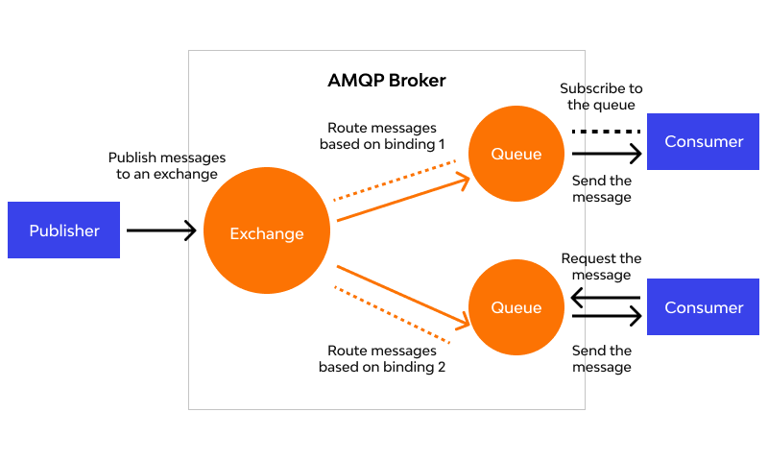

AMQP (Advanced Message Queuing Protocol) boasts a range of features that make it a powerful tool for reliable and secure message exchange between applications. Here are some of its key functionalities:

**Message-oriented Communication:** Unlike traditional methods that establish direct connections for data exchange, AMQP focuses on transmitting messages. Applications send messages to a central server (message broker), and the broker handles routing and delivery to the intended recipient.

**Asynchronous Messaging:** AMQP facilitates asynchronous communication, meaning the sender doesn't wait for the receiver's response. This improves overall system performance and scalability as applications don't block each other. Messages are placed in queues within the broker, allowing applications to send and receive messages at their own convenience.

**Reliable Delivery:** AMQP guarantees message delivery with various options depending on the specific requirement. Here's a breakdown of common delivery guarantees:

* **At-least-once delivery:** This ensures the message is delivered, but there's a possibility of duplicates.
* **At-most-once delivery:** The message is delivered a maximum of once, but delivery might not be guaranteed.
* **Exactly-once delivery:** This offers the strongest guarantee, ensuring the message is delivered only once.

**Flexible Routing:** AMQP employs a routing system that directs messages to specific destinations based on predefined rules. These rules, called bindings, connect exchanges (message distribution points) to queues. Here are some common exchange types:

* **Direct exchange:** Delivers messages to a single specific queue based on a routing key that matches the queue's binding key.
* **Topic exchange:** Routes messages to multiple queues based on wildcards in the routing key and matching binding keys.
* **Fanout exchange:** Broadcasts messages to all queues bound to it.

**Security:** AMQP prioritizes message security by offering features like:

* **Authentication:** Verifies the identity of applications attempting to connect to the message broker.
* **Authorization:** Controls access to specific exchanges, queues, and operations.
* **Encryption:** Scrambles message content to ensure confidentiality during transmission.

**Management Capabilities:** AMQP provides features for managing the messaging infrastructure, allowing for monitoring message flow, queue lengths, and overall system health.

These features make AMQP a versatile solution for various applications, including microservices architectures, integration tasks, event-driven architectures, and the Internet of Things (IoT).

AMQP relies on several key components working together to facilitate reliable message exchange. Here's a breakdown of these essential elements:

1. **Message Broker:** The heart of the AMQP system, the message broker is a server responsible for routing, storing, and delivering messages. It acts as an intermediary between applications, handling communication without requiring direct connections.
2. **Messages:** The core unit of information exchanged in AMQP. Messages consist of a payload (the actual data) and optional headers containing metadata about the message (e.g., priority, routing information).
3. **Exchanges:** These act as distribution points within the message broker. Applications publish messages to exchanges, and the exchange, based on predefined rules, determines where to route the message. Different types of exchanges offer flexibility in message distribution:
   * **Direct Exchange:** Routes messages to a single specific queue based on an exact match between the message's routing key and the queue's binding key.
   * **Topic Exchange:** Uses wildcards in the routing key to potentially match messages to multiple queues based on their binding keys.
   * **Fanout Exchange:** Broadcasts messages to all queues bound to it, essentially replicating the message for all subscribers.
4. **Queues:** Queues act as buffers within the message broker, temporarily storing messages until the recipient (consumer) is ready to receive them. This ensures messages are not lost even if the recipient is unavailable momentarily.
5. **Bindings:** These define the relationship between exchanges and queues, specifying how messages published to an exchange are routed to specific queues. Bindings consist of an exchange, a queue, and a routing key (except for fanout exchanges).
6. **Connections:** Connections establish a communication channel between an application (producer or consumer) and the message broker. Each connection can have one or more channels.
7. **Channels:** Channels operate within a connection, allowing for multiplexed communication. Applications can use a single connection with multiple channels for various tasks like publishing messages, subscribing to queues, and acknowledging message delivery.
8. **Producers:** Applications that send messages to the message broker are referred to as producers. They publish messages to specific exchanges, and the exchange handles routing based on the defined bindings.
9. **Consumers:** Applications that receive messages from the message broker are called consumers. They subscribe to specific queues, and the message broker delivers messages from those queues to the consumers.
10. **Acknowledgments:** Consumers can acknowledge receiving messages, notifying the message broker that the message has been processed successfully. This helps ensure reliable delivery and prevent redeliveries in case of failures.

AMQP FRAME TYPES

There are two main perspectives on AMQP frame types depending on the AMQP version you're considering:

**AMQP 1.0 Frame Types:**

AMQP 1.0 defines five frame types:

1. **Protocol Header Frame:** This frame is only used once at the beginning of a connection to establish communication parameters between the client and the broker. It's not used in subsequent exchanges.
2. **Method Frame:** This is the workhorse of AMQP 1.0, carrying Remote Procedure Calls (RPCs) for nearly all communication between the client and the broker. Examples include publishing messages, subscribing to queues, and acknowledging message delivery.
3. **Content Header Frame:** This frame appears optionally within a method frame and provides additional information about the message content, such as its format and size.
4. **Body Frame:** This frame carries the actual data (payload) of the message. There can be multiple body frames for a single message if the payload is large.
5. **Heartbeat Frame:** This optional frame serves as a keep-alive mechanism to ensure the connection remains active even during periods of inactivity.

**AMQP 0-9-1 Frame Types:**

The newer AMQP 0-9-1 specification introduces a different set of frame types with a more modular approach:

1. **Performative Frame:** This frame type replaces the method frame from AMQP 1.0 and carries various performative actions like opening connections, sending messages, and managing links.
2. **Header Frame:** This frame provides information about the following data, similar to the content header frame in AMQP 1.0.
3. **Body Frame:** The purpose remains the same as in AMQP 1.0, carrying the actual message payload.
4. **Heartbeat Frame:** Similar to AMQP 1.0, this frame maintains connection liveliness.

It's important to note that AMQP 0-9-1 is a more widely used version compared to AMQP 1.0. If you're unsure about the specific version in use, referring to the documentation of your chosen messaging library or broker will help determine the relevant frame types.

UNIT 5

IOT PLATFORMS

ARDUINO

Arduino is an open-source electronics platform that consists of a physical programmable circuit board (often called a microcontroller) and a piece of software, or IDE (Integrated Development Environment) that runs on your computer.

Arduino boards are able to read inputs - light sensors, temperature sensors, buttons - and control outputs - like LEDs, buzzers, and motors. This makes them great for building interactive projects.

There are many different Arduino boards available, each with different capabilities. The most popular board is the Arduino Uno, which is a good starting point for beginners.

Here are some of the things you can do with Arduino:

* Build a simple robot
* Create a temperature or light sensor
* Control an LED light show
* Make a sound effects generator

Arduino is a fantastic platform for getting started with the Internet of Things (IoT). Here's how they work together:

* **Arduino as a physical device:** Arduino boards can be the brains of your IoT project. They can collect data from sensors (temperature, light, etc.), control actuators (LEDs, motors), and communicate with the internet.
* **Connectivity:** Some Arduino boards have built-in Wi-Fi or Ethernet capabilities, allowing them to connect directly to the internet. For boards without built-in connectivity, you can add an external Wi-Fi module or Ethernet shield.
* **Arduino Cloud:** The Arduino Cloud is a platform specifically designed to simplify IoT development with Arduino. It provides an online IDE for coding, tools to connect your Arduino to the cloud, and dashboards to monitor and control your project remotely.
* **Applications:** There are endless possibilities for Arduino and IoT projects. You can build smart home systems that control lights and thermostats, create remote weather stations, or design wearable health monitors.

RASBERRY PI BOARD

**What is a Raspberry Pi?**

Raspberry Pi is a series of single-board computers developed by the Raspberry Pi Foundation, a UK-based charity. Their mission is to make computer science education more accessible and promote the development of new technologies.

**What are the key features?**

* **Size and Affordability:** Raspberry Pi boards are compact, roughly the size of a credit card. They are significantly cheaper than traditional desktop computers, making them a budget-friendly option for hobbyists and educators.
* **Processing Power:** Don't underestimate their size! Raspberry Pi offers various models with varying processing power. You can browse the web, stream media, and even run lightweight games on them.
* **General Purpose Input/Output (GPIO) Pins:** This is where the fun begins for electronics enthusiasts! These pins allow you to connect the Raspberry Pi to various electronic components like sensors, LEDs, and motors. This opens doors to building robots, controlling lights, and creating other interactive projects.
* **Learning Platform:** Raspberry Pi's affordability and user-friendliness make it a popular choice for beginners to learn coding and explore computer science concepts. There's a wealth of online tutorials and project ideas available to guide you on your learning journey.
* **Variety of Models:** The Raspberry Pi Foundation offers a range of models to cater to different needs and budgets. Some popular models include:
  + Raspberry Pi 4 Model B: Most powerful, ideal for demanding tasks like running a desktop or media center.
  + Raspberry Pi 3 Model B+: Good balance of power and affordability, popular for general-purpose computing and hobbyist projects.
  + Raspberry Pi Zero 2 W: Most compact and affordable, perfect for simple projects where size and cost are important.

**What can you do with a Raspberry Pi?**

The possibilities are vast! Here are some popular applications:

* **Learning to Code:** Raspberry Pi is a fantastic platform to learn Python, a popular and versatile programming language. There are many beginner-friendly tutorials and projects available.
* **Media Center:** Set up a Raspberry Pi as a media center to stream movies, music, and TV shows to your TV.
* **Retro Gaming:** Relive your childhood by turning your Raspberry Pi into a retro gaming console! You can emulate classic game systems and play your favorite old-school games.
* **Building Robots:** The GPIO pins make Raspberry Pi ideal for robotics projects. You can connect sensors and motors to build robots that can interact with their environment.
* **Smart Home Hub:** Control your smart home devices like lights, thermostats, and security systems using a Raspberry Pi.
* **DIY Electronics Projects:** The sky's the limit! There are endless creative projects you can build using Raspberry Pi, from weather stations to custom sound effects generators.

OTHER IOT PLATFORMS

**Cloud-based Platforms:**

* **Amazon Web Services (AWS) IoT:** A comprehensive suite of services for building, securing, scaling, and managing IoT applications. It offers device management, data collection, analytics, and machine learning capabilities.
* **Microsoft Azure IoT:** Another robust platform that provides device management, data ingestion, analytics, and visualization tools. It integrates seamlessly with other Microsoft services like Azure Stream Analytics and Power BI.
* **Google Cloud IoT:** Google's offering focuses on secure and scalable device management, data collection, and analytics. It integrates with other Google Cloud services like BigQuery for data storage and AI Platform for machine learning.
* **IBM Watson IoT Platform:** This platform caters to complex industrial IoT applications. It offers device management, data analytics, and cognitive services like machine learning and artificial intelligence.

**Open-source Platforms:**

* **ThingsBoard:** An open-source platform for device management, data collection, visualization, and rule engine functionality. It's a good option for developers who want more control and customization.
* **Eclipse Kura:** Another open-source platform geared towards resource-constrained devices. It's lightweight and offers core functionalities like device management and secure communication.

**Connectivity-focused Platforms:**

* **Particle:** This platform excels in simplifying device connectivity and management. It provides cellular and Wi-Fi connectivity options and tools for managing and updating device firmware remotely.
* **Hologram:** Similar to Particle, Hologram focuses on cellular connectivity for IoT devices. It offers global cellular coverage and tools for managing SIM cards and data usage.

Choosing the right platform depends on your specific needs. Consider factors like:

* **Project complexity:** For simple projects, an Arduino-based solution might suffice. Complex industrial applications might require a platform like IBM Watson IoT.
* **Scalability:** If you anticipate a large number of devices, choose a platform that can handle scaling effectively. Cloud-based platforms typically excel in this area.
* **Security:** Since security is paramount in IoT, ensure the platform offers robust security features for device authentication, data encryption, and access control.
* **Budget:** Cloud-based platforms often have pay-as-you-go pricing models, while open-source options might require investment in setting up your own infrastructure.

DATA ANALYTICS FOR IOT

Data analytics is the lifeblood of the Internet of Things (IoT). The massive amount of data generated by sensors and devices needs to be transformed into actionable insights to unlock the true potential of IoT. Here's a breakdown of data analytics for IoT:

**Why is data analytics important for IoT?**

* **Extracting Meaningful Insights:** Raw sensor data is vast but often meaningless on its own. Data analytics helps extract valuable insights from this data, like identifying trends, anomalies, and patterns.
* **Optimizing Operations:** Businesses can leverage data analytics to optimize various aspects of their operations. For instance, analyzing sensor data from factory machines can help predict maintenance needs and prevent downtime.
* **Predictive Maintenance:** By analyzing sensor data, companies can predict when equipment might fail and schedule maintenance proactively. This can prevent costly breakdowns and improve overall equipment effectiveness.
* **Improved Decision-Making:** Data-driven insights empower businesses to make informed decisions. For example, analyzing energy consumption data from smart buildings can help optimize energy usage and reduce costs.
* **Developing New Products and Services:** Data analytics can reveal valuable customer insights and usage patterns. This information can be used to develop new products and services that cater to specific customer needs.

**The Process of IoT Data Analytics:**

1. **Data Collection:** Sensors and devices continuously collect data, which can be temperature readings, machine vibrations, or customer behavior data.
2. **Data Ingestion and Preprocessing:** The collected data is streamed to a data storage platform, often in the cloud. Here, data is preprocessed to clean and format it for analysis.
3. **Data Analysis:** Various data analytics techniques are employed, including descriptive statistics, machine learning, and artificial intelligence (AI). These techniques help identify trends, patterns, and anomalies within the data.
4. **Visualization:** Data is presented visually using dashboards and charts to make it easier to understand and communicate insights.
5. **Actionable Insights:** The goal is to translate insights into actionable steps. For instance, identifying a failing machine might trigger a maintenance work order.

**Tools and Technologies for IoT Data Analytics:**

* **Cloud Platforms:** Major cloud providers like AWS, Microsoft Azure, and Google Cloud Platform offer comprehensive IoT data analytics solutions that include device management, data storage, and analytics tools.
* **Stream Processing Engines:** These engines are designed to analyze and react to data streams in real-time. This is crucial for applications that require immediate response, like detecting fraudulent activity in financial transactions.
* **Machine Learning and AI:** Machine learning algorithms can uncover hidden patterns in data and make predictions. AI can be used to automate tasks and decision-making processes.

**Benefits of using data analytics for IoT:**

* **Increased Efficiency:** Data analytics can streamline operations and resource allocation, leading to increased efficiency and cost savings.
* **Improved Customer Satisfaction:** By analyzing customer data, businesses can personalize their offerings and provide better customer experiences.
* **New Revenue Streams:** Data analytics can uncover new business opportunities and lead to the development of innovative products and services.
* **Sustainability:** Data analytics can be used to optimize energy consumption and reduce environmental impact.

Data analytics for IoT is a powerful tool that unlocks the true potential of connected devices. By transforming data into actionable insights, businesses can gain a competitive edge and drive innovation across various industries.

CLOUD FOR IOT

Cloud computing plays a critical role in the Internet of Things (IoT) by providing the infrastructure and services needed to manage, analyze, and leverage the massive amount of data generated by IoT devices. Here's a closer look at how cloud for IoT works:

**What is Cloud for IoT?**

Cloud for IoT refers to using cloud computing services to manage and connect IoT devices. It provides a scalable and cost-effective way to handle the following tasks:

* **Device Management:** Cloud platforms offer tools to provision, configure, and monitor large numbers of IoT devices remotely. This simplifies device management and ensures all devices are running the latest software and security patches.
* **Data Collection and Storage:** Sensor data from IoT devices is securely collected and stored in the cloud. Cloud storage offers scalability to handle massive amounts of data and redundancy to prevent data loss.
* **Data Processing and Analytics:** Cloud platforms provide powerful data analytics tools to extract valuable insights from sensor data. This can involve identifying trends, patterns, and anomalies that can be used to improve operations, optimize processes, and develop new products and services.
* **Security:** Cloud providers offer robust security features to protect devices and data from unauthorized access. This includes features like encryption, access control, and identity management.
* **Scalability and Flexibility:** Cloud-based solutions are inherently scalable, allowing you to easily add or remove devices as needed. This flexibility is crucial for businesses with growing IoT deployments.

**Benefits of using Cloud for IoT:**

* **Reduced Costs:** Cloud services eliminate the need for upfront investment in hardware and IT infrastructure. You only pay for the resources you use, making it a cost-effective solution for businesses of all sizes.
* **Scalability and Flexibility:** Cloud platforms can easily scale to accommodate a growing number of devices. This is essential for businesses with expanding IoT deployments.
* **Improved Security:** Cloud providers offer robust security features that can be difficult and expensive to implement on-premise.
* **Reliable Data Storage and Processing:** Cloud storage ensures data availability and redundancy, while cloud-based analytics tools provide powerful capabilities for extracting insights from data.
* **Simplified Device Management:** Cloud platforms offer centralized tools for managing and monitoring large numbers of devices remotely.
* **Faster Time to Market:** Cloud services can help businesses deploy and scale IoT solutions more quickly.

**Popular Cloud Platforms for IoT:**

* **Amazon Web Services (AWS) IoT:** A comprehensive suite of services for building, securing, scaling, and managing IoT applications.
* **Microsoft Azure IoT:** Provides device management, data ingestion, analytics, and visualization tools. Integrates well with other Microsoft services.
* **Google Cloud IoT:** Focuses on secure and scalable device management, data collection, and analytics. Integrates with Google Cloud services like BigQuery and AI Platform.
* **IBM Watson IoT Platform:** Caters to complex industrial IoT applications, offering device management, data analytics, and cognitive services like machine learning and AI.

**Choosing the Right Cloud Platform for IoT:**

Several factors come into play when selecting a cloud platform for your IoT project. Here are some key considerations:

* **Project Requirements:** Consider the scale, complexity, and security needs of your project.
* **Scalability:** Choose a platform that can scale to accommodate growth in your number of devices.
* **Security:** Ensure the platform offers robust security features to protect your devices and data.
* **Cost:** Cloud providers offer different pricing models. Evaluate your budget and choose a platform that fits your needs.
* **Existing Infrastructure:** If you use other cloud services from a particular provider, it might be advantageous to leverage their IoT offerings for better integration.

CLOUD STORAGE MODEL AND COMMUNICATION API’S

The cloud storage model refers to a service offered by cloud computing providers that allows users to store data on remote servers accessed over the internet. This eliminates the need for physical storage devices like hard drives or local servers. Here's a breakdown of the key aspects:

**How it Works:**

1. **Data Upload:** Users upload their data (files, documents, videos, etc.) to the cloud storage provider's servers through a web interface, mobile app, or desktop application.
2. **Data Storage:** The data is securely stored across multiple servers in geographically distributed data centers. This redundancy ensures data availability and protection against hardware failures or natural disasters.
3. **Data Access:** Users can access their stored data from any device with an internet connection. They can download, edit, share, or manage their files through a web browser or the cloud storage provider's application.

**Benefits of Cloud Storage:**

* **Scalability:** Easily increase or decrease storage capacity as needed, eliminating the limitations of physical storage devices.
* **Accessibility:** Access your data from anywhere, anytime, with an internet connection.
* **Cost-Effectiveness:** Pay only for the storage space you use, making it a cost-efficient solution for businesses and individuals.
* **Security:** Cloud storage providers offer robust security features like encryption and access control to safeguard your data.
* **Disaster Recovery:** Data redundancy across geographically distributed servers ensures data availability even in case of hardware failures or natural disasters.
* **Collaboration:** Easily share files and folders with colleagues or friends, enabling seamless collaboration.
* **Data Backup and Sync:** Automatically backup your data to the cloud for peace of mind and keep files synchronized across multiple devices.

**Cloud Storage Models:**

There are three main cloud storage models, each suited for different needs:

1. **Object Storage:** Stores data as individual objects (files) with unique identifiers and metadata tags. Ideal for storing unstructured data like images, videos, and audio files.
2. **Block Storage:** Divides storage into fixed-size blocks, similar to a traditional hard drive. Well-suited for storing operating systems, databases, and applications.
3. **File Storage:** Creates a virtual file system that mimics the structure of local storage on your computer. Provides familiar directory structures for easy access and management of files and folders.

**Popular Cloud Storage Providers:**

* **Dropbox:** A popular choice for personal use, offering free storage with paid plans for additional space.
* **Google Drive:** Integrated with Google Workspace, offering free storage with paid plans for increased capacity.
* **Microsoft OneDrive:** Integrated with Microsoft 365 suite, providing free storage with paid plans for more space.
* **Amazon S3:** Scalable object storage service from Amazon Web Services, ideal for large-scale data storage needs.
* **iCloud:** Cloud storage solution offered by Apple, integrated with Apple devices and iCloud services.

**Choosing the Right Cloud Storage Provider:**

When selecting a cloud storage provider, consider the following factors:

* **Storage Needs:** How much storage space do you require?
* **Security:** What security features are offered to protect your data?
* **Accessibility:** How will you access your data (web browser, mobile app, etc.)?
* **Cost:** Compare pricing plans and choose a service that fits your budget.
* **File Sharing:** Do you need collaboration features for sharing files with others?

In the realm of the Internet of Things (IoT), communication APIs play a crucial role in enabling data exchange between devices and various platforms. These APIs act as messengers, ensuring seamless flow of information between the physical world and the digital realm. Here's a deeper dive into communication APIs for IoT:

**Why are Communication APIs Important for IoT?**

* **Device Connectivity:** Communication APIs provide a standardized way for IoT devices to connect to cloud platforms, data centers, or other devices. This eliminates the need for complex, device-specific protocols.
* **Data Exchange:** APIs facilitate the transfer of sensor data, control commands, and other information between devices and applications.
* **Scalability:** As your IoT deployment grows, communication APIs can handle the increasing volume of data traffic efficiently.
* **Security:** Many APIs offer built-in security features like encryption and authentication to safeguard sensitive data during transmission.
* **Simplified Development:** Developers can leverage pre-built functionalities to integrate communication capabilities into their IoT applications, saving time and resources.

**Types of Communication APIs for IoT:**

* **REST APIs (REpresentational State Transfer):** A popular choice known for their simplicity and flexibility. REST APIs use HTTP requests (GET, POST, PUT, DELETE) to exchange data between devices and servers.
* **MQTT (Message Queuing Telemetry Transport):** Lightweight messaging protocol designed for resource-constrained devices. MQTT operates on a publish-subscribe model, where devices publish data to topics and interested parties subscribe to receive relevant information.
* **CoAP (Constrained Application Protocol):** Another lightweight protocol optimized for devices with limited processing power and bandwidth. CoAP is based on HTTP but uses a simpler message format for efficient communication.
* **WebSockets:** Enable real-time, two-way communication between devices and servers. This is ideal for applications requiring continuous data exchange, like remote monitoring or control.

**Choosing the Right Communication API for your IoT Project:**

The selection of the most suitable communication API hinges on several factors specific to your project:

* **Device capabilities:** Consider the processing power, memory constraints, and network connectivity of your devices.
* **Data volume and frequency:** The amount and frequency of data transmission will influence the choice between lightweight protocols like MQTT and CoAP or more robust options like REST APIs.
* **Security requirements:** The level of security needed for data transmission will guide your decision. Opt for APIs with strong encryption and authentication features if security is paramount.
* **Real-time vs. non-real-time communication:** For scenarios requiring continuous data flow, WebSockets might be ideal. For non-real-time communication, REST APIs or MQTT could be sufficient.
* **Scalability needs:** If you anticipate a large-scale deployment, choose an API that can handle a high volume of data traffic efficiently.

**Examples of Communication API Providers for IoT:**

* **Twilio:** Offers APIs for various communication channels, including cellular connectivity for sending and receiving SMS or data messages to/from devices.
* **Losant:** Provides a comprehensive IoT platform with built-in communication APIs for device connectivity, data management, and analytics.
* **Xively (now owned by LogMeIn):** Offers cloud-based platform with APIs for device management, data collection, and visualization.
* **AWS IoT Core:** Amazon Web Service's offering for managing and connecting IoT devices at scale. It includes APIs for secure device registration, data publishing, and message subscription.
* **Microsoft Azure IoT Hub:** Microsoft's solution for managing and connecting IoT devices to the Azure cloud platform. It provides APIs for device provisioning, secure communication, and data management.

IOT CASE STUDIES

## Deep Dive into IoT Case Studies:

Here's a deeper look into the previously mentioned IoT case studies, exploring the technical aspects, challenges faced, and the overall impact:

**1. Smart Cities: San Diego's Intelligent Traffic Management**

* **Technical Aspects:**
  + Network of sensors: Traffic cameras, embedded road sensors, and connected parking meters collect data on traffic flow, occupancy, and parking availability.
  + IoT platform: Analyzes real-time and historical data to identify traffic patterns, predict congestion, and optimize traffic light timings.
  + Communication: Sensors transmit data wirelessly using protocols like cellular or low-power wide-area networks (LPWAN).
* **Challenges:**
  + Data security: Ensuring secure data transmission and storage to protect privacy concerns.
  + Interoperability: Integrating data from various sensor types and communication protocols into a unified platform.
  + Scalability: The system needs to handle the increasing volume of data as the city grows.
* **Impact:**
  + Reduced traffic congestion: Studies show a 10-15% decrease in travel times during peak hours.
  + Improved air quality: Optimized traffic flow leads to fewer idling vehicles and reduced emissions.
  + Enhanced citizen experience: Shorter commutes and better traffic management lead to a more livable city.

**2. Predictive Maintenance in Manufacturing: GE Aviation's Engine Health Monitoring**

* **Technical Aspects:**
  + Embedded sensors: Sensors monitor parameters like vibration, temperature, oil pressure, and fuel flow within jet engines.
  + Wireless communication: Sensor data is transmitted wirelessly from the aircraft to the cloud platform.
  + Machine learning algorithms: Analyze sensor data to identify anomalies and predict potential equipment failures.
* **Challenges:**
  + Sensor placement: Strategic placement of sensors to capture critical data points without affecting engine performance.
  + Data volume and processing: Managing the high volume of sensor data generated by multiple engines in real-time.
  + Cybersecurity: Ensuring the security of sensitive engine data from cyberattacks.
* **Impact:**
  + Reduced maintenance costs: Proactive maintenance prevents costly in-flight failures and unscheduled downtime.
  + Improved safety: Early detection of potential issues enhances flight safety and reduces the risk of accidents.
  + Increased engine lifespan: Proper maintenance practices extend the life of jet engines.

**3. Remote Patient Monitoring in Healthcare: Atrium Health's Wearable Technology**

* **Technical Aspects:**
  + Wearable devices: Patients wear smartwatches, fitness trackers, or other devices that monitor vital signs like heart rate, blood pressure, blood oxygen levels, and activity patterns.
  + Secure data transmission: Data is encrypted and transmitted securely to a cloud platform.
  + Telehealth platforms: Healthcare providers can access patient data remotely, monitor trends, and schedule virtual consultations.
* **Challenges:**
  + Patient adoption: Encouraging patients, especially the elderly, to wear and use the technology consistently.
  + Data privacy: Ensuring patient privacy and adherence to healthcare data regulations.
  + Interoperability: Ensuring compatibility between different wearable devices and healthcare IT systems.
* **Impact:**
  + Improved care coordination: Remote monitoring allows for early detection of potential health issues and timely intervention.
  + Reduced hospital readmission rates: Proactive monitoring helps prevent complications and the need for re-hospitalization.
  + Enhanced patient experience: Patients receive care from the comfort of their homes, improving overall satisfaction.

**4. Smart Agriculture: Dutch Farmers and Precision Irrigation**

* **Technical Aspects:**
  + Soil moisture sensors: These sensors are embedded in agricultural fields to measure water content in the soil at different depths.
  + Wireless communication: Sensor data is transmitted wirelessly to a central hub or cloud platform.
  + Irrigation control systems: Data is used to control irrigation systems precisely, delivering the optimal amount of water to crops.
* **Challenges:**
  + Sensor reliability: Ensuring accurate and consistent data collection from soil moisture sensors.
  + Network connectivity: Reliable internet connectivity is needed in rural areas for data transmission.
  + Farmer education: Encouraging farmers to adopt new technologies and integrate them into their existing practices.
* **Impact:**
  + Reduced water usage: Precision irrigation practices can save significant amounts of water, a valuable resource in many regions.
  + Increased crop yields: Optimal water delivery promotes healthy plant growth and improves crop yields.
  + Environmental benefits: Reduced water usage leads to lower energy consumption and a smaller environmental footprint.

**5. Asset Tracking and Supply Chain Management: Maersk's Container Tracking**

* **Technical Aspects:**
  + GPS and sensor tags: Shipping containers are equipped with tags that track location, temperature, humidity, and other environmental conditions

pen_spark